CLAUSEGUARD: LEGAL CONTRACT COMPLEXITY AND PREDATORY CLAUSE DETECTOR
(ClauseGuard)
A project report submitted in partial fulfilment of the requirements for the award of the degree of
BACHELOR OF TECHNOLOGY
in
COMPUTER SCIENCE AND ENGINEERING (DATA SCIENCE)
Submitted by
CH.PRANATHI | 23K91A6744
G.PRANAVI | 23K91A6762
G.CHARAN JOSEPH | 23K91A6753
G.BHAGWATH | 23K91A6760
Batch A6 (CSE - Data Science, Section A)
Under the esteemed guidance of
[GUIDE NAME]
[DESIGNATION]
[COLLEGE LOGO]
DEPARTMENT OF COMPUTER SCIENCE AND ENGINEERING (DATA SCIENCE)
[COLLEGE NAME]
[COLLEGE ADDRESS / AFFILIATING UNIVERSITY]
[ACADEMIC YEAR]

[COLLEGE LOGO]
[COLLEGE NAME]
DEPARTMENT OF COMPUTER SCIENCE AND ENGINEERING (DATA SCIENCE)
CERTIFICATE
This is to certify that the project report entitled "ClauseGuard: Legal Contract Complexity and Predatory Clause Detector (ClauseGuard)" is a bonafide record of the work carried out by CH.PRANATHI (23K91A6744), G.PRANAVI (23K91A6762), G.CHARAN JOSEPH (23K91A6753), G.BHAGWATH (23K91A6760), in partial fulfilment of the requirements for the award of the degree of Bachelor of Technology in Computer Science and Engineering (Data Science), during the academic year [ACADEMIC YEAR], under my supervision.

Project Guide  [GUIDE NAME]  [DESIGNATION] | Head of the Department  [HOD NAME]  Department of Computer Science and Engineering (Data Science) | External Examiner  [NAME AND SIGNATURE]
DECLARATION
We hereby declare that the project report entitled "ClauseGuard: Legal Contract Complexity and Predatory Clause Detector (ClauseGuard)", submitted to the Department of Computer Science and Engineering (Data Science), [COLLEGE NAME], in partial fulfilment of the requirements for the award of the degree of Bachelor of Technology in Computer Science and Engineering (Data Science), is a record of original work carried out by us under the guidance of [GUIDE NAME], [DESIGNATION]. The results embodied in this report have not been submitted to any other university or institution for the award of any degree or diploma.

CH.PRANATHI | 23K91A6744
G.PRANAVI | 23K91A6762
G.CHARAN JOSEPH | 23K91A6753
G.BHAGWATH | 23K91A6760
Place: [PLACE]
Date: [DATE]
ACKNOWLEDGEMENT
We express our sincere gratitude to our project guide, [GUIDE NAME], [DESIGNATION], for valuable guidance, encouragement and constructive suggestions throughout this project.
We thank [HOD NAME], Head of the Department of Computer Science and Engineering (Data Science), for providing the facilities and support needed to complete this work, and [PRINCIPAL NAME], Principal, [COLLEGE NAME], for the encouragement given to us.
We thank the project coordinators and all faculty and staff members of the department for their help, and our families and friends for their constant support.
We also acknowledge the authors of the base paper, Fayha Almutairy, Shahad Almutairi, Milaf Abdullah and Sara Salman, the creators of the Contract Understanding Atticus Dataset (Hendrycks, Burns, Chen and Ball) and The Atticus Project that released it under a CC BY 4.0 licence, and the authors and maintainers of the open-source software on which ClauseGuard is built, in particular FastAPI, SQLAlchemy, PyMuPDF, python-docx, NumPy, NetworkX, scikit-learn, React and Vite.

CH.PRANATHI
G.PRANAVI
G.CHARAN JOSEPH
G.BHAGWATH
ABSTRACT
Individuals, freelancers and small businesses sign contracts without legal help, and such contracts can hide unfair termination terms, penalties, unlimited liability or one-sided arbitration. Professional review is costly, commercial analysis tools target US and EU law, and most research systems judge clauses one at a time. The base paper by Almutairy et al. (IEEE Access, 2026) builds a retrieval-augmented, Gemini-based legal assistant and contract checker for Saudi Arabia; for Indian contracts no comparable open, measured system was found in the literature survey.
This project builds ClauseGuard, a web application that reads an uploaded PDF or DOCX contract, splits it into clauses with page numbers, assigns each clause one of 20 CUAD categories by comparing a Gemini embedding with category centroids, flags eight predatory patterns with deterministic rules tied to Indian statutes, detects three risky clause combinations in a clause graph, and scores complexity from readability, legal jargon, cross-references and sentence length into a grade A to F. Gemini then writes a plain-language reason, the triggering provision and safer wording for each flag, and a summary of the contract. The backend is FastAPI with SQLite and JWT authentication; the front end is React. The abstract named the Claude API, pgvector and Neo4j; the build uses Gemini, SQLite with NumPy and an in-memory NetworkX graph, and does not retrieve from a legal corpus.
Classification and predatory detection are scored separately. On 240 held-out CUAD spans the classifier reaches top-1 accuracy 0.792 and top-3 accuracy 0.979 (0.800 when no training span comes from the same contract). The 40-clause test set, written with the rules, gives precision 1.00 and recall 0.94; on an independent probe set of 40 clauses the same rules reach precision 0.79 and recall 0.46, because paraphrases without the keyword are missed. The non-API pipeline processes all 510 CUAD contracts at 56 ms each. Further findings: the tie-break and unclassified thresholds never fire, a PDF loses two of eight rules that the identical DOCX triggers, and an upload with eight flags takes 113.6 s. Sixty-eight automated tests pass and five documented limits are marked as expected failures. The report states these limits and lists the work needed to move from a validated prototype to use on real Indian contracts.
Keywords: contract analysis, predatory clauses, Indian contract law, CUAD, text embeddings, clause graph, readability.
TABLE OF CONTENTS
CHAPTER 1 INTRODUCTION 1
1.1 Introduction to the Project Domain 1
1.2 Background and Motivation 2
1.3 Problem Statement 3
1.4 Need for the Proposed System 3
1.5 Objectives 4
1.6 Scope of the Project 4
1.7 Key Contributions 6
1.8 Limitations and Assumptions 7
1.9 Organisation of the Report 8
CHAPTER 2 LITERATURE SURVEY 9
2.1 Overview of the Literature Survey 9
2.2 Base Paper Analysis 9
2.3 Related Work 11
2.4 Datasets and Algorithms Used in the Literature and in ClauseGuard 14
2.5 Strengths and Limitations of Existing Work 14
2.6 Research Gap 15
CHAPTER 3 FEASIBILITY STUDY 16
3.1 Technical Feasibility 16
3.2 Economic Feasibility 17
3.3 Operational Feasibility 17
3.4 Schedule Feasibility 18
3.5 Advantages and Constraints 18
CHAPTER 4 SYSTEM REQUIREMENTS AND ANALYSIS 20
4.1 Existing System and its Limitations 20
4.2 Proposed System and its Advantages 20
4.3 Functional Requirements 21
4.4 Non-Functional Requirements 22
4.5 Hardware and Software Requirements 22
4.6 User Roles and Constraints 22
CHAPTER 5 SYSTEM DESIGN 24
5.1 System Architecture 24
5.2 High-Level Workflow 25
5.3 Data-Flow Diagrams 26
5.4 UML Diagrams 28
5.5 Database Design 31
5.6 Module Design 33
5.7 User Interface Design 33
CHAPTER 6 METHODOLOGY AND SOFTWARE IMPLEMENTATION 36
6.1 Overall Methodology 36
6.2 Dataset 37
6.3 Preprocessing: Parsing and Segmentation 38
6.4 Algorithm Choice and Justification 39
6.5 Mathematical Formulation 40
6.6 Model Construction, Thresholds and Measured Results 41
6.7 Application Architecture 42
6.8 Key Code Walkthroughs 43
6.9 Implementation Decisions and Reasoning 45
6.10 API Design 46
6.11 Security and Error Handling 47
6.12 Installation and Execution 48
CHAPTER 7 SYSTEM TESTING 49
7.1 Testing Strategy 49
7.2 Unit Testing 49
7.3 Integration Testing 50
7.4 Functional Testing 51
7.5 Security Testing 52
7.6 Validation and Edge Cases 52
7.7 Performance Testing 53
7.8 User Acceptance Testing 55
7.9 Limits of the Testing Done 55
CHAPTER 8 RESULTS AND OUTPUT SCREENS 56
8.1 Output Screens 56
8.2 Model Performance 61
8.3 Results of the Application 66
8.4 Comparison with the Base Paper 67
8.5 Sample Inputs and Outputs 69
8.6 Success and Failure Analysis 70
8.7 Limitations of the Results 71
8.8 Objectives versus Outcomes 71
CHAPTER 9 CONCLUSION 73
9.1 Summary of the Work 73
9.2 Objectives Achieved 73
9.3 Key Findings 74
9.4 Practical Applications 74
9.5 Known Limitations 75
CHAPTER 10 FUTURE SCOPE 76
10.1 Improvements 76
10.2 Additional Features 76
10.3 Scalability and Deployment 77
10.4 Further Research 77
REFERENCES 78
APPENDIX A IMPORTANT CODE 79
A.1 Nearest-Centroid Classification with Tie-Break 79
A.2 One Predatory-Clause Rule and the Detector 79
A.3 Complexity Score 80
A.4 Risky Combinations 80
APPENDIX B INSTALLATION AND USER GUIDE 81
B.1 Installation Guide 81
B.2 User Guide 82
APPENDIX C ADDITIONAL SCREENS 83

LIST OF FIGURES
Fig. 5.1: System architecture of ClauseGuard 24
Fig. 5.2: High-level workflow 25
Fig. 5.3: Data-flow diagram, level 0 (context) 26
Fig. 5.4: Data-flow diagram, level 1 27
Fig. 5.5: Data-flow diagram, level 2: Classify clauses (process 3.0) 28
Fig. 5.6: Use-case diagram 29
Fig. 5.7: UML class diagram 29
Fig. 5.8: Sequence diagram: uploading a contract and reading the report 30
Fig. 5.9: Flowchart of the core algorithms 31
Fig. 5.10: Entity-relationship diagram 32
Fig. 5.11: Sign-up page 34
Fig. 5.12: Upload page before a file is chosen 34
Fig. 5.13: Contract report: grade, six figures, summary and severity chart 35
Fig. 5.14: Clause table with type, flags and risk 35
Fig. 5.15: Clause detail: reason, quoted provision and safer wording 35
Fig. 5.16: Clause graph with the risky combinations 35
Fig. 5.17: My contracts list with three analysed contracts 35
Fig. 5.18: Evaluation page with the measured scores 35
Fig. 7.1: One contract in three input forms: eight of eight rules fire on the DOCX, six of eight on the PDF, and eight of eight again when whitespace is collapsed before matching 53
Fig. 7.2: Measured response times: endpoints without Gemini (log scale, median and 95th percentile) and the three real uploads against the 180 s browser timeout 54
Fig. 8.1: Landing page 56
Fig. 8.2: Sign-up form 56
Fig. 8.3: Upload page with a file selected 56
Fig. 8.4: Analysis in progress 56
Fig. 8.5: Contract report: one-sided freelance agreement 57
Fig. 8.6: Obligations and risky combinations 57
Fig. 8.7: Clause detail: unilateral termination 58
Fig. 8.8: Clause detail: penalty versus liquidated damages 58
Fig. 8.9: Clause graph 59
Fig. 8.10: Contract report: fair consulting agreement 59
Fig. 8.11: Contract report: real supply agreement (PDF) 60
Fig. 8.12: Validation error for a wrong file type 60
Fig. 8.13: My contracts 60
Fig. 8.14: Evaluation page 61
Fig. 8.15: Recall of the classifier for each of the 20 CUAD categories (12 held-out spans each) 62
Fig. 8.16: Confusion matrix of the classifier on the 240 held-out spans (rows are true categories and sum to 12) 63
Fig. 8.17: Precision, recall and F1 of the rule engine on the shipped set and on the independent probe set 64
Fig. 8.18: Recall of each rule on the two test sets (three probe clauses per rule) 64
Fig. 8.19: Share of CUAD spans on which the closest rule fires 65
Fig. 8.20: Complexity scores of the 510 CUAD contracts with the grade boundaries 66
Fig. C.1: Landing page, measured results and how it works 83
Fig. C.2: Log-in form 83
Fig. C.3: Upload page before a file is chosen 83
Fig. C.4: Clause table of the freelance agreement 83
Fig. C.5: Clause detail: restraint of trade 84
Fig. C.6: Clause table of the real PDF contract 84
Fig. C.7: Evaluation page, per-rule table and classification 84

LIST OF TABLES
Table 1.1: Organisation of the report 8
Table 2.1: Papers in the batch literature survey and the two papers added 9
Table 2.2: Base paper compared with ClauseGuard 11
Table 2.3: Comparison of the surveyed works 13
Table 2.4: Datasets in the literature and in this project 14
Table 2.5: Techniques and their role 14
Table 2.6: Strengths and limitations of the surveyed works 14
Table 2.7: Research gaps and the response of this project 15
Table 3.1: Technical risks and mitigations 16
Table 3.2: Items and costs 17
Table 3.3: Project milestones with recorded dates 18
Table 3.4: Advantages and constraints of the project 18
Table 4.1: Limitations of the existing system 20
Table 4.2: Features of ClauseGuard 20
Table 4.3: Limitations answered by the proposed system 21
Table 4.4: Functional requirements 21
Table 4.5: Non-functional requirements 22
Table 4.6: Hardware and software requirements 22
Table 4.7: User roles 22
Table 5.1: Database tables 32
Table 5.2: Modules of ClauseGuard 33
Table 6.1: Pipeline of ClauseGuard 36
Table 6.2: Datasets used 37
Table 6.3: The eight predatory-clause rules 38
Listing: Heading pattern in services/parsing.py 38
Table 6.4: Algorithm choices 39
Table 6.5: Configuration of the analysis pipeline 42
Table 6.6: Technology stack of the implementation 42
Listing: Heading-based segmentation in services/parsing.py 43
Listing: Nearest centroid, tie-break and floor in services/classification.py 43
Listing: The no-refund rule in services/rules.py 44
Listing: Combination detection in services/graph.py 44
Listing: Weighted complexity score in services/complexity.py 44
Listing: Per-clause processing in services/pipeline.py 45
Listing: Ownership check in routes/contracts.py 45
Table 6.7: Implementation decisions 45
Table 6.8: API endpoints 46
Listing: Upload response (shape, abbreviated) 47
Table 6.9: Installation and execution 48
Table 7.1: Unit-level tests (53) 49
Table 7.2: Selected unit test cases 50
Table 7.3: Integration tests (20, one of them an expected failure) 50
Table 7.4: Backend test inventory (pytest 9.1.1, 26 October 2026) 50
Table 7.5: Functional test cases (live walk-through) 51
Table 7.6: Security test cases 52
Table 7.7: Validation and edge cases 52
Table 7.8: API response times without Gemini (live server) 54
Table 8.1: Clause classification results (unmodified ml/eval.py on cached embeddings) 61
Table 8.2: Shipped classifier against simple baselines 62
Table 8.3: Rule engine on two test sets 63
Table 8.4: Rules against the closest CUAD categories (a proxy, not a recall) 64
Table 8.5: Non-API pipeline over all 510 CUAD contracts 65
Table 8.6: Effect of the input format on the rule engine 66
Table 8.7: Real uploads through the web application 66
Table 8.8: SmartLaw Advisor [1] and ClauseGuard side by side (figures are as reported or measured by each) 68
Table 8.9: Related work, results as reported by their authors 68
Table 8.10: Sample outputs for the one-sided freelance agreement 69
Table 8.11: Sample summaries 70
Table 8.12: Failure cases with cause 70
Table 8.13: Objectives against outcomes 71
Listing: classify_clause() in backend/app/services/classification.py 79
Listing: The first of the eight rules and detect_flags() in backend/app/services/rules.py 79
Listing: score_contract() in backend/app/services/complexity.py 80
Listing: detect_risky_combinations() in backend/app/services/graph.py 80
Table B.1: Common problems 81
Table B.2: User guide 82

LIST OF ABBREVIATIONS
Abbreviation | Expansion
AI | Artificial Intelligence
API | Application Programming Interface
CC BY | Creative Commons Attribution
CSS | Cascading Style Sheets
CUAD | Contract Understanding Atticus Dataset
DFD | Data-Flow Diagram
DOCX | Office Open XML Word document
ER | Entity-Relationship
FK | Foreign Key
FR | Functional Requirement
HTTP | Hypertext Transfer Protocol
JSON | JavaScript Object Notation
JWT | JSON Web Token
kNN | k-Nearest Neighbours
LLM | Large Language Model
ML | Machine Learning
NFR | Non-Functional Requirement
NLP | Natural Language Processing
ORM | Object-Relational Mapping
PDF | Portable Document Format
PK | Primary Key
RAG | Retrieval-Augmented Generation
REST | Representational State Transfer
SLM | Small Language Model
SQL | Structured Query Language
TF-IDF | Term Frequency-Inverse Document Frequency
UI | User Interface
UML | Unified Modeling Language
URL | Uniform Resource Locator

CHAPTER 1
INTRODUCTION

1.1 Introduction to the Project Domain
A contract is the instrument through which most economic relationships are fixed: a freelancer agrees to deliver software for a fee, an employee accepts a bond and a notice period, a small business takes a supply or subscription agreement. Such documents are drafted by the party with more bargaining power and are usually signed without legal advice. They contain terms that can shift risk heavily to the weaker party: a right for one side to terminate at will, a penalty for delay that bears no relation to the loss, a promise not to work for any competitor for years, unlimited liability, a clause that assigns all of a freelancer's intellectual property, an arbitration clause in which one party appoints the arbitrator, or a subscription that renews itself. Individually each of these is common. A signatory who cannot tell which clauses matter, or who does not see how several clauses combine, signs with less information than the counterparty has.
The domain of this project is therefore automated contract review for non-lawyers under Indian contract law. It lies between several established areas. Legal natural language processing supplies datasets and benchmarks such as the Contract Understanding Atticus Dataset (CUAD) [8] and domain models such as LEGAL-BERT [9]. Text embeddings [10], [12], [13] turn a clause into a vector that can be compared with other clauses, and retrieval-augmented generation (RAG) [11] grounds a language model's answer in retrieved text. Keyword weighting [14] and readability formulas [15] give simple, auditable measures of text. Graph structures [16] can represent relationships between items. The base paper of this project, SmartLaw Advisor by Almutairy et al. [1], combines a large language model, a RAG pipeline over a Saudi legal corpus and a contract-analysis module for Arabic documents.
ClauseGuard, the system built in this project, accepts a contract as a PDF or DOCX file, splits it into clauses with page numbers, assigns each clause one of twenty CUAD-style clause types, applies eight curated rules drawn from Indian statutes [20]-[23] to flag predatory terms, checks whether flagged clauses form one of three risky combinations, computes a complexity score with an A to F grade, and asks a language model to explain each flag in plain language and to propose safer wording. The results are shown clause by clause in a web application.
One point of wording must be made at the outset. The batch abstract describes a RAG architecture that combines the Claude API with pgvector semantic search and a Neo4j knowledge graph. What was built and measured differs in three respects. The language model and the embedding model are Google Gemini, not Claude. Clause vectors are stored as binary columns in SQLite and compared with NumPy, not stored in pgvector. The clause graph is an in-memory NetworkX graph with three fixed combination patterns, not a Neo4j database of clause types, legal concepts and precedents. There is also no retrieval over a legal corpus: the only retrieval step is the nearest-centroid match of a clause against twenty CUAD categories. These differences, and their consequences, are discussed in Chapters 6 and 8.

1.2 Background and Motivation
Five observations motivated the project, and they follow the batch introduction. First, individuals, freelancers, gig workers and small businesses increasingly sign digital contracts without legal support. Second, such contracts can contain unfair termination terms, hidden liabilities or one-sided arbitration clauses. Third, non-experts struggle to recognise these clauses, which creates an information asymmetry against the weaker party. Fourth, professional legal review is expensive and not always accessible: one of the surveyed papers puts the check of a 10-page commercial contract for clause completeness alone at 45 to 90 minutes of a legal professional's time [4], and the benchmark literature on automated review begins from that cost [2]. Fifth, language models with retrieval can read a contract and explain risks in plain language [1], which makes an affordable first-pass reviewer technically possible.
Recent work shows both the promise and the limits of that possibility. The ContractEval benchmark [2] evaluated 19 language models on the CUAD test data over 41 clause categories and found that the best proprietary models reached an F1 of about 0.64, so that even strong models miss or mis-extract a considerable share of risk clauses. A study of a domain-trained small model [3] reported a macro F1 of 0.812 on 26 extraction fields over 24 contracts, at a much lower cost than frontier models. A cloud-based clause extraction and risk-scoring system [4] reported 94.2% average extraction accuracy on 20 synthetic contracts. The base paper [1] reported high accuracy for a Saudi legal assistant, but for Arabic text and Saudi law.
Almost all of this work concerns US or European commercial contracts, or Saudi regulation, and it analyses clauses one at a time. Indian contract law has its own provisions on the questions that matter most to a signatory: agreements in restraint of trade are void under section 27 of the Indian Contract Act, 1872, and compensation for breach is limited by section 74 [20]; the Arbitration and Conciliation Act, 1996 [21] governs arbitration clauses; the Consumer Protection Act, 2019 [22] addresses unfair contract terms for consumers; and the Copyright Act, 1957 [23] governs the assignment of authors' rights. A tool for Indian signatories has to reflect these provisions.
Taken together, the observations point to a gap: an affordable, jurisdiction-aware tool that flags predatory clauses, notices when clauses combine into something worse than each alone, and explains the result in plain language. The project asks how far a student team can go towards such a tool with open data (CUAD), a hosted language model and curated rules, and how honestly the result can be evaluated when no labelled corpus of Indian contracts is available.

1.3 Problem Statement
Non-experts cannot easily identify predatory or ambiguous clauses in contracts. Legal review is expensive and inaccessible for freelancers and small businesses. Existing tools ignore Indian contract law and analyse clauses in isolation. Users sign contracts without understanding hidden liabilities or unfair terms.
Formal statement. Given a contract file in PDF or DOCX format, produce (i) a segmentation of the text into clauses, each with its page number; (ii) a clause type for each clause drawn from a fixed set of twenty CUAD categories, with a confidence value; (iii) for each clause, the set of predatory-clause rules, from a curated set tied to Indian statutes, that the clause triggers, together with a plain-language reason, the quoted triggering words and a safer rewording; (iv) the risky combinations of rules that occur anywhere in the contract; (v) a complexity score from 0 to 100 and a grade from A to F; and (vi) a plain-language summary with the key obligations of the signatory. Clause classification and predatory-clause detection must be evaluated separately.
The problem is a systems problem as much as a modelling problem: six outputs have to be produced consistently from one document, kept for later viewing by the user who uploaded it, and explained in a way that a non-lawyer can follow.

1.4 Need for the Proposed System
- Cost and access. Professional review is slow and costly for the people most exposed to one-sided terms. A tool that gives a clause-level first reading in about a minute (15.5 s to 113.6 s in the three uploads of this project, almost all of it waiting for the language model) can help a signatory decide which clauses to ask a lawyer about.
- Jurisdiction. The surveyed systems and benchmarks work on US, EU or Saudi texts [1]-[4], [8]. A reviewer for Indian signatories has to encode the provisions of Indian statutes [20]-[23].
- Combinations of clauses. A termination-at-will clause, a no-refund clause and a penalty clause are each common, but together they let one side end the contract, keep the payment and still charge a penalty. Clause-by-clause tools do not report this.
- Explanations that a non-lawyer can use. A label such as Liquidated Damages does not tell a freelancer what to do. A flag has to say why the clause is risky, quote the words that triggered it and offer a fairer wording.
- Honest evaluation. Clause classification and predatory-clause detection are different tasks and are often conflated. The need is for a tool whose two scores are measured separately, on data that is described, with the weaknesses stated.

1.5 Objectives
The project has six objectives, taken from the batch objectives document. For each, the note in brackets states what was delivered.
1. Segment uploaded contracts into clauses and classify clause types. [Delivered: a heading-based segmenter with a paragraph fallback, and a nearest-centroid classifier over twenty CUAD categories using Gemini embeddings.]
2. Build a RAG pipeline using the Claude API and pgvector semantic search. [Delivered in a different form: Gemini for embeddings and generation, vectors in SQLite and NumPy; there is no retrieval over a legal corpus, so the pipeline is retrieval-assisted classification plus prompted generation, not a full RAG system.]
3. Model clause relationships and legal concepts in a Neo4j knowledge graph. [Delivered in part: an in-memory NetworkX graph with one node per clause and edges drawn from three fixed combination patterns; no legal-concept or precedent nodes and no graph database.]
4. Flag predatory clauses and clause combinations using Indian contract law criteria. [Delivered: eight curated regular-expression rules tied to Indian statutes and three combination patterns.]
5. Compute an overall contract complexity score and a plain-language risk summary. [Delivered: a 0 to 100 score from four text measures, an A to F grade, and a Gemini-written summary and list of obligations.]
6. Evaluate clause classification and predatory detection separately using CUAD and curated criteria. [Delivered: separate measurements on 240 held-out CUAD spans and on a 40-clause curated set, extended in this work by an independent probe set and a 510-contract corpus run.]
Chapter 8 measures each objective against the results and states where an objective was met only in part.

1.6 Scope of the Project

1.6.1 In scope
- Contracts in English as PDF (with real page numbers) or DOCX files, read for text; the file is removed from the server after analysis.
- Segmentation into clauses at numbered headings (1., 2.1, Section 3, Article 4), with a paragraph-merging fallback.
- Classification of each clause into one of twenty substantive CUAD categories by Gemini embedding and nearest centroid, with an optional language-model tie-break.
- Eight predatory-clause rules (restraint of trade, penalty versus liquidated damages, unilateral termination, unlimited liability, one-sided arbitration, automatic renewal, intellectual-property overreach, no-refund) and three risky combinations.
- A complexity grade from readability, legalese density, cross-references and sentence length, and a Gemini plain-language summary with key obligations.
- A web application with sign-up and log-in, upload, a contract list, a report, a clause detail page, a clause graph and an evaluation page, and a REST API with JWT authentication.
- Separate evaluation of classification and predatory detection, a probe set of independently written clauses, a run over all 510 CUAD contracts, API timings and an automated test suite.

1.6.2 Out of scope
- Legal advice. The output is information to help a signatory prepare questions for a lawyer; no lawyer reviewed the explanations.
- Training or fine-tuning a model. Nothing is trained; the twenty centroids are means of cached example embeddings.
- Scanned or image-only documents (no OCR), languages other than English, and documents other than contracts.
- A corpus of Indian contracts, a case-law or statute retrieval index, precedent modelling, and a Neo4j or pgvector deployment.
- Negotiation, redlining and e-signature, multi-user organisations, and any payment feature.
- Production hardening such as HTTPS termination, rate limiting, a hosted database and load testing.

1.6.3 Assumptions
- The uploaded file contains selectable text and numbered clause headings in the form the segmenter recognises.
- A Gemini API key with enough quota is available; the build was measured on a shared free-tier key.
- The eight rules and three combinations encode the author's reading of the cited statutes and are not a complete statement of Indian law.
- The application runs on one machine with a single SQLite database for one demonstration deployment.

1.7 Key Contributions
1. An end-to-end contract reviewer for Indian agreements. One application, ClauseGuard, that parses PDF and DOCX files, segments them into clauses with page numbers, classifies each clause, flags predatory terms, finds risky combinations, grades complexity and explains each flag, with 9 API endpoints, 4 database tables and 7 screens. It adopts the jurisdiction-aware, language-model-based design of the base paper [1] for Indian contracts.
2. An Indian-law rule set with explanations. Eight regular-expression rules, each tied to a named statute [20]-[23], and for every flag a reason, the quoted provision and a safer wording written by the language model from the rule's stated legal basis. On the 40-clause test set written with the rules they reach precision 1.000 and recall 0.941; on an independent probe set of 40 clauses they reach precision 0.786 and recall 0.458, which is the more honest figure.
3. Clause-combination logic. Three combinations of rule identifiers (unilateral termination with no refund and penalty; restraint of trade with unlimited liability; automatic renewal with unilateral termination) are reported when all their rules occur anywhere in a contract. On the 510 CUAD contracts 11 show a combination; the invented one-sided contract shows all three.
4. A complexity grade. A weighted score from the Flesch reading ease [15], legal-jargon density, cross-reference count and sentence length, graded A to F. Over the 510 CUAD contracts the grades are A 4, B 169, C 268, D 68 and F 1. The measure is lexical: the invented one-sided contract scored B and the fair one A.
5. Separate evaluation of classification and predatory detection. Clause classification reaches top-1 accuracy 0.792 and top-3 accuracy 0.979 on 240 held-out CUAD spans in 20 categories, against 0.675 for a TF-IDF [14] plus logistic-regression baseline; predatory detection is scored on its own test sets. The two scores are never merged.
6. Measured findings about the build itself. Parity between DOCX and PDF input (8 of 8 rules against 6 of 8 on identical text), thresholds that never act (the tie-break and the Unclassified floor), a split of the evaluation data that is not contract-disjoint, a 56 ms per contract processing time for the non-API pipeline, and upload times of 15.5 s to 113.6 s. These are reported rather than hidden.
7. A tested and documented code base. A suite of 73 automated tests (68 pass, 5 expected failures that document known limits), API response times, and reproducible experiment scripts.
Contributions 1 to 4 are engineering contributions; contributions 5 and 6 are the evaluation contributions. Compared with the base paper [1], which works on Arabic text and Saudi law, retrieves from a legal corpus with a reranker and reports 98.67% accuracy on 150 legal questions, this project works on English contracts under Indian law, has no legal-corpus retrieval, adds combinations and a complexity grade, and reports its own metrics on its own data. The tasks and data differ, so no numeric head-to-head is claimed.

1.8 Limitations and Assumptions
- The rules are regular expressions. On the independent probe set they miss 13 of 24 predatory clauses (recall 0.458) because they need the keyword, and they flag three of 16 benign look-alikes. The 40-clause test set was written by the author of the rules, so its scores (1.000 precision, 0.941 recall) are an upper bound, and the Evaluation screen's wording "held-out" overstates it.
- Classification is measured on annotation spans. The 240 test items are CUAD answer spans of about 290 characters, whereas the product classifies whole clauses of about 1,158 characters. In 19 whole clauses from two uploaded contracts about half of the labels were plausible (author's reading, indicative only). The split is by text and not by contract (192 of 240 items share a contract with training examples), although the contract-disjoint score is similar (0.800).
- Two thresholds never act. On the 240 spans the top similarity ranges from 0.657 to 0.849, so the tie-break (which needs a value below 0.60) and the Unclassified floor (below 0.35) are never reached, and every clause receives one of the twenty labels even if it belongs to none.
- Input format matters. PDF line breaks defeat rules that use a bounded gap between key phrases (6 of 8 rules found in the PDF form of a contract for which the DOCX form gives 8 of 8); text before the first numbered heading is discarded; 84 of 510 CUAD contracts produce fewer than five clauses; scanned PDFs cannot be read.
- The complexity grade is lexical. It does not measure fairness, and its weights and cut-offs were chosen by the author and are not validated against human ratings.
- Language-model output is unverified. Explanations, safer wording and summaries come from Gemini, were not checked by a lawyer, and were not measured for errors.
- No Indian contract data. CUAD consists of US filings; no corpus of Indian contracts was available, so nothing was evaluated on Indian documents.
- Dependence on a hosted model. The free tier of the default text model allowed 20 requests per day; a call takes about 12 s; the user interface times out after 180 s, so a contract with many flags could fail in the browser although the server would finish.
- Single machine, single database, no load, concurrency or penetration testing, and no user study.

1.9 Organisation of the Report
Table 1.1: Organisation of the report
Chapter | Title | Content
1 | Introduction | Domain, motivation, problem statement, objectives, scope, contributions, limitations
2 | Literature Survey | Base paper, related work by theme, datasets and algorithms, strengths and limitations, research gap
3 | Feasibility Study | Technical, economic, operational and schedule feasibility
4 | System Requirements and Analysis | Existing and proposed system, requirements, platform, user roles
5 | System Design | Architecture, workflow, DFDs, UML, database, modules, user interface
6 | Methodology and Software Implementation | Pipeline, datasets, preprocessing, algorithms, mathematics, application, API, security, installation
7 | System Testing | Strategy, unit, integration, functional, security, validation, performance, acceptance, limits
8 | Results and Output Screens | Output screens, measured results, comparison, failure analysis, objectives against outcomes
9 | Conclusion | Summary, objectives achieved, findings, applications, limitations
10 | Future Scope | Improvements, features, deployment, research

CHAPTER 2
LITERATURE SURVEY

2.1 Overview of the Literature Survey
The survey covers four groups of work. The first is the base paper [1], a legal assistant and contract analyser for Arabic documents under Saudi law. The second is work that evaluates language models on clause-level risk identification and extraction in English commercial contracts [2], [3] and that builds clause-extraction and risk-scoring systems [4]. The third is the learning, retrieval and text-analysis techniques from which ClauseGuard is built [8]-[19]. The fourth is the Indian statutes that define what is predatory in this project [20]-[23].
The batch literature survey lists five papers. The base paper [1] was read in full from its PDF, and so was the ContractEval benchmark [2], whose PDF is in the project's archive. Three listed papers (ClauseMiner [5], the Legal-BERT contract risk paper [6] and the construction-contract risk study [7]) could not be retrieved during this work, so they are named by title, year and venue as listed and no result is attributed to them. To avoid resting the review on titles alone, two further papers whose full text is in the project's archive were read and are reported: a comparison of a domain-trained small model with frontier language models on contract extraction [3] and an AWS-based clause extraction and risk-scoring system [4].
Table 2.1: Papers in the batch literature survey and the two papers added
No. | Paper (as listed or added) | Year | Venue | Status in this survey
1 | SmartLaw Advisor: AI-powered legal consultation and contract analysis for Saudi Arabia [1] (base paper) | 2026 | IEEE Access | Read in full
2 | ContractEval: benchmarking LLMs for clause-level legal risk identification in commercial contracts [2] | 2025 | arXiv:2508.03080 (listed for NLLP 2025) | Read in full
3 | ClauseMiner: prompt-engineered LLM for accurate, scalable legal clause extraction [5] | 2026 | Eng. Appl. of Artificial Intelligence | Listed; not retrieved
4 | Autonomous contract analysis and clause risk detection using Legal-BERT [6] | 2025 | ICSCN 2025 | Listed; not retrieved
5 | A study on LLM-based approach for construction contract risk detection [7] | 2024 | Int. Conf. Big Data and Digital Management | Listed; not retrieved
6 | A few good clauses: LLMs vs domain-trained small language models on structured contract extraction [3] | 2026 | arXiv:2605.05532 | Added; read in full
7 | Automated legal clause extraction and risk scoring using NLP and generative AI [4] | 2026 | IJRASET vol. 14 issue IV | Added; read in full

2.2 Base Paper Analysis
Base paper. F. Almutairy, S. Almutairi, M. Abdullah, and S. Salman, "SmartLaw Advisor: AI-powered legal consultation and contract analysis for Saudi Arabia," IEEE Access, vol. 14, pp. 32638 ff., 2026, doi: 10.1109/ACCESS.2026.3665420.
Problem and scope. Almutairy et al. start from the complexity of local laws and the scarcity of affordable legal support in Saudi Arabia, and from the absence of Arabic digital assistants aligned with Saudi legislation. They propose a virtual legal advisory platform with two functions: a legal chatbot that answers questions from a Saudi legal corpus, and a contract analysis system that extracts and classifies clauses of Arabic documents and checks them against national law. The paper was received on 24 December 2025 and published on 17 February 2026.
Retrieval pipeline. The chatbot uses retrieval-augmented generation. Legal documents are cut into coherent chunks by a semantic chunking step with a window of at most 1,024 tokens, embedded with GATE-AraBERT-v1 (an Arabic embedding model fine-tuned on legal terms), and indexed in the Chroma vector database (the paper also mentions a FAISS index of about 18,400 vectors and 152 MB). A query is embedded by the same model, the nearest chunks are retrieved (the paper states that the retriever returns a small number of candidates, k = 1), re-ranked by a cross-encoder (ARA-Reranker-V1), compressed to the essential passage and passed to Gemini 1.5 Flash. The generation settings are a temperature of 0.2, a maximum of 1,024 tokens, top-p 0.95 and top-k 40, so that the answer is nearly deterministic and tied to the supplied context.
Contract analysis. A user uploads a PDF, which is read by an OCR step that uses the multimodal ability of Gemini and is validated for errors in dates, figures and clause numbers. Each contract is compared with a checklist of essential clauses (payment terms, governing law, dispute resolution, termination, liability allocation, confidentiality and force majeure) that Saudi legal practitioners validated, and every clause is analysed by the language model for prohibited terms, ambiguous obligations and legally incomplete formulations. The paper describes the combination as hybrid rule-based and LLM-guided. The output is structured JSON with recommendations in Arabic, and a further step lists contradictory clause pairs.
Data and experiments. The evaluation set has 150 legal questions over ten legal domains and 50 real contract drafts; the authors justify the small size by the lack of public machine-readable Saudi legal data and by privacy rules, and note that the sets were built under expert supervision. All experiments ran in a cloud environment (Intel Xeon Platinum 8272CL, 32 GB, Ubuntu 20.04, API round-trip of 280 to 350 ms) and timings were averaged over three runs.
Reported results. Without retrieval, Gemini 1.5 Flash answered 148 of 150 questions correctly (98.67%) with an average response time of 1.63 s, ahead of GPT-3.5 (98.00%, 147 correct), GPT-4 (97.33%, 146, 2.56 s) and ALLaM (96.00%, 144, 4.51 s). With RAG the average similarity to the reference answer was 96.57% for Gemini at 143.52 s per query, which the authors explain as the cost of a full evaluation pipeline without caching, not the latency of the deployed system. For contract analysis the paper reports no numeric score; it compares sample outputs. In the sample shown, Gemini returned seven flagged clauses, six of which were judged accurate and the first erroneous, ALLaM nine (the first incorrect, with repetition), Command A five (the first incorrect) and GPT-4 six (the first wrong, and one clause that merged three issues).
Failure cases and limitations stated by the authors. Three kinds of error are described: incomplete retrieval when a relevant clause spans several chunks, misclassification of multi-purpose clauses that cover payment, liability and confidentiality together (the model assigns only one category), and, in a few answers, a statutory citation that was not in the retrieved context. They also note that performance on very ambiguous texts may vary, that a limited legal database restricts adaptation to changing regulation, that language models carry bias, and that legal data are unstructured and must be cleaned.
What ClauseGuard adopts and what it changes. ClauseGuard keeps the jurisdiction-aware, language-model-based design: contract text is turned into clauses, clause-level analysis uses a hosted Gemini model, and the result is written in plain language. It changes the following: the jurisdiction (Indian law, English text), the detection method (curated rules tied to statutes instead of a checklist and free-form LLM judgement), the unit of risk (combinations of clauses, which the base paper's own failure analysis does not address), the addition of a complexity grade, and the evaluation (clause classification and predatory detection scored separately on stated data). It drops the pieces it did not build: the legal-corpus retrieval with re-ranking, OCR and the chatbot.
Table 2.2: Base paper compared with ClauseGuard
Aspect | Base paper [1] | ClauseGuard
Jurisdiction and language | Saudi law, Arabic | Indian contract law, English
Language model | Gemini 1.5 Flash | Gemini (embeddings; text model gemini-flash-latest by default, gemini-3.1-flash-lite in the measured run)
Retrieval | Semantic chunks, GATE-AraBERT-v1, Chroma, cross-encoder re-ranking | No legal-corpus retrieval; nearest centroid over 20 CUAD categories (NumPy cosine, SQLite vectors)
Contract analysis | Checklist of essential clauses plus clause-level LLM analysis; contradiction pairs | Eight statute-tagged regex rules, three clause combinations, LLM explanation and safer wording
Complexity measure | None | Flesch, legalese density, cross-references, sentence length, A-F grade
Input | PDF through an OCR step | PDF (text layer) and DOCX; no OCR
Data | 150 questions, 50 contract drafts (Arabic) | CUAD for classification (240 held-out spans), 40 curated clauses and 40 probe clauses for rules, 510 CUAD contracts for scale
Evidence of contract analysis | Qualitative comparison of sample outputs | Measured: precision 1.000 / recall 0.941 (authored set), 0.786 / 0.458 (probe set); top-1 0.792 (classification)
Comparability | Different language, law, task and data | No numeric head-to-head is claimed

2.3 Related Work

2.3.1 Benchmarks of language models on clause-level risk
ContractEval [2] asks whether open-source models can match proprietary ones at identifying clause-level legal risk. It builds on the CUAD test data [8] (41 clause categories annotated by lawyers) and evaluates 19 models (four proprietary and fifteen open-source) by F1 and F2, by the Jaccard similarity of the extracted span to the labelled span, and by a "laziness" rate, the share of answers that wrongly say that no related clause exists. GPT-4.1 reached F1 0.641 and F2 0.672, and GPT-4.1 mini F1 0.644 and F2 0.678; Gemini 2.5 Pro Preview reached F1 0.497 and Claude Sonnet 4 F1 0.523, although Gemini 2.5 Pro had the lowest laziness rate (0.011) and the highest Jaccard score (0.506) among the proprietary models. The best open-source result was F1 0.540 (Qwen3 8B in thinking mode). The authors conclude that proprietary models are more correct, that larger open models do better with diminishing returns, that thinking mode raises output effectiveness but lowers correctness, and that most models perform at the level of a junior legal assistant. For this project the paper shows that even strong models miss many CUAD risk clauses, which supports pairing a language model with auditable rules instead of trusting it alone.

2.3.2 Domain-trained and frontier models for contract extraction
Lincoln et al. [3] compare a domain-trained Mixture-of-Experts model, Olava Extract, with five frontier systems (Claude Opus 4.6, Claude Sonnet 4.6, Gemini 2.5 Pro, Gemini 3.1 Pro Preview and GPT-5.4) on 24 held-out public contracts with 508 labelled field instances over 26 fields. Each contract was given whole to the model in one call, without chunking or retrieval, and the train and test contracts were separated by document identifier. The domain model reached a macro F1 of 0.812 and a micro F1 of 0.842, the highest precision (fewer unsupported answers) and a cost of $0.018 per contract under batching, but it trailed the leader by more than 0.05 F1 on 7 of the 26 fields, mostly currency, date and option-list fields. The lesson for ClauseGuard is methodological: separating training and test contracts by document is the stricter protocol, and the CUAD split used by the project's evaluation script does not do this (Chapter 8).

2.3.3 Clause extraction and risk-scoring systems
The LDAS system of Dhaksha Charan R and colleagues [4] is a serverless pipeline on AWS (Lambda, S3 and a generative model reached through Bedrock) that extracts ten clause types from PDF and DOCX files, marks clauses that are missing against a configurable template, and computes a weighted risk score from 0 to 100 in which high-risk clause types weigh 10 and medium types 5. On its primary test document, a software-services invoice, it reported eight deviations (six high, two medium), a score of 87 and no false positives; on 20 synthetic contracts a 94.2% average extraction accuracy; a Pearson correlation of 0.87 between its risk score and expert ratings over 30 sample contracts; and 14 of 15 contract pairs compared correctly. An end-to-end run took 62 s on average over 50 submissions. The system detects missing clauses, not predatory wording, and its evidence rests on one primary document and synthetic contracts. It is nevertheless the closest published example of the score-and-explain design used here, and it reports the one validation of a risk score against human ratings that this project lacks.
Three further papers appear in the batch survey: ClauseMiner, a prompt-engineered language model for scalable legal clause extraction [5]; a study of contract risk detection with Legal-BERT [6]; and a study of language-model-based risk detection in construction contracts [7]. They could not be retrieved, so only their titles are used: they indicate that prompt-based extraction, a legal-domain encoder and a vertical (construction) application are active directions, but nothing about their data or results is claimed here.

2.3.4 Legal-domain language models and text embeddings
BERT [10] introduced pre-trained bidirectional transformers for language understanding, and LEGAL-BERT [9] showed that pre-training or further pre-training on legal text helps legal tasks. Sentence-BERT [12] made sentence embeddings practical for similarity search, and Gemini Embedding [13] is the family to which the embedding model of this project belongs. ClauseGuard does not train or fine-tune any of them: it uses a hosted embedding model and measures how well the clause vectors separate the twenty CUAD categories.

2.3.5 Retrieval-augmented generation
Retrieval-augmented generation [11] combines a retriever with a generator so that an answer can rest on retrieved passages. The base paper [1] applies it to a Saudi legal corpus. ClauseGuard does not retrieve from a corpus of laws: it embeds the clause, finds the nearest category centroid and, for each rule hit, places the rule's hand-written statement of its legal basis in the prompt. This is grounding by prompt, not retrieval, and the report says so wherever the architecture is described.

2.3.6 Readability, complexity and graph reasoning
The Flesch reading ease [15] is a long-standing measure of how difficult a text is to read, computed from sentence and word length. None of the surveyed contract tools reports a document-level complexity grade, which is the contribution of this project's scoring module; its weights are the author's own and are not validated. Graph libraries such as NetworkX [16] make it easy to represent clauses as nodes and relations as edges. No surveyed work reasons over combinations of risky clauses, and the ClauseGuard graph is limited to three patterns written by hand.
Table 2.3: Comparison of the surveyed works
Work | Approach | Data | Reported result | Limitation for this project
Almutairy et al. 2026 [1] (base) | Gemini 1.5 Flash with RAG over a Saudi corpus; contract analysis by checklist and clause-level LLM analysis | 150 legal questions, 50 real contract drafts, Arabic | 98.67% (148/150) on questions; contract analysis judged by inspecting sample outputs | Arabic, Saudi law; no clause combinations; no complexity score; contract results qualitative
Liu et al. 2025 [2] (ContractEval) | Benchmark of 19 LLMs asked to extract risk clauses from whole contracts | CUAD test data, 41 categories | Best F1 0.644 (GPT-4.1 mini); best open-source F1 0.540 | Extraction of spans, not Indian law; no explanation or combination analysis
Lincoln et al. 2026 [3] | Domain-trained small model against five frontier LLMs, full-document extraction | 24 held-out contracts, 508 labelled field instances, 26 fields | Macro F1 0.812, micro F1 0.842; cost down 78%-97% | Extraction of fields, not risk; closed domain model
Dhaksha Charan R et al. 2026 [4] (LDAS) | Serverless pipeline; generative model extracts ten clause types; template comparison; weighted risk score | 20 synthetic contracts, 30 sample contracts, one primary test document | 94.2% extraction accuracy; risk score correlation r = 0.87; 100% on the primary document | Detects missing clauses against a template, not predatory wording; small, partly synthetic data
ClauseMiner 2026 [5] | Prompt-engineered LLM clause extraction (from the title) | Not retrieved | Not retrieved | Not retrieved
Legal-BERT contract risk 2025 [6] | Legal-BERT clause risk detection (from the title) | Not retrieved | Not retrieved | Not retrieved
Construction contract risk 2024 [7] | LLM-based risk detection (from the title) | Not retrieved | Not retrieved | Not retrieved

2.4 Datasets and Algorithms Used in the Literature and in ClauseGuard

2.4.1 Datasets
Table 2.4: Datasets in the literature and in this project
Dataset | Content | Use in ClauseGuard
CUAD v1 [8] | 510 commercial contracts, 41 categories of clause annotated by lawyers, CC BY 4.0; mostly US filings | Twenty substantive categories: 500 training spans (25 per category) for the centroids, 240 held-out spans (12 per category) for classification; all 510 contracts for the scale run
Curated Indian-law test set | 40 clauses labelled with the rules they should trigger, written with the rules | Predatory-detection score of the shipped evaluation (precision 1.000, recall 0.941)
Independent probe set | 24 predatory paraphrases and 16 benign look-alikes written during the documentation run | Second predatory-detection score (precision 0.786, recall 0.458)
Invented and public sample contracts | Two invented contracts (one-sided freelance, fair consulting) and one real CUAD contract typeset as PDF | End-to-end uploads and screenshots
Saudi corpus and contract drafts [1] | 150 questions and 50 Arabic drafts of the base paper | Not available; cited only

2.4.2 Algorithms and software
Table 2.5: Techniques and their role
Technique | Reference | Role in ClauseGuard
Text embeddings (gemini-embedding-001, 3,072 dimensions) | [10], [12], [13] | Clause vectors for nearest-centroid classification
Nearest centroid, cosine similarity | [12] | Assign one of 20 CUAD categories; baselines were k-NN, logistic regression and TF-IDF
TF-IDF term weighting and logistic regression | [14], [17] | Baselines in the classification experiment (top-1 0.621 and 0.675)
Retrieval-augmented generation | [11], [1] | Compared with; ClauseGuard grounds explanations through the rule's legal basis in the prompt
Regular-expression rules tied to statutes | [20]-[23] | Eight predatory-clause detectors
Language-model explanation | [1] | Reason, quoted provision, safer wording, summary and key obligations
Flesch reading ease | [15] | Readability component of the complexity score
Graph of clauses (NetworkX) | [16] | Nodes for clauses, edges for the three risky combinations
bcrypt password hashing, JSON Web Tokens | [18], [19] | Authentication of users and API calls
scikit-learn | [17] | Baseline classifiers and metrics in the experiment scripts

2.5 Strengths and Limitations of Existing Work
Table 2.6: Strengths and limitations of the surveyed works
Work | Strengths | Limitations for this project
SmartLaw Advisor [1] | Complete pipeline with retrieval, re-ranking, OCR and contract analysis; expert-validated checklist; model comparison; honest failure analysis | Arabic and Saudi law; contract-analysis results are qualitative; no combinations of clauses; no complexity measure; small data
ContractEval [2] | Expert-annotated CUAD test data; 19 models; correctness, span quality and laziness measured separately | Measures extraction of spans, not explanation or jurisdiction; US contracts; no combination logic
A Few Good Clauses [3] | Full-document protocol; contracts separated by identifier; cost and latency reported | Field extraction, not risk; domain model is closed; 24 contracts
LDAS [4] | Score and explanation in one product; end-to-end timing; correlation of the score with expert ratings | Detects absent clauses rather than predatory wording; one primary document, synthetic and sample contracts
ClauseMiner, Legal-BERT contract risk, construction risk [5]-[7] | Indicate prompt-based extraction, a legal encoder and a vertical application | Not retrieved; nothing about their data or results is claimed
Commercial contract tools (general knowledge, not surveyed) | Enterprise integration and large clause libraries | Aimed at companies, US or EU law; not assessed in this work

None of the surveyed systems analyses combinations of clauses, reports a document-level complexity grade, or covers Indian contract law. These three facts define the gap that ClauseGuard addresses. The last row of the table is general background and was not examined in detail in this work.

2.6 Research Gap
Contract analysis tools mostly target US and EU law and single clauses; jurisdiction-aware detection of predatory clause combinations in Indian contracts remains underrepresented. The table lists the specific gaps, the evidence in the surveyed work and how far this project closes each one.
Table 2.7: Research gaps and the response of this project
Gap | Evidence in the surveyed work | How ClauseGuard responds, and how far
Indian contract law is not covered | The base paper is Saudi [1]; the benchmark and extraction studies use US contracts [2], [3], [8] | Eight rules tied to the Indian Contract Act, the Arbitration and Conciliation Act, the Consumer Protection Act and the Copyright Act [20]-[23]. Partly closed: the rules are keyword patterns (recall 0.458 on independent clauses) and no Indian contract corpus was available
Clauses are analysed one at a time | No surveyed work reports a risk that arises from a combination of clauses | Three fixed combinations of rule identifiers. Partly closed: 3 patterns, matched anywhere in the contract; no data to say how common or harmful they are beyond 11 of 510 CUAD contracts
Classification and risk detection are conflated | ContractEval scores extraction by category; LDAS reports one risk score; the base paper reports question accuracy [1], [2], [4] | Two separate scores: top-1 0.792 for classification and precision/recall for rules. Closed for this build; both scores have caveats stated in Chapter 8
Reviews are not written for non-lawyers | Outputs of the surveyed work are labels, spans or scores | Plain-language reason, quoted provision, safer wording and summary per contract. Not verified by a lawyer
No complexity grade for the whole document | None of [1]-[4] reports one | A to F grade from four text measures. Lexical only; unvalidated against human ratings
Grounded retrieval over Indian law | The base paper retrieves from a Saudi corpus [1] | Not closed: ClauseGuard has no retrieval over a legal corpus and no knowledge graph of concepts and precedents

CHAPTER 3
FEASIBILITY STUDY

3.1 Technical Feasibility
ClauseGuard needs six capabilities: reading PDF and DOCX files, splitting text into clauses, turning clauses into vectors, applying rules, scoring text and generating explanations. Each one was available as an existing library or service, and each was exercised in this project. PDF text with page numbers is read by PyMuPDF and DOCX text by python-docx. Segmentation is a regular expression over numbered headings. Clause vectors (3,072 dimensions) come from the Gemini embedding model [13] and are compared with NumPy. Rules are Python regular expressions. The complexity score needs only string processing. Explanations come from a Gemini text model. The API layer is FastAPI with SQLAlchemy and SQLite, and the interface is a React application. No capability required training a model or a GPU.
Technical feasibility was confirmed by measurement. The non-API part of the pipeline (segmentation, rules, combinations, complexity) processed all 510 CUAD contracts, 23,869 clauses, in 28.5 s, which is 56 ms per contract. The API endpoints that do not call Gemini answered in 2.5 ms to 15.3 ms (median), except the bcrypt operations at about 255 ms to 265 ms. The 73 automated tests (68 pass, 5 expected failures documenting known limits) run in about 10 s with the language model replaced by stubs. Three contracts were uploaded through the browser with real Gemini calls and each produced a report.
The principal technical risks, with the measured effect and the mitigation used in the prototype, are listed below.
Table 3.1: Technical risks and mitigations
Risk | Likelihood and effect (measured) | Mitigation in the prototype
Gemini quota and latency | The default text model gemini-flash-latest resolved to gemini-3.8-flash with a free tier of 20 generate requests per day; it returned 429 and timed out at the start of the work. A text call took about 12 s | The backend reads the model name from .env; the measured run used gemini-3.1-flash-lite. Embedding calls were not limited in practice (about 740 in 7 minutes)
Keyword rules miss paraphrases | Recall 0.458 on 24 independently written predatory clauses; 3 of 16 benign look-alikes flagged | Rules are auditable; each flag is shown with the quoted provision so a reader can judge it; the limitation is stated
PDF text differs from DOCX text | Same contract: 8 of 8 rules in DOCX, 6 of 8 in PDF, because line breaks break bounded-gap patterns | Documented; whitespace collapsing before matching restored 8 of 8 in the experiment but is not applied in the shipped code
Segmentation by numbered headings | 84 of 510 CUAD contracts gave fewer than 5 clauses; text before the first heading is dropped | A paragraph-merging fallback exists when a page has fewer than two headings; documented as a limit
Classification confidence | All similarities lie between 0.657 and 0.849, so the tie-break and Unclassified branches never act | Reported; top-3 accuracy (0.979) shows the right category is almost always among the first three
Upload time | 15.5 s to 113.6 s for the three uploads; the browser request times out at 180 s | Progress is shown; the number of language-model calls grows with the number of flags
No GPU | Not needed: all models are remote API calls | None required

3.2 Economic Feasibility
The project was built with open-source software, an existing computer and a shared free-tier API key, so no direct cost was incurred. The table lists the items.
Table 3.2: Items and costs
Item | Choice | Cost in this project
Hardware | One Windows 11 PC, Intel Core i5-12500, 15.7 GB RAM, no GPU | Existing equipment
Back-end software | Python 3.11.9, FastAPI, SQLAlchemy, SQLite, PyMuPDF, python-docx, NumPy, NetworkX | Free and open source
Front-end software | Node 24, React 19, Vite 6, Tailwind CSS 4, TanStack Query, Recharts | Free and open source
Dataset | CUAD v1 [8], CC BY 4.0 | Free
Embeddings | gemini-embedding-001 through the Gemini API | Free tier; the price of a paid tier was not measured
Text generation | gemini-flash-latest by default; gemini-3.1-flash-lite in the measured run | Free tier with 20 text requests per day per model observed
Hosting | Local machine; two processes (ports 8106 and 5106) | None

The running cost of the product is dominated by the language-model calls. For one upload the number of calls is the number of clauses (embeddings) plus one explanation call per flag plus one summary call; a tie-break call is added when two categories are close and the best similarity is below 0.60, which did not happen in any measured case. The invented one-sided contract (11 clauses, 8 flags) therefore needed 11 embedding calls and 9 text calls; the fair contract (8 clauses, no flags) 8 embedding calls and 1 text call; the real CUAD contract as PDF (11 clauses, 1 flag) 11 embedding calls and 2 text calls. With a limit of 20 text requests per day, a free key supports two contracts like the first one per day, or many contracts with few flags. The cost per contract on a paid tier was not measured, so no figure is given. For comparison, a surveyed paper puts the cost of running GPT-4.1 on the CUAD test set at about $50 [2], and another reports a cost of $0.018 per contract for a self-hosted domain model [3]; neither figure applies to ClauseGuard.
Economic feasibility is therefore established for a prototype and for low volumes. At higher volumes the paid price of the language-model calls would have to be measured, and the free-tier quota would be the first constraint to be reached.

3.3 Operational Feasibility
The intended users are freelancers, individuals and small businesses that sign contracts without in-house counsel, and legal-operations staff who want a first pass. The use is simple: register with an e-mail address and a password of at least six characters, upload a PDF or DOCX file, wait for the analysis, read the report and open the flagged clauses. The interface shows an upload progress bar and then an indeterminate bar while the server works, and it states the reason when a file of the wrong type is chosen. Setup on a new machine is two commands (setup.bat, then run.bat) plus a Gemini key in .env.
Operation needs little maintenance: nothing is trained, the centroids are cached in a file, and the rules and combinations are constants in two source files. The things that need attention are the API key and its quota, the choice of model name, and the rule wording when a legal provision or a drafting style changes. Privacy deserves a plain statement: the text of every uploaded clause is sent to Google's Gemini API for embedding and explanation, the uploaded file is deleted from the server after analysis, and the extracted text and results are kept in the local database under the uploading user's account. A deployment that handles confidential contracts would need a decision on whether a hosted model is acceptable.
The operational limit that users will feel first is waiting time (about 15 s for a short contract without flags to nearly two minutes for a contract with eight flags) and the 180 s timeout of the browser request.

3.4 Schedule Feasibility
The dates below are those recorded in the repository history or in file timestamps; the duration of the other phases was not recorded and is not claimed.
Table 3.3: Project milestones with recorded dates
Date (2026) | Milestone | Evidence
19 Sep | Batch details, abstract, base paper, literature survey and objectives fixed | Batch documents 1 to 6
21-25 Sep | Project prompts prepared; CUAD v1 and the derived samples obtained | Repository history; data/ timestamps
22 Sep | First evaluation run: predatory detection only, classification not computed (no key) | experiments/eval/metrics.json of that date
15 Oct | Front end rebuilt (React, Vite) | Commit "Rebuild frontend with kit V1"
26 Oct | Classification evaluation, probe set, corpus run, tests, screenshots, diagrams, decks, documents | Documentation run

The schedule was feasible because every heavy component was an existing library or hosted service, and because the data needed for the first predatory-detection result was written together with the rules. The same fact explains why the evidence for real-world accuracy was weak until independent clauses were written and the CUAD experiments were run late in the work.

3.5 Advantages and Constraints
Table 3.4: Advantages and constraints of the project
Advantages | Constraints
Runs on one ordinary PC with no GPU, no training and no licence fee | Depends on a hosted model: quota (20 text requests per day observed), cost on a paid tier unmeasured, about 12 s per call
Every flag shows the quoted provision, the rule's legal basis and a safer wording | Eight regular-expression rules: recall 0.458 on independently written clauses
Classification and predatory detection are scored separately (top-1 0.792; precision/recall on two sets) | No Indian contract corpus; CUAD is US data; spans, not whole clauses, were scored
Combinations of clauses are reported, which clause-by-clause tools do not do | Only three combinations, matched anywhere in the contract
Non-API processing is fast (56 ms per contract; 2.5-15 ms for read endpoints) | PDF line breaks lose some rules; scanned PDFs cannot be read; no OCR
Authenticated API: bcrypt, JWT, owner check on every contract route | CORS is open, the default signing key applies when .env has none, and there is no rate limiting

CHAPTER 4
SYSTEM REQUIREMENTS AND ANALYSIS

4.1 Existing System and its Limitations
Today a contract is reviewed in one of four ways. A lawyer reads it, which is accurate but slow and costly. The signatory reads it alone and relies on common sense. Commercial contract-analysis software, built for enterprises and trained on US or EU contracts, extracts clause types and obligations at volume. Or a general-purpose chatbot is asked to summarise the text. Research systems, such as those surveyed in Chapter 2, classify clause types with datasets such as CUAD [8] or extract fields with language models [2]-[4].
These approaches share the limitations in the table below, which follow the batch literature survey and were checked against the surveyed papers.
Table 4.1: Limitations of the existing system
Limitation of the existing system | Consequence
Professional review is costly and slow for individuals and small businesses | Most freelancers and small firms sign without review
Tools target enterprises and US or EU law and rarely consider Indian contract law | Provisions such as section 27 and section 74 of the Indian Contract Act [20] are not applied
Clauses are analysed in isolation | Combinations of clauses that are harmful together are missed
Clause classification and predatory-clause detection are conflated in evaluation | A good classification score is read as good risk detection
General chatbot summaries may be inaccurate and give no clause-level references | The signatory cannot check what the summary relied on
Outputs are labels, spans or scores, not advice written for a non-lawyer | The signatory does not know what to ask for or what to change

4.2 Proposed System and its Advantages
ClauseGuard accepts a PDF or DOCX contract and returns a clause-by-clause report. Each clause carries its page number, a CUAD-style type with a confidence value, and, where a rule fires, the flag with a plain-language reason, the quoted words and a safer wording. The report adds the risky combinations found, an A to F complexity grade with its four component measures, and a plain-language summary with the signatory's key obligations. A clause graph shows which clauses form a combination, and an evaluation page shows the measured scores.
The proposed system differs from the batch abstract in three architectural respects, which are stated here so that the requirement tables below are read correctly: Gemini replaces the Claude API; SQLite with NumPy replaces pgvector; and an in-memory NetworkX graph replaces Neo4j.
Table 4.2: Features of ClauseGuard
Feature | What it does | Advantage over the existing system
Upload and segmentation | PDF per page and DOCX; numbered headings; paragraph fallback | Every result points to a clause and a page
Clause classification | Gemini embedding, nearest of 20 CUAD centroids; top-1 0.792, top-3 0.979 on 240 spans | A first map of what each clause is about; scored separately from risk
Predatory-clause rules | 8 rules tied to Indian statutes; reason, quoted provision, safer wording | Auditable and jurisdiction-aware; the decision is not left to the language model
Risky combinations | 3 patterns over rule identifiers; clause graph | Reports risk that arises only from several clauses together
Complexity grade | Flesch, legalese density, cross-references, sentence length, 0-100 and A-F | A quick measure of how hard the document is to read
Plain-language summary | Gemini summary and key obligations | Readable by a non-lawyer; not verified by a lawyer
Evaluation page | Precision, recall per rule, classification top-1 and top-3 | Numbers shown to the user, with the caveats stated in this report

Table 4.3: Limitations answered by the proposed system
Limitation of the existing system | Answering feature | Status in the prototype
Cost and speed of review | Automated first reading in 15.5 s to 113.6 s | Met for first reading; not a substitute for a lawyer
Little coverage of Indian law | Eight statute-tagged rules | Partly met: keyword patterns, recall 0.458 on independent clauses
Clauses analysed in isolation | Three combinations and the clause graph | Partly met: three patterns only
Conflated evaluation | Separate classification and predatory scores | Met; both with stated caveats
Ungrounded summaries without references | Every flag keeps clause, page, quoted provision and legal basis | Met for flags; the summary is still generated text

4.3 Functional Requirements
Table 4.4: Functional requirements
ID | Requirement | Satisfied by
FR1 | A visitor can register with an e-mail address and a password of at least six characters, and log in | POST /api/auth/register, POST /api/auth/login; pages Sign up, Log in
FR2 | A signed-in user can upload a PDF or DOCX contract; other types are rejected | POST /api/contracts/upload; HTTP 400 for other extensions; page Upload
FR3 | The system splits the contract into clauses with page numbers | services/parsing.py (PDF per page, DOCX as page 1)
FR4 | Each clause is classified into one of 20 CUAD categories with a confidence value | services/classification.py, services/vectorstore.py
FR5 | Each clause is checked against the eight predatory-clause rules | services/rules.py (detect_flags)
FR6 | Each flag has a plain-language reason, the quoted provision and a safer wording | services/explain.py (explain_flag)
FR7 | Risky combinations of rules are reported | services/graph.py (3 combinations)
FR8 | A complexity score and an A-F grade are computed | services/complexity.py
FR9 | A plain-language summary and key obligations are produced | services/explain.py (summarize_contract)
FR10 | A user can list their contracts and open a report, a clause and the clause graph | GET /api/contracts, /{id}, /{id}/clauses/{cid}, /{id}/graph
FR11 | A user cannot see another user's contract | Ownership check returns HTTP 404
FR12 | The evaluation results are visible to anyone | GET /api/eval/metrics; page Evaluation

4.4 Non-Functional Requirements
Table 4.5: Non-functional requirements
ID | Requirement | How it is met / measured
NFR1 Performance | Read endpoints respond quickly; the analysis finishes in about a minute | Median 2.5-15.3 ms for read endpoints; upload 15.5 s, 54.6 s and 113.6 s for the three contracts (dominated by Gemini calls); non-API pipeline 56 ms per contract
NFR2 Security | Passwords hashed; tokens signed; routes protected; ownership enforced | bcrypt [18]; JWT HS256, 1,440 minutes [19]; missing token gives 403 and an invalid token 401; other users' contracts give 404 (tested). Gaps: open CORS, default signing key when .env has none, no rate limiting
NFR3 Reliability | A failure of the language model must not corrupt data | Gemini failure after 3 retries returns HTTP 502; the transaction is not committed, so no contract is stored; the temporary file is removed (tested). The user loses the partial result
NFR4 Usability | A non-expert can use the tool | Seven screens; progress bar; plain error messages; flags with reason and safer wording
NFR5 Privacy | Contract files are not kept | Uploaded file deleted after analysis; text is sent to the Gemini API; results stay in the local database
NFR6 Portability | Runs on a standard Windows PC | setup.bat and run.bat; Python 3.10+ (3.11.9 used); Node LTS
NFR7 Maintainability | Rules and thresholds are easy to find and change | Rules in rules.py, combinations in graph.py, weights in complexity.py; 72 automated tests
NFR8 Verifiability | Results can be regenerated | Experiment scripts and metrics.json files; ml/eval.py

4.5 Hardware and Software Requirements
Table 4.6: Hardware and software requirements
Item | Requirement
Computer used | Intel Core i5-12500 (12 threads), 15.7 GB RAM, Windows 11; no GPU is used
Minimum to run | Any modern PC with 8 GB RAM and a network connection to the Gemini API
Python and packages | Python 3.11.9 (3.10+ works); FastAPI 0.115, Uvicorn 0.30, SQLAlchemy 2.0, PyMuPDF 1.24, python-docx 1.1, google-generativeai 0.8, NumPy 1.26, NetworkX 3.3, PyJWT 2.9, bcrypt 4.2
Front end | Node 24 (LTS works); React 19, Vite 6, Tailwind CSS 4, TanStack Query 5, Axios, Recharts, React Router
Database | SQLite (file data/app.db), created automatically
External service | Gemini API key in .env: embedding model models/gemini-embedding-001; text model gemini-flash-latest by default
Ports | Back end 8106, front end 5106 (open the app as localhost)
Test and experiment tools | pytest, scikit-learn, matplotlib, Playwright with Chrome for the screenshots

4.6 User Roles and Constraints
ClauseGuard has no separate administrator or reviewer role. Access is decided by whether a valid token is present, and by whether the contract belongs to the user holding it.
Table 4.7: User roles
Role | Can do | Cannot do
Visitor (no token) | Open the landing page, register, log in, read the evaluation page and GET /api/eval/metrics | Upload, list or open any contract
Signatory (registered user) | Upload PDF or DOCX files; list own contracts; open own reports, clauses and graphs | See another user's contract (HTTP 404); delete or edit a contract; upload other file types
Evaluator (operator of the machine) | Run ml/eval.py and the experiment scripts; the results appear on the evaluation page | Not a role in the application; needs shell access
Gemini API (system actor) | Supply embeddings, tie-break answers, explanations and summaries | Decide whether a clause is predatory: that is decided by the rules

4.6.1 Constraints
- A user needs a network connection and a valid Gemini key on the server; without a key the upload returns HTTP 503.
- Only English text with a text layer is analysed; scanned pages are not read.
- Headings must be numbered in a form the segmenter recognises, or the fallback groups paragraphs into chunks of about 400 characters.
- A report is read-only; to correct an analysis the contract must be uploaded again.
- The output is information for the signatory, not legal advice, and was not reviewed by a lawyer.

CHAPTER 5
SYSTEM DESIGN

5.1 System Architecture
ClauseGuard is a single-machine web application: a React front end, a FastAPI back end, a SQLite database and a client for the Google Gemini API. It contains no model that was trained for this project; the two learned components, the embedding model and the text model, are remote services. The figure below shows the layers.
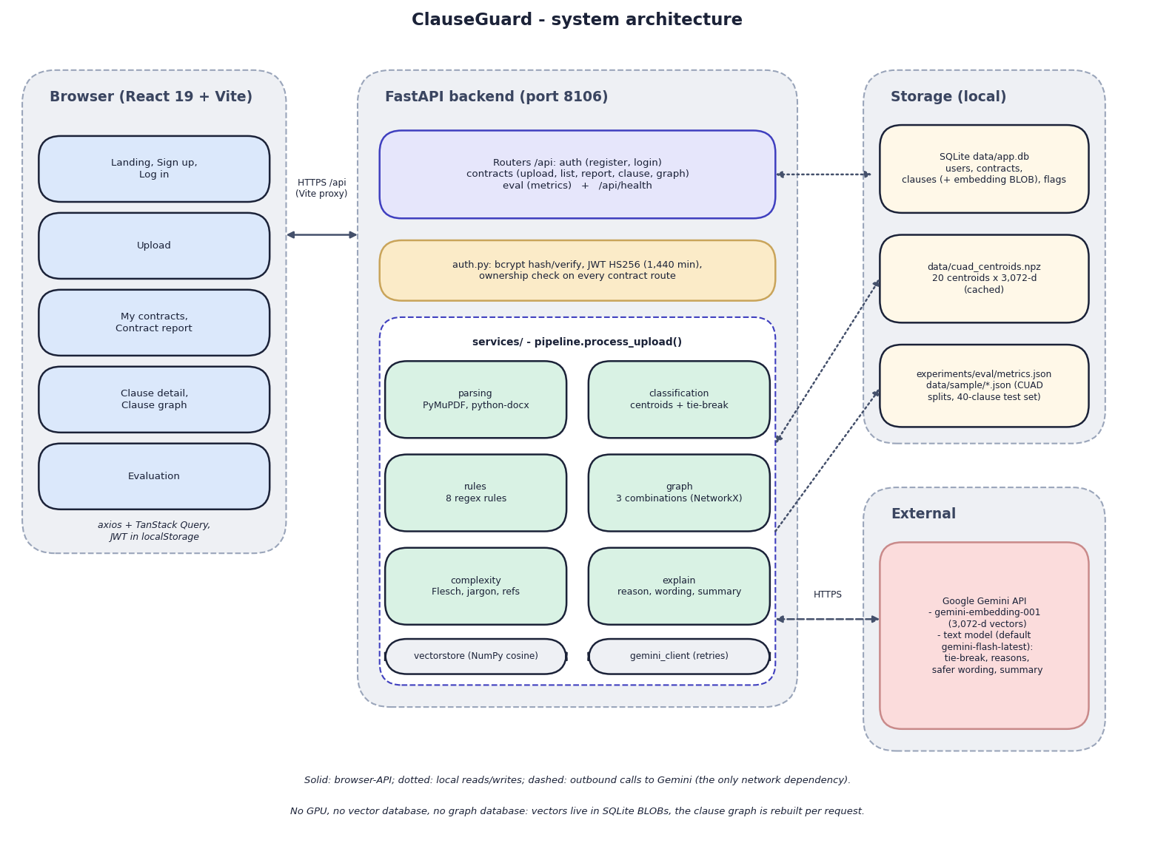
Fig. 5.1: System architecture of ClauseGuard
The diagram shows four zones. On the left is the browser: a React 19 single-page application built with Vite. Its pages are grouped as landing, sign-up and log-in; upload; my contracts and the contract report; clause detail and clause graph; and the evaluation page. The application talks to the server through Axios and TanStack Query, and it keeps the JSON Web Token in the browser's local storage. In development the Vite server on port 5106 proxies every /api call to the backend, so the browser sees one origin.
In the centre is the FastAPI backend on port 8106. A thin router layer (auth, contracts and eval, plus /api/health) validates requests; auth.py hashes passwords with bcrypt, signs HS256 tokens and is the dependency that identifies the caller, and every contract route checks that the contract belongs to that caller. Below it, pipeline.process_upload() orchestrates six services: parsing (PyMuPDF and python-docx), classification (centroids and an optional tie-break), the eight regular-expression rules, the NetworkX combination graph, the complexity score and the explanation service that writes the wording. Two helpers sit underneath: the NumPy cosine routines and the Gemini client with its retries.
On the right, local storage holds the SQLite file data/app.db (users, contracts, clauses with their embedding blobs, flags), the cached centroid file data/cuad_centroids.npz, and the JSON files that carry the CUAD splits, the 40-clause test set and the evaluation results. The only external dependency is the Google Gemini API, called over HTTPS for embeddings (gemini-embedding-001, 3,072 values per vector) and for text (tie-break, reasons, safer wording and summaries). The footnote of the figure states what the design does not contain: no vector database and no graph database.
The design follows five principles. Decide with rules, explain with a language model. Whether a clause is predatory is decided by a deterministic, auditable rule, so the same clause always gives the same flag; Gemini only writes the reason, quotes the trigger and drafts the safer wording. Keep every claim traceable. Each flag stores the rule id, the clause and the page, and the interface repeats this to the user. Enforce ownership on the server. The browser hides other users' contracts, but the decision is made by _get_owned_contract() in the API, which returns 404 for a contract of another user. Keep storage local and simple. Vectors are float32 blobs in SQLite and the clause graph is rebuilt per request, which removes the need for a vector or graph server at the cost of linear scans and no graph persistence. Isolate the network dependency. Gemini is reached through one module (gemini_client.py), so the model names, the retry policy and a future replacement of the provider are confined to a single file.
The design differs from the abstract of the project in three places that should be stated here: the abstract names the Claude API, pgvector and Neo4j, while the build uses Gemini, SQLite with NumPy, and NetworkX. The reasons and consequences are discussed in Chapters 1 and 6.

5.2 High-Level Workflow
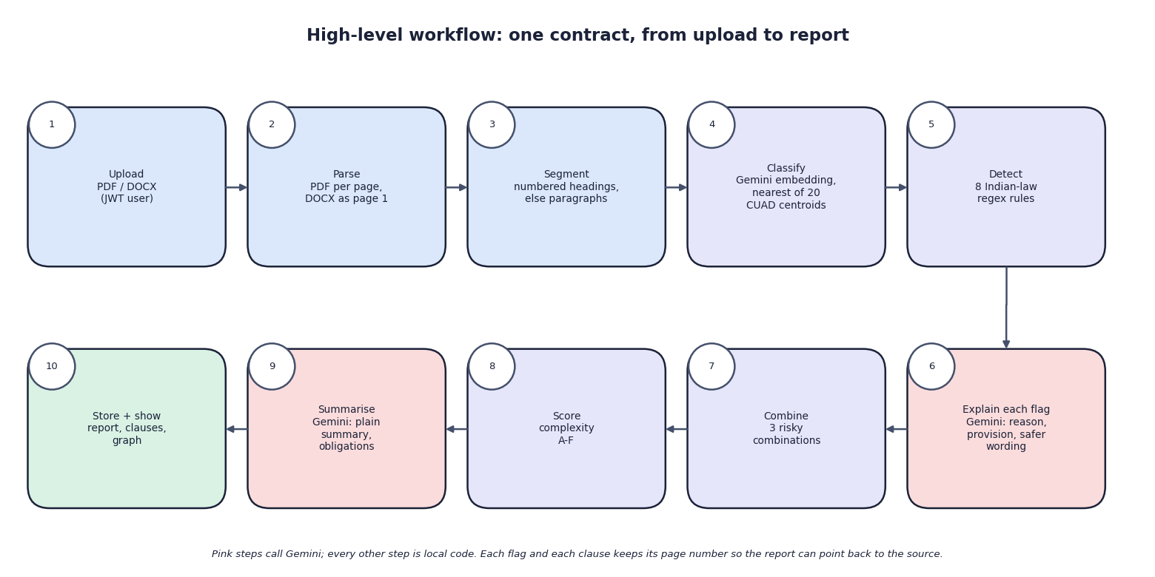
Fig. 5.2: High-level workflow
Ten steps take one contract from upload to report. A signed-in user uploads a PDF or DOCX (1); the file is parsed, page by page for a PDF and as a single page for a DOCX (2); each page is segmented at numbered headings or, failing that, at paragraphs (3). Each clause is then embedded and given the label of the nearest of 20 CUAD category centroids (4), and the eight Indian-law rules are tested on its text (5). Every rule hit is sent to Gemini together with the rule's legal basis, and the answer supplies the plain-language reason, the quoted provision and the safer wording (6). After the last clause, the risky combinations are looked up (7), the complexity score and grade are computed (8) and a second Gemini call writes the summary and the list of obligations (9). Everything is committed in one transaction and the report is shown (10).
The pink boxes are the steps that call Gemini (4, 6 and 9); every other step is local code. The decision that a clause is risky is made by step 5, never by Gemini. A failed Gemini call after three attempts stops the whole upload, and nothing is saved.

5.3 Data-Flow Diagrams
The data-flow diagrams show how data moves through ClauseGuard at three levels of detail: the context (level 0), the seven main processes with their data stores (level 1) and the expansion of the classification process (level 2).
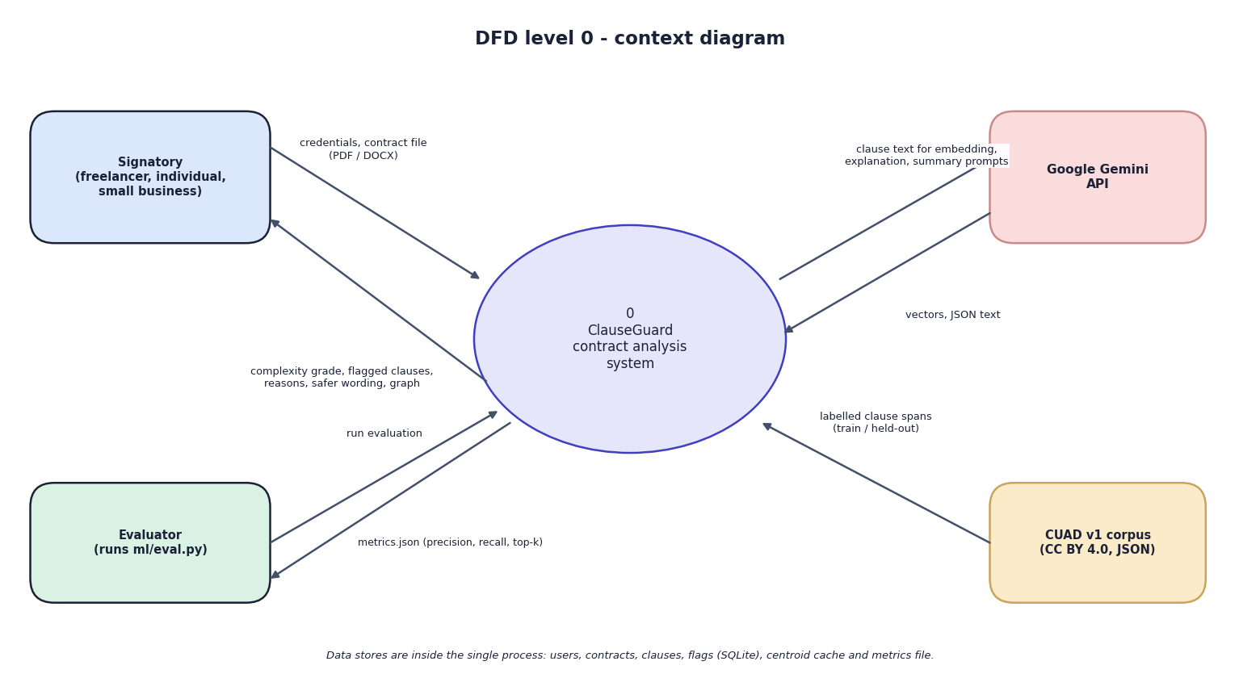
Fig. 5.3: Data-flow diagram, level 0 (context)
At the highest level ClauseGuard is one process with four external entities. The signatory, who may be a freelancer, an individual or a small business, sends credentials and a contract file and receives the complexity grade, the flagged clauses with reasons and safer wording, and the clause graph. Google Gemini receives clause text and prompts and returns vectors and JSON text. The evaluator, who is whoever runs ml/eval.py, starts an evaluation and receives metrics.json with the precision, recall and top-k scores; the CUAD v1 corpus supplies the labelled clause spans from which the training and held-out sets were drawn. The data stores are inside the single process and are not drawn at this level.
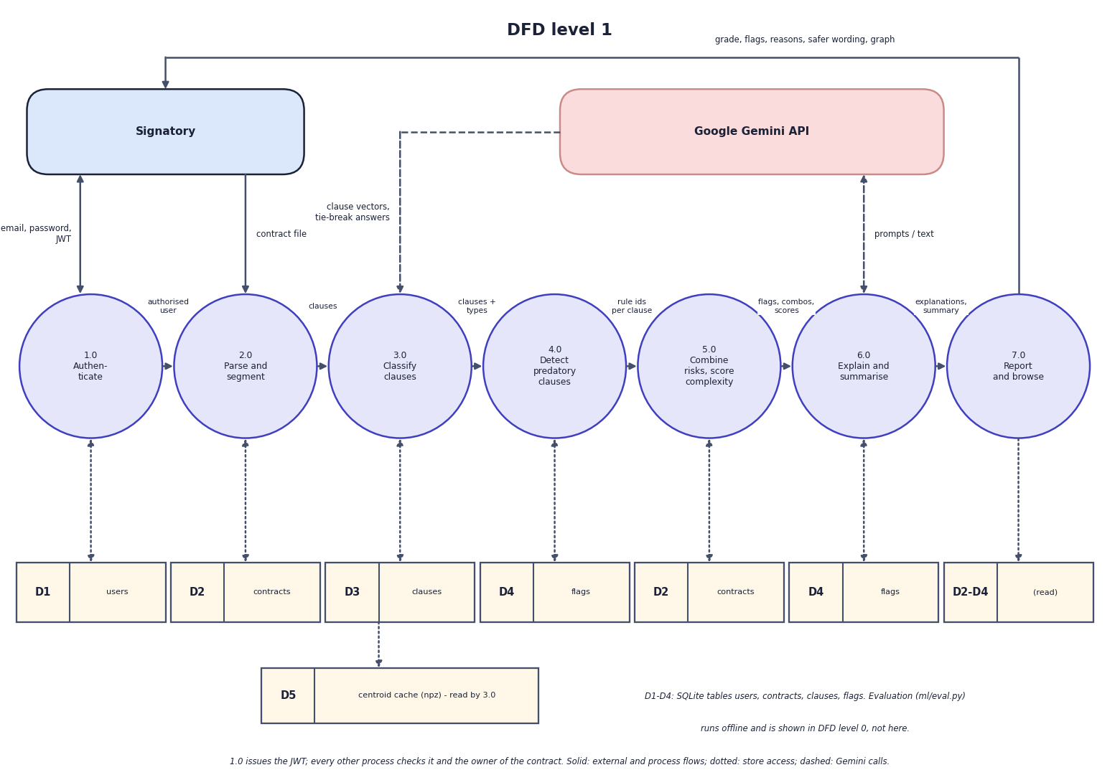
Fig. 5.4: Data-flow diagram, level 1
Level 1 splits the system into seven processes: authenticate (1.0), parse and segment (2.0), classify clauses (3.0), detect predatory clauses (4.0), combine risks and score complexity (5.0), explain and summarise (6.0), and report and browse (7.0). The stores are D1 users, D2 contracts, D3 clauses (with the embedding), D4 flags and D5 the centroid cache; D2 and D4 are drawn twice because two processes use each. Process 1.0 issues the token, and every later process checks it and the owner of the contract. Process 2.0 creates the contract row and produces clauses; 3.0 reads D5, calls Gemini for vectors and writes the clause type to D3; 4.0 produces the rule ids and writes the flags to D4; 5.0 finds the combinations, computes the grade and writes both to D2; 6.0 calls Gemini and writes reasons and wording to D4 and the summary to D2; 7.0 only reads.
The order of the numbers is logical, not temporal. In the code the explanation for a flag is requested as soon as the rule fires for a clause, inside the loop of the pipeline, and the combinations and the complexity score are computed after the last clause. The offline evaluation script is not part of this diagram; it appears in level 0.
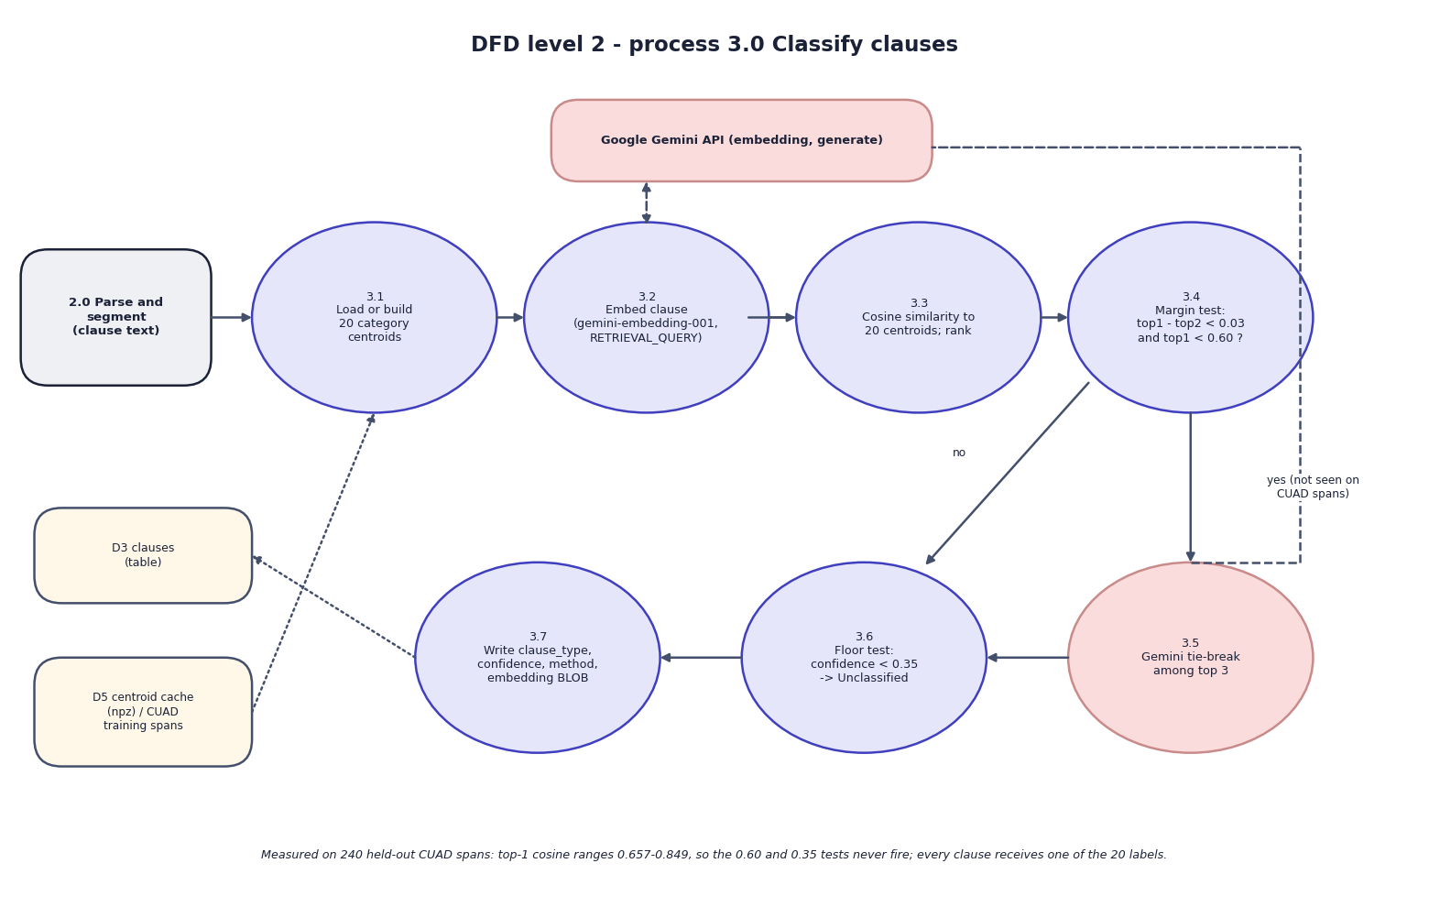
Fig. 5.5: Data-flow diagram, level 2: Classify clauses (process 3.0)
Process 3.0 expands into seven steps that follow classify_clause(). The 20 category centroids are loaded from the cache, or built from the 500 training spans if the cache is missing (3.1). The clause is embedded with the task type RETRIEVAL_QUERY through the Gemini API (3.2), and its cosine similarity to every centroid is computed and ranked (3.3). A margin test then asks whether the best two categories are within 0.03 of each other and the best similarity is below 0.60 (3.4). If so, Gemini is asked to choose among the top three categories (3.5); if not, the top category is kept. A floor test replaces the label by "Other / Unclassified" when the confidence is below 0.35 (3.6), and the label, confidence, method and embedding blob are written to the clause row (3.7).
The note under the figure records a measurement: on the 240 held-out CUAD spans the best similarity ranges from 0.657 to 0.849, so the 0.60 and 0.35 tests never fire and every clause receives one of the 20 labels (Chapter 6, section on the model, shows the distributions).

5.4 UML Diagrams
Three UML views describe the design: the use-case diagram (who does what), the class diagram (what the code contains) and the sequence diagram (how the main flow runs). The two core algorithms are shown as flowcharts in the same chapter.
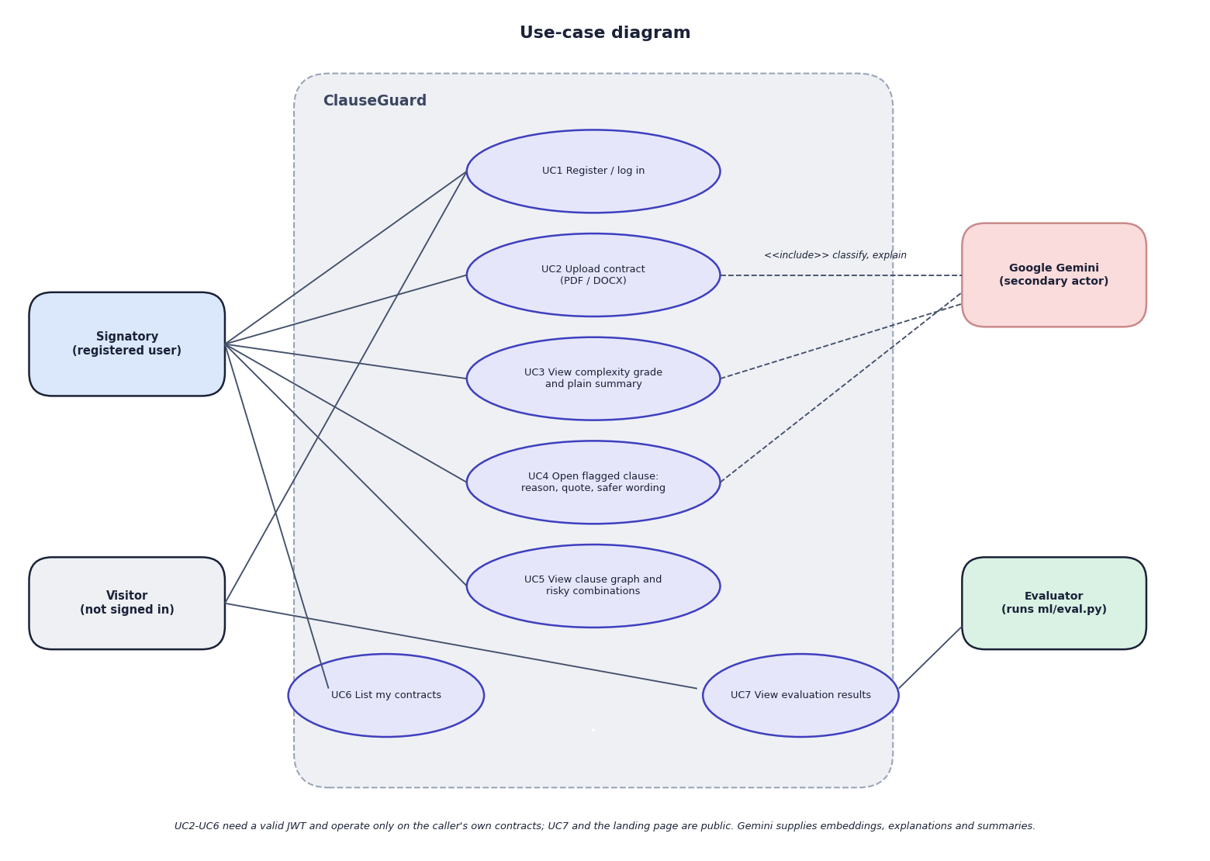
Fig. 5.6: Use-case diagram
Four actors appear. The signatory (a registered user) registers or logs in (UC1), uploads a contract (UC2), views the grade and plain summary (UC3), opens a flagged clause to read the reason, the quoted provision and the safer wording (UC4), views the clause graph and the risky combinations (UC5), and lists the contracts (UC6). The visitor, who is not signed in, can register or log in and can open the evaluation page (UC7), which is public. The evaluator runs ml/eval.py, which produces the figures that UC7 shows. Google Gemini is a secondary actor attached to the use cases that call it: uploading (classification and explanation), the summary and the clause explanation.
Use cases UC2 to UC6 need a valid token and work only on the caller's own contracts. There is no administrator role, no sharing between users and no way to edit or delete a contract in the interface.
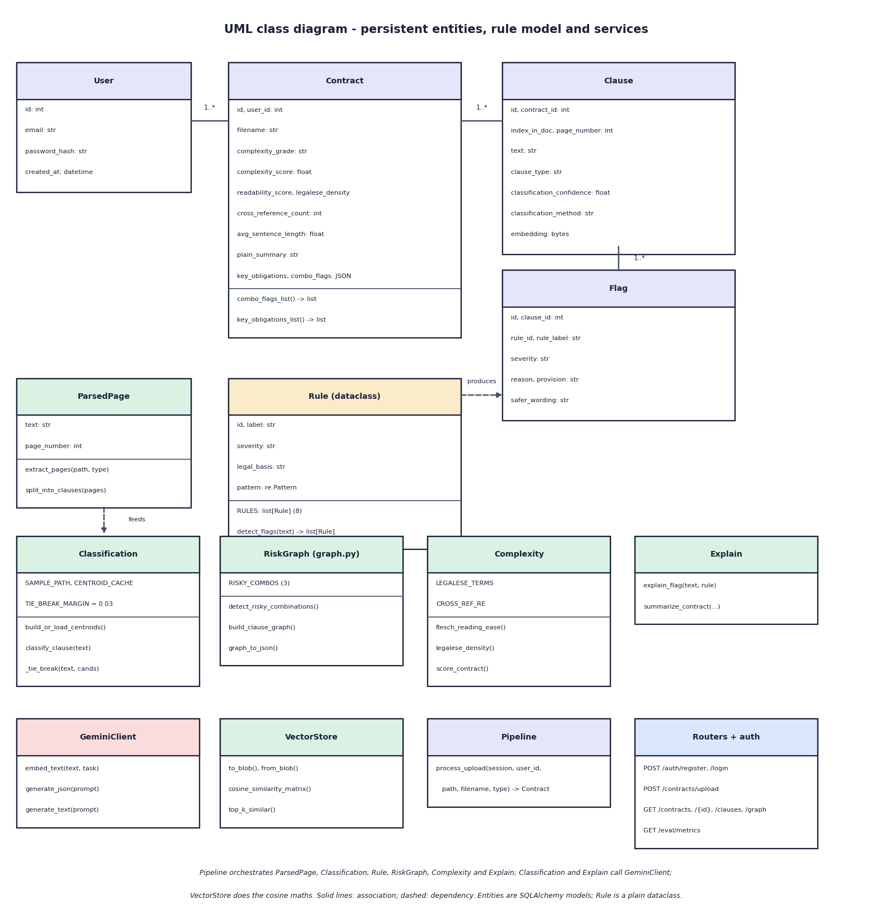
Fig. 5.7: UML class diagram
The upper part shows the four persistent entities (User, Contract, Clause and Flag) with their attributes and the 1..* associations, the Rule dataclass with its pattern and legal basis, and ParsedPage, the small value object that the parsing module passes to the segmenter. A Rule produces Flag rows; a ParsedPage feeds the classification service through the clause text. The lower part shows the services as classes of functions: Classification, RiskGraph, Complexity, Explain, GeminiClient, VectorStore, Pipeline and the routers with the authentication helpers. Pipeline coordinates the others; Classification and Explain use GeminiClient; VectorStore does the cosine arithmetic. The service modules are plain Python modules, so the diagram shows them as classes only to make their operations visible.
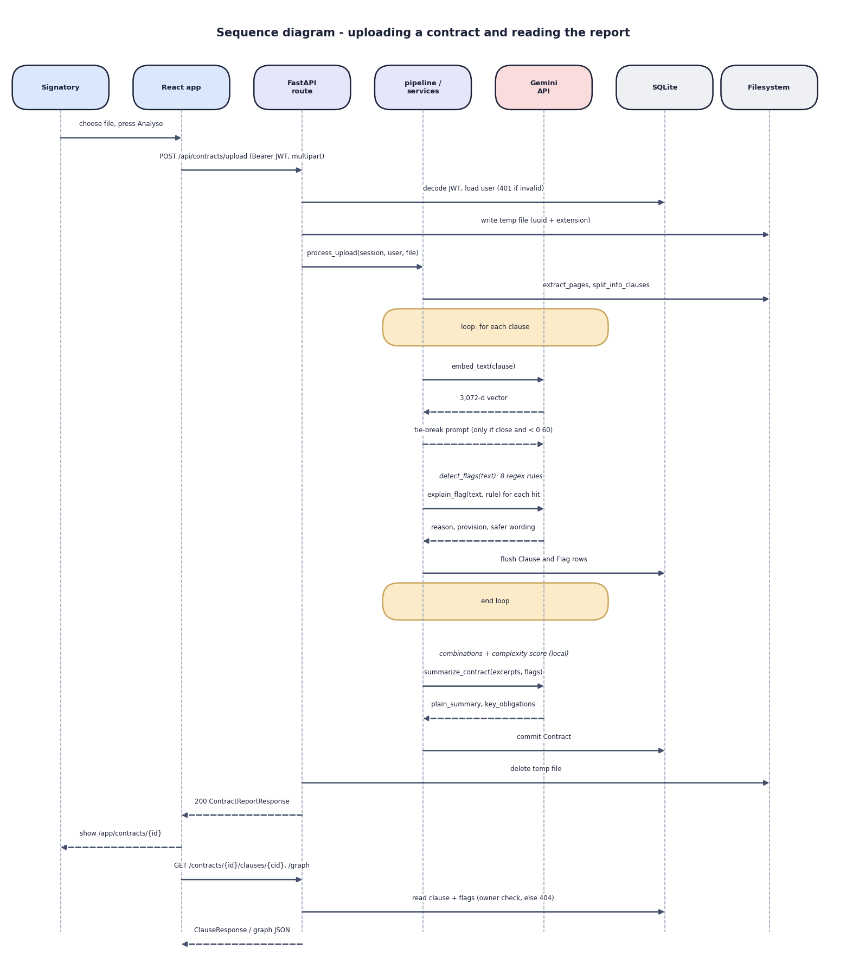
Fig. 5.8: Sequence diagram: uploading a contract and reading the report
The diagram follows one upload through seven participants. The user chooses a file and presses Analyse; the React app posts the multipart request with the bearer token; the route decodes the token and loads the user from SQLite (a bad token ends here with 401); the file is written under a random name and the pipeline is called. The pipeline reads the pages and splits them into clauses, then loops over the clauses: it requests the embedding from Gemini, sends a tie-break prompt only when the margin and similarity tests require it (which did not occur in the measured runs), applies the rules locally, requests an explanation for each hit and flushes the clause and flag rows. After the loop the combinations and the complexity score are computed locally, one more Gemini call returns the summary, and the contract is committed. The route deletes the temporary file and returns the report, the browser navigates to the report, and later requests for a clause or the graph read the rows again after the ownership check.
The sequence makes the cost visible: the number of Gemini calls is the number of clauses plus the number of flags plus one, and they run one after another. This is why the measured upload of an eleven-clause, eight-flag contract took 113.6 s and the fair eight-clause contract 15.5 s.
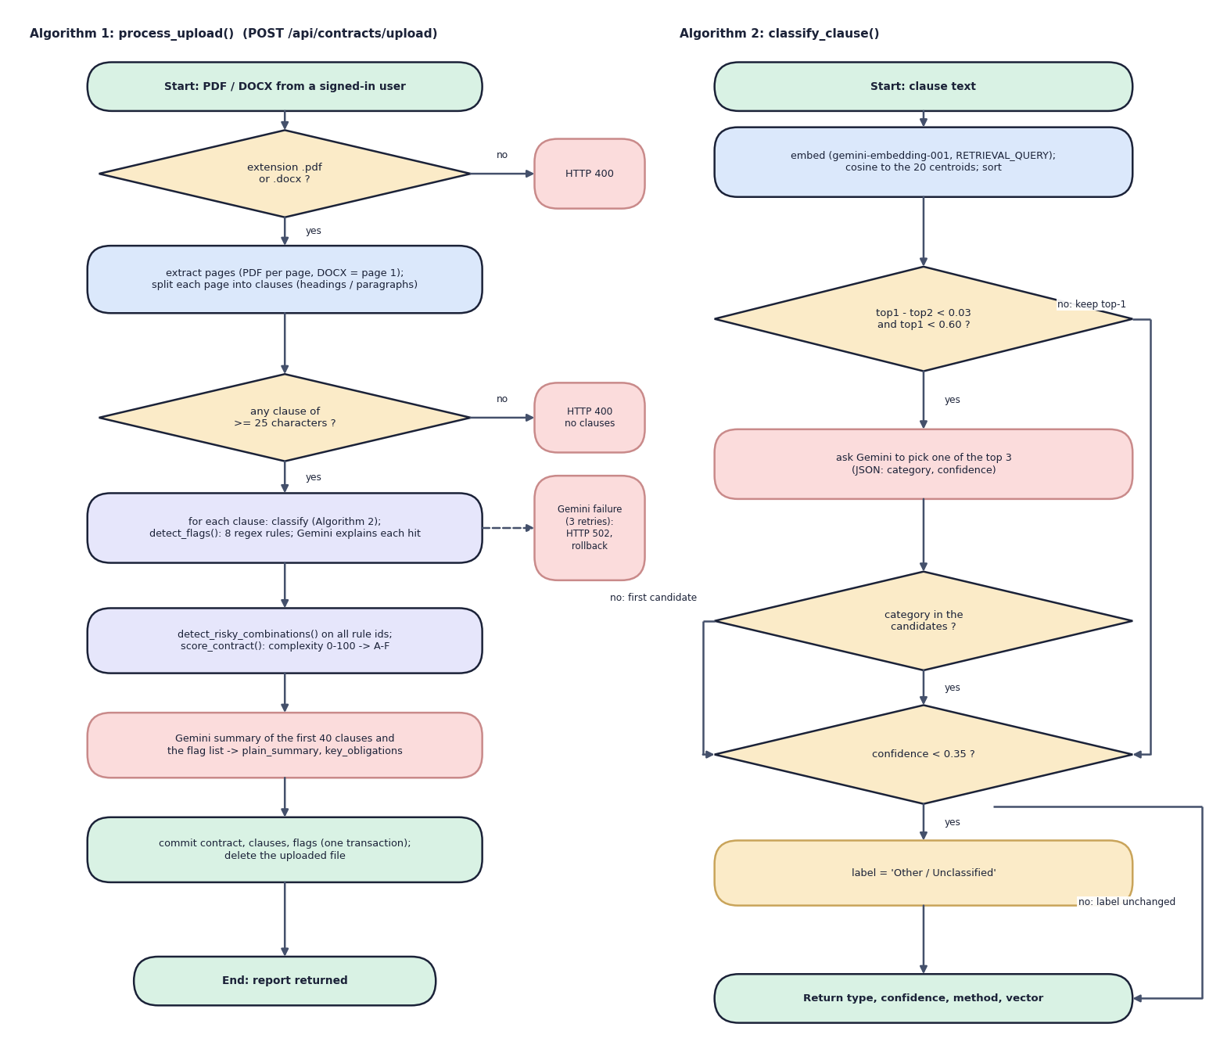
Fig. 5.9: Flowchart of the core algorithms
Algorithm 1 is process_upload(). The extension must be .pdf or .docx (otherwise HTTP 400); the pages are extracted and split, and at least one clause of 25 or more characters must remain (otherwise HTTP 400 "no readable clauses"). For every clause the pipeline classifies, applies the eight rules and asks Gemini to explain each hit; a Gemini failure after three retries raises an error that the route reports as HTTP 502 and the transaction is rolled back. After the loop come the combinations, the complexity score, the summary and one commit.
Algorithm 2 is classify_clause(). The clause is embedded and ranked against the 20 centroids. If the best two categories differ by less than 0.03 and the best similarity is below 0.60, Gemini chooses among the top three; an answer outside the candidates falls back to the first candidate with the embedding similarity as its confidence. Finally, a confidence below 0.35 changes the label to "Other / Unclassified". The result carries the label, the confidence, the method (embedding or gemini_tiebreak) and the vector.

5.5 Database Design
The database is SQLite, created by SQLAlchemy 2 at start-up with create_all; there are no migrations. Results that are read and written whole (the key obligations and the risky combinations of a contract) are stored as JSON text. The uploaded file itself is not kept: it is written to data/uploads under a random name, parsed and deleted, and only its clause text, vectors and flags remain.
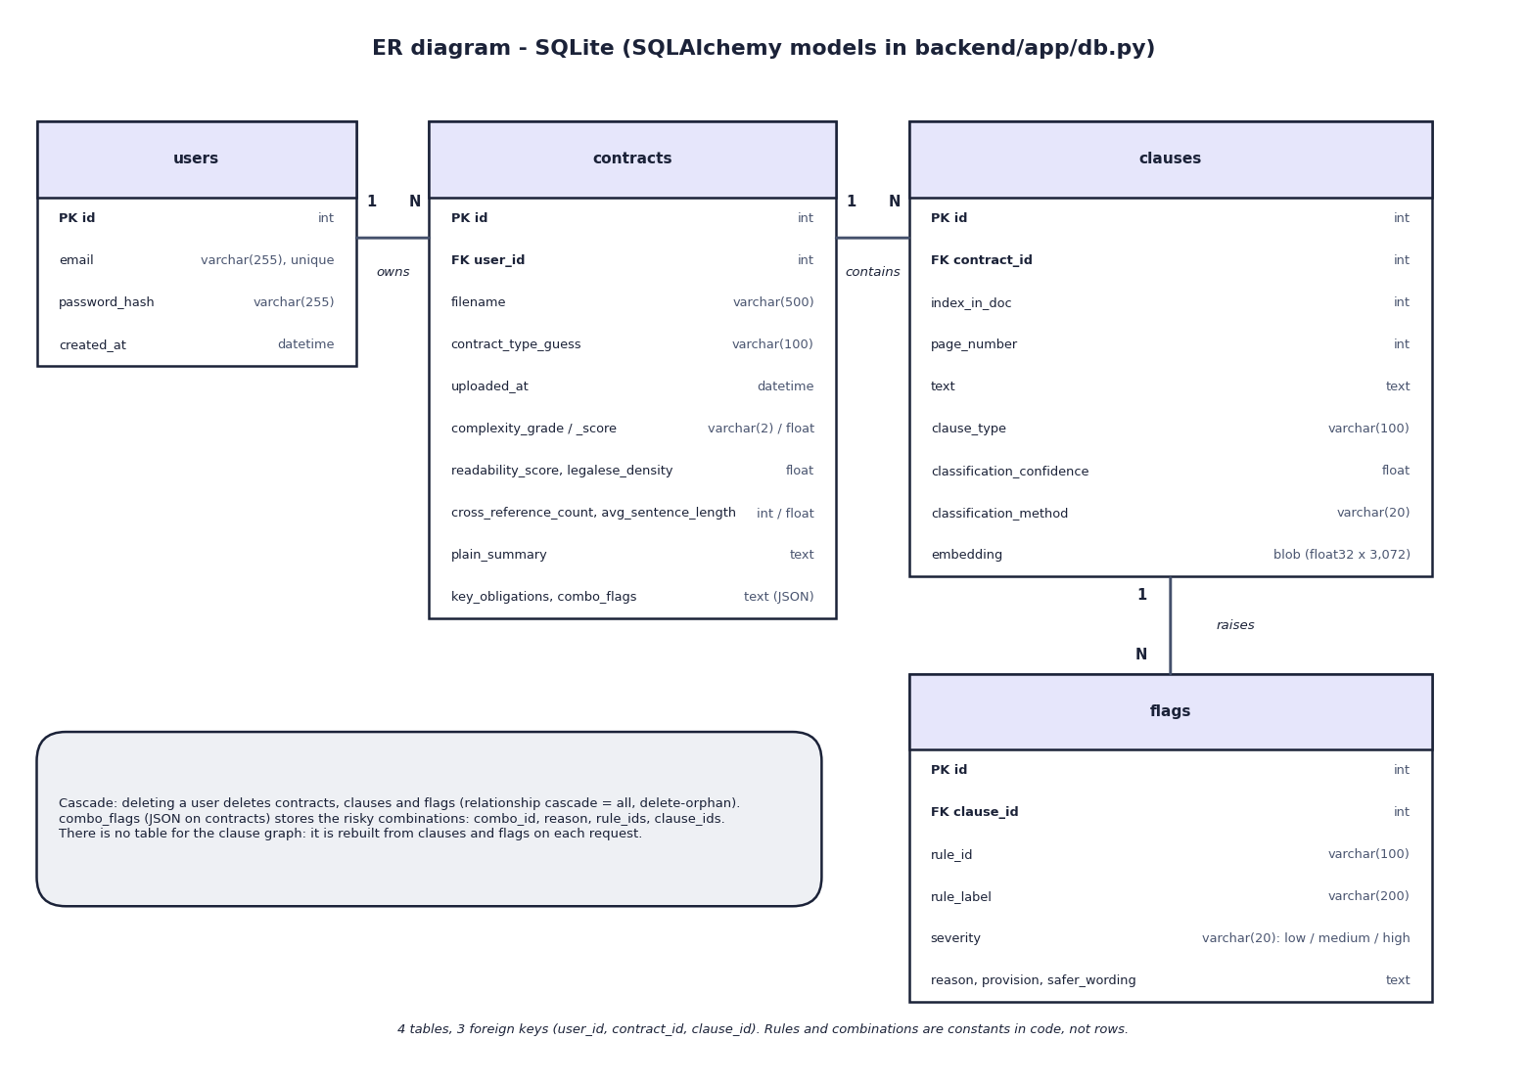
Fig. 5.10: Entity-relationship diagram
The database has four tables joined by three one-to-many relations: a user owns many contracts, a contract contains many clauses, and a clause raises many flags. The foreign keys are contracts.user_id, clauses.contract_id and flags.clause_id. The two JSON values of a contract (key_obligations and combo_flags) are stored as text columns, and the clause vector is a float32 blob of 3,072 values. The box in the figure notes that deleting a user cascades to everything below it through the SQLAlchemy relationships, and that the clause graph has no table because it is rebuilt from clauses and flags whenever it is requested.
Table 5.1: Database tables
Table | Purpose | Columns
users | Accounts | id (PK), email (unique, indexed), password_hash (bcrypt, 255), created_at
contracts | One analysed contract | id (PK), user_id (FK users), filename, contract_type_guess (default "general"; never set by any code), uploaded_at, complexity_grade, complexity_score, readability_score, legalese_density, cross_reference_count, avg_sentence_length, plain_summary, key_obligations (JSON text), combo_flags (JSON text)
clauses | One segmented clause | id (PK), contract_id (FK), index_in_doc, page_number, text, clause_type (one of 20 CUAD labels or "Other / Unclassified"), classification_confidence (cosine), classification_method ("embedding" or "gemini_tiebreak"), embedding (float32 blob, 3,072 values = 12,288 bytes)
flags | One rule hit on one clause | id (PK), clause_id (FK), rule_id, rule_label, severity (low, medium, high), reason, provision, safer_wording

Four design points should be noted. First, the relationships carry cascade="all, delete-orphan" in SQLAlchemy, so deleting a user removes their contracts, clauses and flags, but no foreign key declares an ON DELETE rule in SQLite itself and no route offers deletion. Second, the combinations are kept as JSON in contracts.combo_flags (combination id, reason, rule ids, clause ids); the clause graph is derived from clauses, flags and this column on every request, so there is no graph table and no graph database. Third, the foreign keys are not indexed, which is acceptable for the measured sizes (a report of eleven clauses is returned in a median of 9.3 ms) but would matter at scale. Fourth, the severity and the classification method are plain strings, not enumerations, and timestamps use datetime.utcnow. Passwords are never stored in clear text.

5.6 Module Design
Table 5.2: Modules of ClauseGuard
Module | Code (lines) | Responsibility
Application | backend/app/main.py (35) | Creates the FastAPI app, CORS, table creation at start-up and /api/health; includes the three routers
Configuration | app/config.py (28) | Reads .env: Gemini key and model names, ports, JWT secret and lifetime; creates the data, upload and experiment folders
Database | app/db.py (103) | Engine, session dependency and the four models (User, Contract, Clause, Flag)
Security | app/auth.py (47) | bcrypt hashing and checking, HS256 token creation and decoding, get_current_user dependency
Schemas | app/schemas.py (79) | Pydantic request and response types (registration with e-mail and 6-character password, report, clause, flag)
Auth routes | app/routes/auth.py (33) | POST /api/auth/register and /login
Contract routes | app/routes/contracts.py (133) | Upload with validation, list, report, clause detail, graph, ownership check
Evaluation route | app/routes/eval.py (22) | Serves experiments/eval/metrics.json
Parsing | app/services/parsing.py (95) | PDF and DOCX text extraction, heading-based segmentation with paragraph fallback
Classification | app/services/classification.py (109) | Centroid cache, nearest-centroid classification, Gemini tie-break, confidence floor
Rules | app/services/rules.py (134) | The eight predatory-clause rules with severity and legal basis; detect_flags()
Combination graph | app/services/graph.py (79) | Three risky combinations, NetworkX graph, JSON for the interface
Complexity | app/services/complexity.py (110) | Flesch reading ease, legalese density, cross-references, sentence length, weighted score and grade
Explanation | app/services/explain.py (54) | Prompts for the reason, provision and safer wording of a flag and for the contract summary
Gemini client | app/services/gemini_client.py (65) | Embedding and text calls, three retries, JSON extraction
Vector store | app/services/vectorstore.py (31) | float32 blob conversion and cosine similarity with NumPy
Pipeline | app/services/pipeline.py (89) | process_upload(): the loop over clauses, combinations, score, summary, commit
Evaluation | ml/eval.py (144) | Rule precision, recall and F1 on the 40-clause set; CUAD top-1 and top-3; writes metrics.json
Data scripts | scripts/build_cuad_samples.py (82), download_data.py (43), smoke_test.py (149) | Seeded CUAD train and held-out split, corpus download, live end-to-end smoke test
Tests | tests/ (5 files) | 68 passing tests and 5 expected failures, with Gemini stubbed
Web application | frontend/src/ (56 files, 4,507 lines) | 9 pages, 17 interface-kit components, motion and landing components, the API client, authentication and theme providers

The backend application code is about 1,250 lines in 17 files. The directory backend/app/services holds all of the analysis logic; the routers contain no business rules except the ownership check and the status-code mapping.

5.7 User Interface Design
The web application has nine pages. The public pages are the landing page, sign-up, log-in and the evaluation page. After log-in a sidebar layout offers two entries, My contracts and Upload contract, and the contract pages are reached from the list: the contract report, the clause detail page with two tabs (Flags and Clause text) and the clause graph. Four pages (landing, evaluation, contract report and clause graph) are loaded on demand, and a protected-route component sends a visitor without a token to the log-in page; the older paths /upload and /contracts redirect to the new ones.
The design decisions follow from the users, who are not lawyers. The report opens with the grade as a large badge and six figures (readability, legalese density, cross-references, average sentence length, flagged clauses and the score), followed by the plain-language summary, the key obligations and a chart of the clauses by their highest severity. Risky combinations are shown in their own warning-coloured panel. Each flagged clause shows the reason, the quoted provision and the safer wording in separate blocks, with severity as a coloured badge that is also written as a word. The upload page validates the extension in the browser, shows a progress bar and then an indeterminate bar while the server works, and states that the file is removed after analysis. The sidebar repeats the promise that every flag is tied to the exact clause and page. A theme toggle switches between light and dark.
Three limitations of the interface should be stated. The clause graph places its nodes evenly on a circle, so the position of a node carries no meaning; only the red colour and the lines between clauses of the same combination do. The upload request has a client timeout of 180 s, which a contract with many flags can exceed because the server makes one Gemini call per flag (the measured eight-flag contract needed 113.6 s). And the evaluation page describes its scores as measured "on a held-out set" although the 40 clauses behind them were written together with the rules, a point examined in Chapter 8. The screens below were captured from the running application with the three real uploads of this project; the complete set is in Chapter 8 and Appendix C.
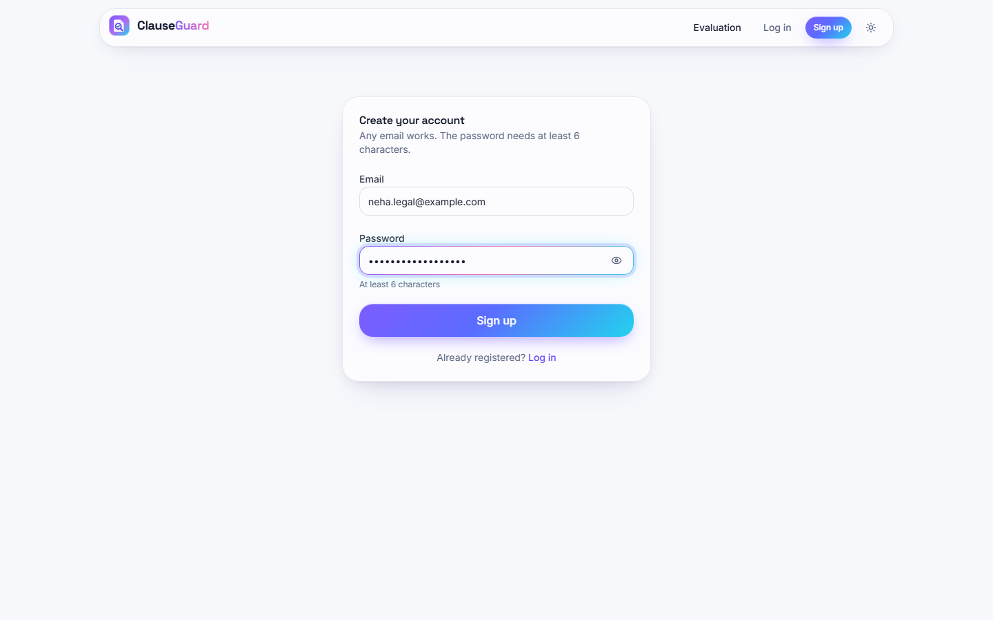  Fig. 5.11: Sign-up page | 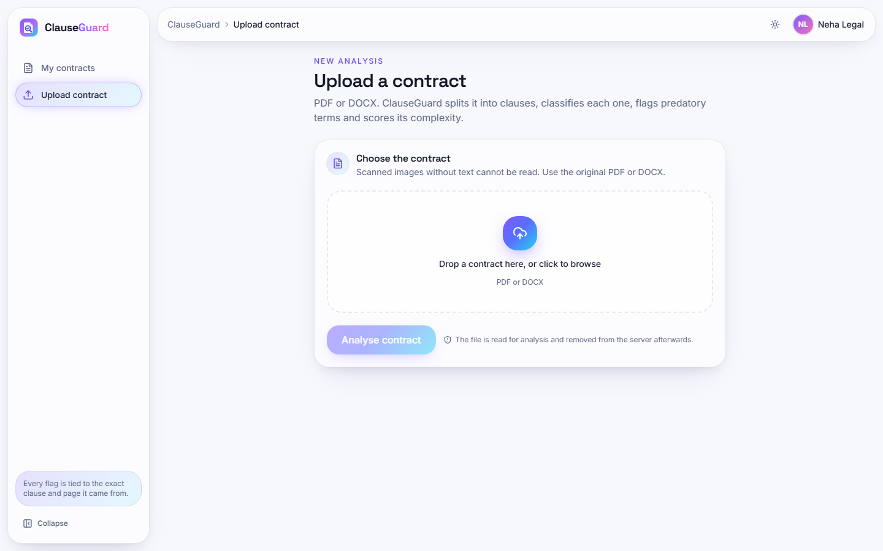  Fig. 5.12: Upload page before a file is chosen

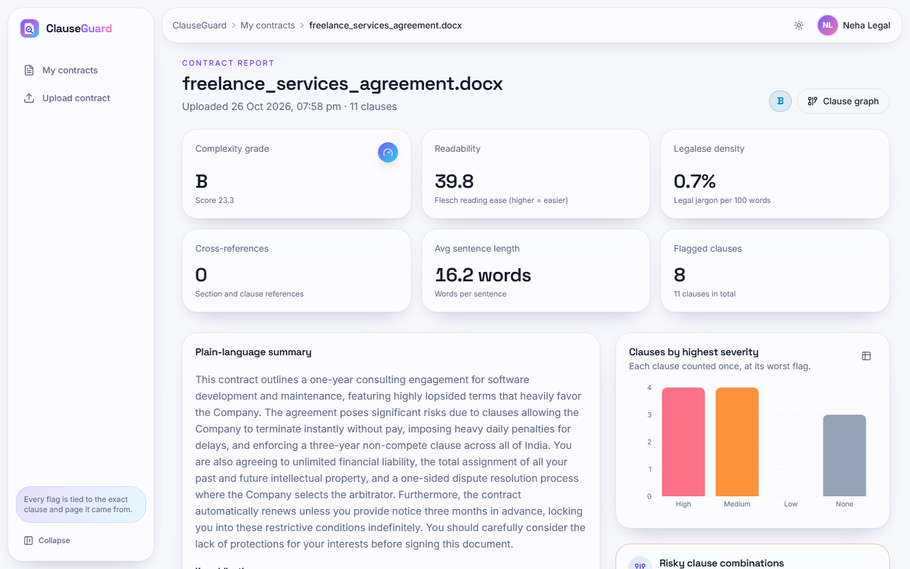  Fig. 5.13: Contract report: grade, six figures, summary and severity chart | 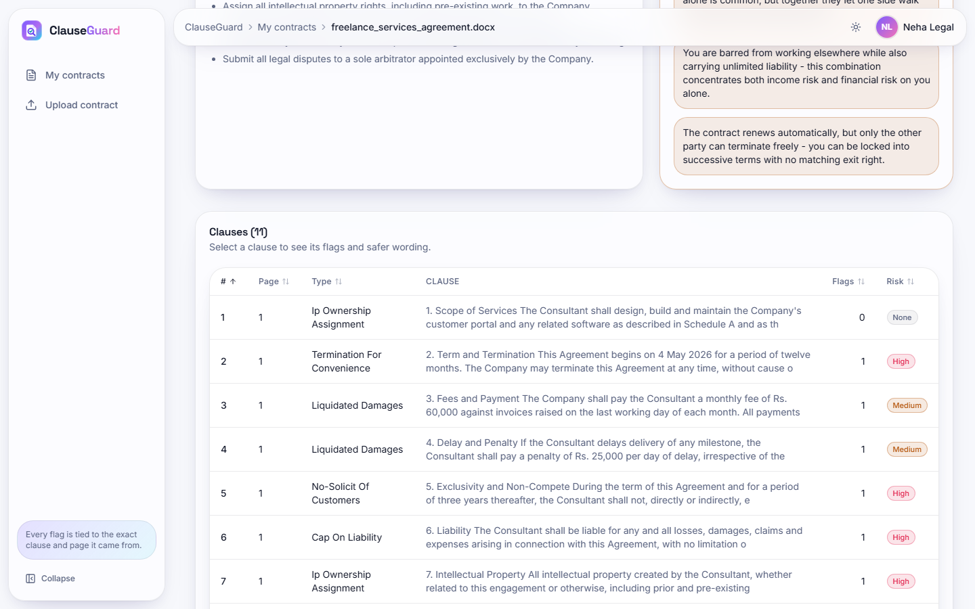  Fig. 5.14: Clause table with type, flags and risk

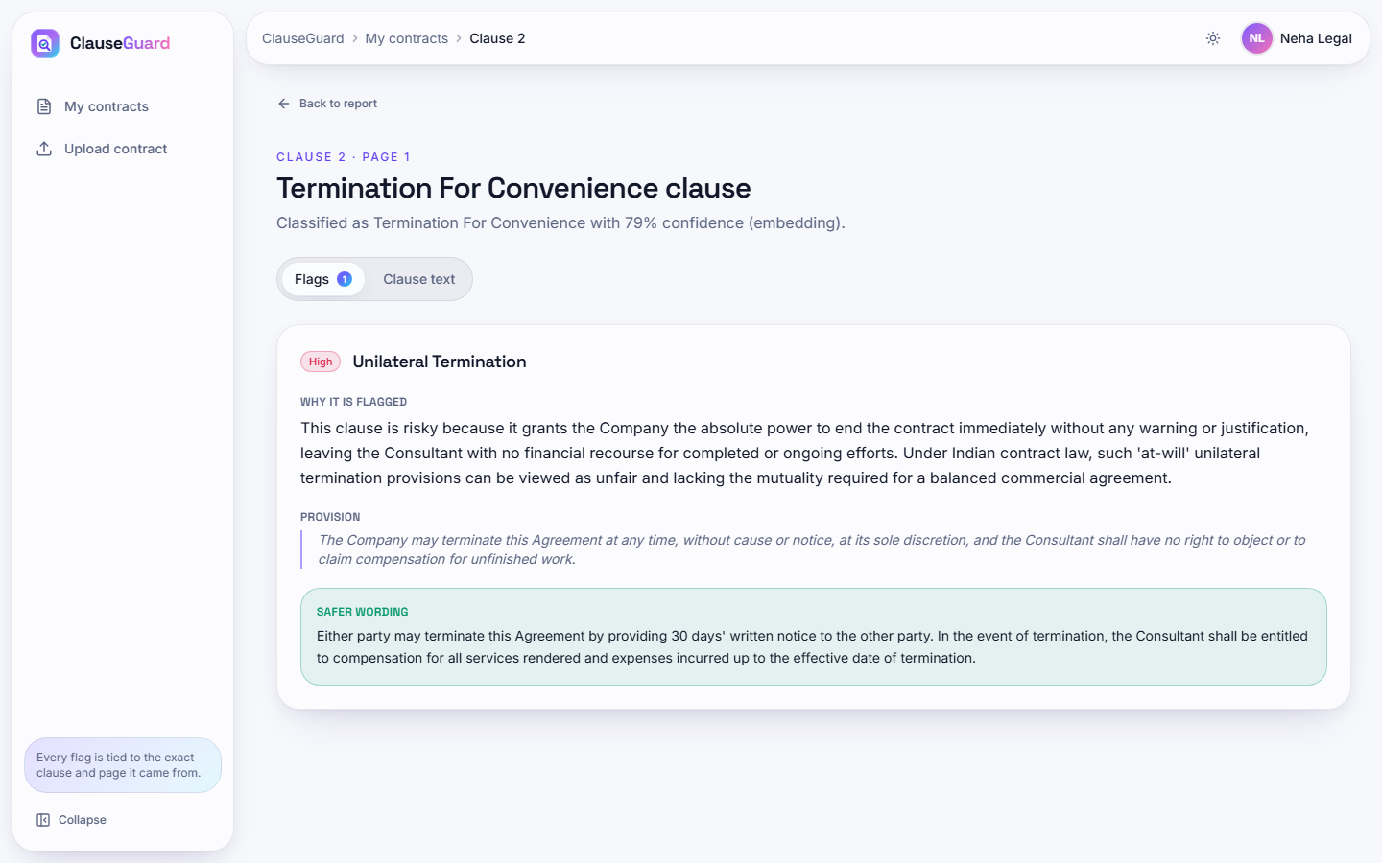  Fig. 5.15: Clause detail: reason, quoted provision and safer wording | 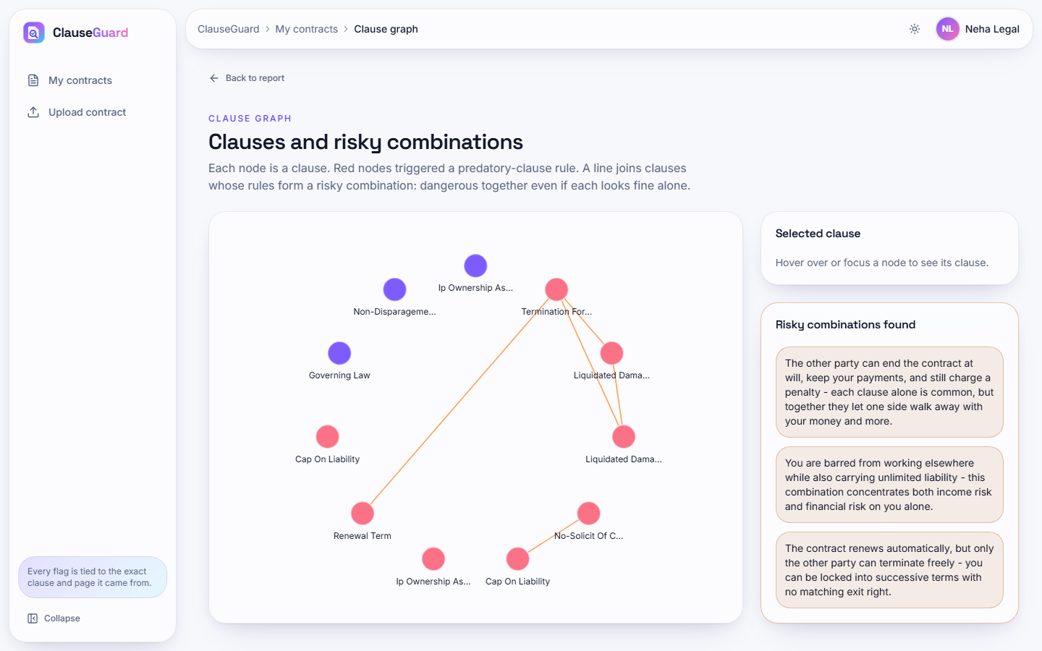  Fig. 5.16: Clause graph with the risky combinations

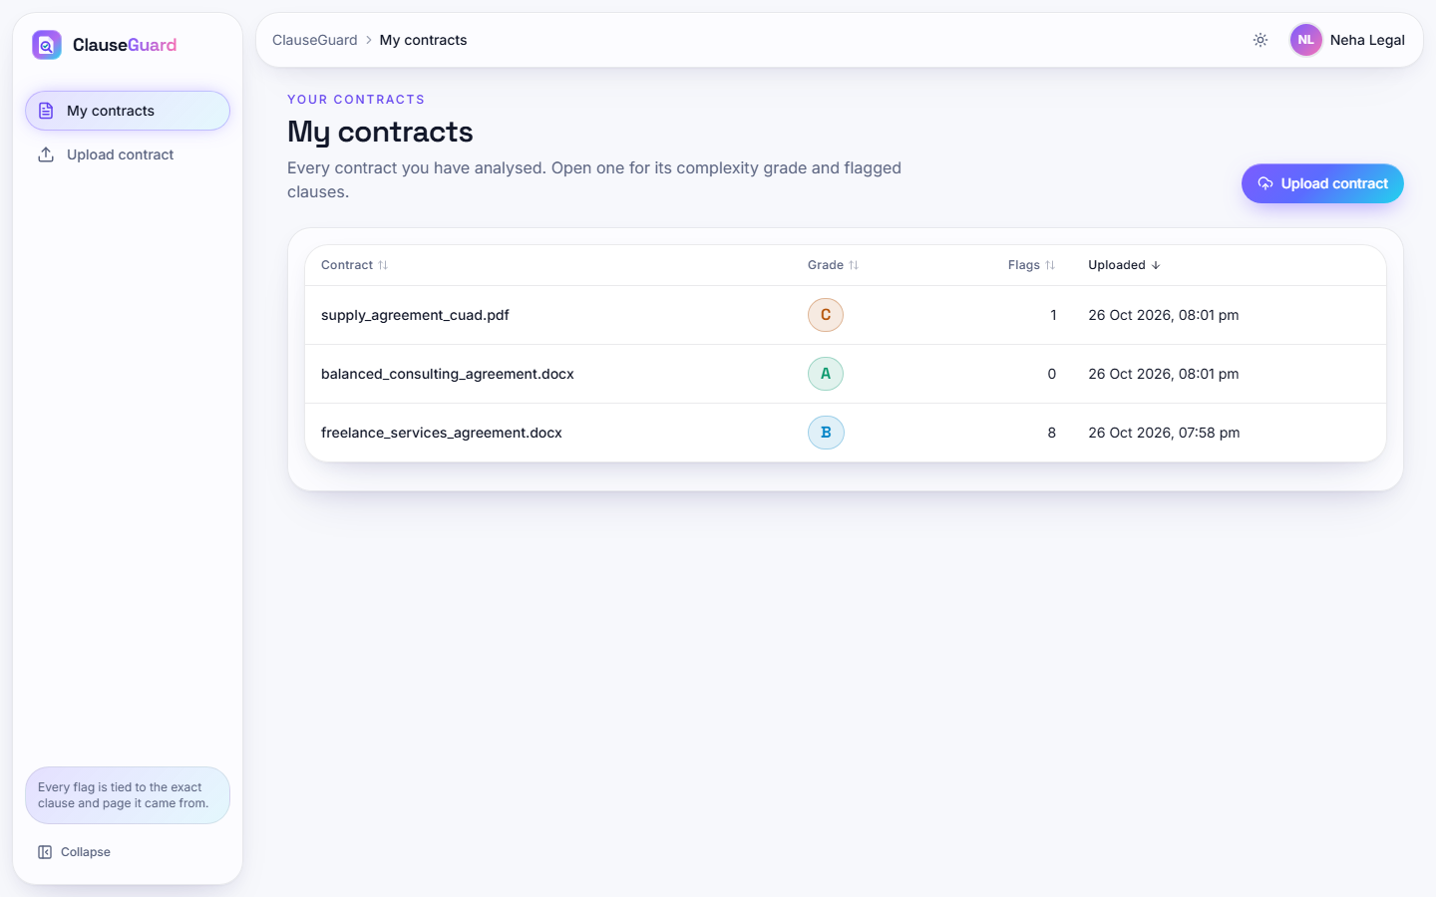  Fig. 5.17: My contracts list with three analysed contracts | 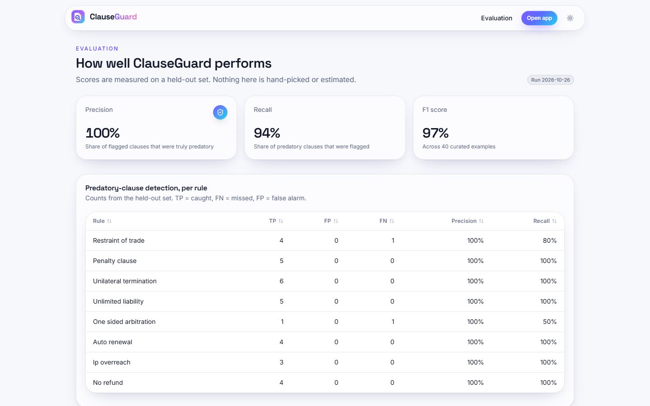  Fig. 5.18: Evaluation page with the measured scores

CHAPTER 6
METHODOLOGY AND SOFTWARE IMPLEMENTATION

6.1 Overall Methodology
ClauseGuard follows a review chain that a careful reader would follow by hand, and automates each link: the contract is read, split into clauses, each clause is given a type, each clause is tested against a short list of terms that Indian contract law treats as suspect, the clauses that are dangerous only in combination are found, the wording is scored for difficulty, and the findings are written back in plain language with a fairer alternative. The base paper [1] builds a retrieval-augmented consultation system and a contract-analysis module on Gemini 1.5 Flash for Saudi law, and checks contracts against a checklist of essential clauses with an LLM-assisted semantic test. ClauseGuard keeps the idea of a jurisdiction-aware, Gemini-based analysis, but changes the division of labour: the decision that a clause is predatory is taken by deterministic rules, and the language model is used for embeddings and for wording.
Three differences from the project abstract and from the base paper must be stated at the outset. First, the build uses Gemini for embeddings and text; the abstract names the Claude API. Second, vectors are stored as blobs in SQLite and compared with NumPy, and the clause graph is a NetworkX graph rebuilt for every request; the abstract names pgvector and Neo4j. Third, there is no retrieval over a legal corpus: the only retrieval step is the nearest-centroid match of a clause against 20 CUAD category centroids, and Gemini is given the rule's legal basis in the prompt rather than retrieved passages. The method is therefore a rule-and-embedding pipeline with an LLM writing layer, and it should be judged as that.
Table 6.1: Pipeline of ClauseGuard
Step | Method | Output
1 Parse | PyMuPDF for PDF (one page per page); python-docx for DOCX (whole file is page 1) | Pages of raw text
2 Segment | Split each page at numbered headings (1., 2.1, Section 3); if a page has fewer than two headings, merge blank-line paragraphs up to about 400 characters | Clauses with index and page number
3 Classify | Gemini embedding (3,072 values); cosine similarity to 20 CUAD category centroids; Gemini tie-break when two categories are close | Clause type, confidence, method
4 Detect | Eight case-insensitive regular-expression rules, each tagged with severity and an Indian statute | Flags per clause
5 Explain | One Gemini call per flag: reason, quoted provision, safer wording | Plain-language flag record
6 Combine | Three combinations of rule ids matched anywhere in the contract; NetworkX graph | Risky combinations and graph edges
7 Score | Flesch reading ease, legalese density, cross-references, sentence length; weighted 0-100 score; grade A-F | Complexity grade and four component values
8 Summarise | One Gemini call over the first 40 clause excerpts and the flag list | Plain summary and key obligations
9 Store and show | One SQLite transaction; report, clause and graph endpoints | Report, clause detail, graph

6.2 Dataset
The project has no labelled corpus of Indian contracts, and none is publicly available in a form that could be used here. The only labelled clause data is the Contract Understanding Atticus Dataset (CUAD) [8], a corpus of United States commercial contracts filed with the Securities and Exchange Commission and annotated by lawyers with 41 clause categories. The predatory-clause rules are therefore written by hand, and the classification step is trained and tested on CUAD. The datasets used are summarised below.
Table 6.2: Datasets used
Dataset | Role | Source and licence | Size
CUAD v1 [8] | Source of all classification data; corpus-scale run | The Atticus Project, data/cuad/CUADv1.json (about 40 MB), CC BY 4.0 | 510 contracts, 41 categories; 20 substantive categories used
Training spans | Build 20 category centroids | Derived from CUAD by scripts/build_cuad_samples.py, seed 42 | 500 spans (497 distinct texts), 25 per category
Held-out spans | Classification test | Derived from CUAD, same script and seed | 240 spans, 12 per category
Shipped rule test set | Rule precision and recall | Written for the project by the author of the rules | 40 labelled clauses
Independent probe set | Second rule test | Written in the documentation run after the rules were final | 40 clauses: 24 predatory paraphrases, 16 benign look-alikes
Sample contracts | End-to-end runs and screenshots | Two invented contracts and one real CUAD contract typeset to PDF | 3 files, 8 to 11 clauses each

6.2.1 How the classification data were derived
The script walks every annotation of CUAD, keeps the answer spans of the 20 chosen categories (Governing Law, Termination For Convenience, Non-Compete, Exclusivity, Audit Rights, Cap On Liability, Change Of Control, Insurance, Ip Ownership Assignment, License Grant, Liquidated Damages, Minimum Commitment, No-Solicit Of Customers, No-Solicit Of Employees, Non-Disparagement, Post-Termination Services, Renewal Term, Revenue/Profit Sharing, Uncapped Liability and Warranty Duration), normalises whitespace, keeps spans of 40 to 900 characters, removes duplicates within a category, shuffles with seed 42, and takes the first 25 spans of each category for training and the next 12 for testing. The administrative categories (document name, parties, dates) are left out because they describe metadata and not clauses.
The split has three properties that limit what the scores mean. It is by span text, not by contract: 192 of the 240 held-out spans come from a contract that also supplied a training span (the contract-disjoint check in section 6.6 shows that this did not inflate the result). Four held-out texts are exact duplicates of training texts. And the items are annotation spans, with a mean length of about 300 characters (306 for the training spans, 290 for the held-out spans), whereas the clauses that the product segments from a contract have a median length of 1,158 characters (measured over the 510 CUAD contracts), so the classification score describes short, focused text and not whole clauses.

6.2.2 The rule set
Each rule is a case-insensitive regular expression with a severity and a statement of its legal basis, which is also the text given to Gemini when it explains a hit. The legal basis is a short description written by the project, not a quotation of the statute.
Table 6.3: The eight predatory-clause rules
Rule id | Severity | Pattern recognises | Legal basis stated in the code
restraint_of_trade | high | non-compete wording, "shall not engage / work / provide services", competing business, solicitation of clients or employees | Indian Contract Act 1872 [20], s. 27: agreements in restraint of trade are void, with narrow exceptions
penalty_clause | medium | "penalty", "liquidated damages", forfeiture of the entire amount | ICA s. 74: only a genuine pre-estimate of loss is enforceable
unilateral_termination | high | termination at sole or absolute discretion; "company may terminate ... without cause / at any time" | Mutuality of termination rights under Indian contract principles (no section cited)
unlimited_liability | high | "unlimited liability", "no limitation of liability", "liable for any and all losses" | Reasonableness of liability terms under ICA ss. 73 and 74
one_sided_arbitration | medium | arbitrator "solely appointed by" one party; arbitration only at one party's option | Arbitration and Conciliation Act 1996 [21]: fairness of appointment and venue
auto_renewal | medium | "automatically renew", "auto-renew", "deemed renewed", renewal for successive terms unless notice | Consumer Protection Act 2019 [22]: unfair contract terms for consumers
ip_overreach | high | assignment of all intellectual property including prior or unrelated work; work made for hire | Copyright Act 1957 [23] and the ICA: assignment beyond the scope of the engagement
no_refund | medium | "non-refundable", "no refund shall be made", "not entitled to any refund" | Consumer Protection Act 2019: blanket no-refund terms

6.3 Preprocessing: Parsing and Segmentation

6.3.1 Text extraction
A PDF is read with PyMuPDF page by page, so every clause keeps its real page number. A DOCX is read with python-docx as the list of paragraph texts joined by line breaks; python-docx exposes no page breaks, so the whole file is treated as page 1. Other extensions are rejected before any work is done. Scanned PDFs without a text layer return no text and are therefore refused with the message that no readable clauses were found. The text is not otherwise cleaned: line breaks, hyphenation and running headers of a PDF stay exactly as extracted.

6.3.2 Segmentation into clauses
Each page is split at lines that start with a heading number. The pattern accepts an optional word (Article, Section or Clause), one or two digits, optional sub-numbers such as 2.1, an optional full stop, bracket or colon, and then text. If the page has at least two such headings, the text from one heading to the next is one clause; otherwise the page is split into blank-line paragraphs, and consecutive paragraphs are merged until the buffer reaches about 400 characters. A chunk shorter than 25 characters is discarded.
Listing: Heading pattern in services/parsing.py
CLAUSE_HEADER_RE = re.compile(
r"^\s*(?:(?:Article|Section|Clause)\s+)?(\d{1,2}(?:\.\d{1,2})*)[\.\):]?\s+\S",
re.MULTILINE,
)

Four consequences follow from this design and were verified, by unit tests and by the corpus run. (1) Text before the first numbered heading is dropped whenever the page has two or more headings: the title, the parties and the recitals do not become clauses. (2) A clause that runs across a page break is cut in two, because pages are segmented independently. (3) Headings in other styles ("ARTICLE I", roman numerals, lettered lists) are not recognised, and such a page falls back to paragraph merging. Over the 510 CUAD contracts 444 were split on numbered headings and 84 produced fewer than five clauses; the median clause had 1,158 characters, and the 510 contracts gave 23,869 clauses (median 20.5 per contract, maximum 611). (4) Text without headings or blank lines, which is what PDF extraction usually produces, is not split at all: the real CUAD contract typeset into ten PDF pages gave eleven clauses, about one per page.

6.3.3 Whitespace and the PDF problem
Several rules contain a gap of the form .{0,60} between two key phrases. In a regular expression the dot does not match a line break, and a PDF keeps the line breaks of its layout, so a phrase that wraps onto the next line can break a rule. The same invented contract was uploaded as a DOCX and as a PDF with identical text: the DOCX fired 8 of 8 rules and the PDF 6 of 8 (ip_overreach and one_sided_arbitration were missed); when the whitespace of each clause was collapsed to single spaces before matching, the PDF again fired 8 of 8. The product does not collapse whitespace; the finding is reported as a defect with a one-line remedy.

6.3.4 Limits applied before calling the model
To bound cost and prompt size, the embedding call receives the first 8,000 characters of a clause, the tie-break and explanation prompts the first 1,500 characters, and the summary prompt the first 40 clauses with 400 characters each. A contract with more than 40 clauses is therefore summarised from its first 40 clauses only, although every clause is still classified and checked by the rules.

6.4 Algorithm Choice and Justification
Table 6.4: Algorithm choices
Decision | Chosen | Alternatives | Why
Clause type | Gemini embedding + nearest centroid of 20 CUAD categories [13] | TF-IDF [14] centroid 0.621, TF-IDF + logistic regression (scikit-learn [17]) 0.675, 1-NN 0.604, 5-NN 0.746, embedding + logistic regression 0.800 (all measured) | No training step and no extra service beyond the embedding call; 500 spans are enough to give 20 centroids; new categories need only examples
Predatory decision | Eight regular-expression rules | A classifier trained on labelled predatory clauses; an LLM verdict | No labelled Indian predatory-clause data exists; a rule is auditable, deterministic and free; the price is recall (section 6.6)
Combinations | Three fixed rule-id sets matched anywhere in the contract; NetworkX graph [16] | Neo4j knowledge graph with concepts and precedents (abstract) | A single-process, dependency-light build; three patterns need no query language; edges are derived, not stored
Wording | Gemini, one call per flag and one for the summary | Fixed templates | The reason must refer to the actual wording and the safer clause must keep its purpose, which a template cannot do
Complexity | Weighted sum of four lexical measures [15] | A model trained on human difficulty ratings | No ratings exist; the formula is transparent; weights are the author's and not validated
Storage | SQLite blobs + NumPy cosine | pgvector, a vector database | At 20 centroids and tens of clauses per contract a linear scan is immediate

The comparison on the held-out spans is an honest one. The shipped nearest-centroid classifier scores 0.792, while a logistic regression trained on the same embeddings scores 0.800. With 240 test items the binomial standard error of an accuracy near 0.80 is about 2.6 points, so the two are indistinguishable; the nearest-centroid method was kept because it needs no fitting and is easy to explain, not because it is more accurate. The embedding methods are clearly better than the TF-IDF baselines (0.117 above the best of them), and all are far above chance (0.05).
The rule engine was kept simple for a reason that is also its weakness. A regular expression never changes its answer, so a lawyer can read every rule; but it only recognises the vocabulary it was written for. The rules were written before the independent probe set existed and were not changed after it, so the probe scores in section 6.6 are an honest estimate of how the rules behave on wording they were not tuned for.

6.5 Mathematical Formulation
The formulas below are those implemented in the code; symbols are defined where they are used.

6.5.1 Clause classification
Let e(t) in R^3072 be the Gemini embedding of a text t. For each of the K = 20 categories, the centroid is the mean of the embeddings of its n = 25 training spans, c_k = (1 / n) Σ_(t in S_k) e(t), computed with the task type RETRIEVAL_DOCUMENT; a clause x is embedded with RETRIEVAL_QUERY. The similarity of the clause to category k is the cosine s_k = (e(x) · c_k) / ( ||e(x)|| ||c_k|| ). Sort the similarities so that s_(1) >= s_(2) >= s_(3) ... and let k_1, k_2, k_3 be the corresponding categories. The embedding label is k_1 with confidence s_(1).
Tie-break rule. If s_(1) - s_(2) < 0.03 and s_(1) < 0.60, Gemini is asked to choose one of {k_1, k_2, k_3}; if it answers with a category outside this set, the label is k_1 and the confidence s_(1); otherwise the label is the chosen category and the confidence is the value that Gemini returns. Confidence floor. If the final confidence is below 0.35 the label is replaced by "Other / Unclassified". The margin is the named constant TIE_BREAK_MARGIN = 0.03 in classification.py; 0.60 and 0.35 are literals in the same function.

6.5.2 Predatory-clause rules and combinations
Each rule j is a regular expression ρ_j, and the flag indicator for clause x is r_j(x) = 1 if ρ_j matches x (case-insensitively) and 0 otherwise. The flag set is F(x) = { j : r_j(x) = 1 }. A combination C is a fixed set of rule ids; with U the union of F(x) over all clauses x of the contract, C fires when C is a subset of U, and the clauses involved are all clauses carrying at least one rule of C. Edges are drawn between every pair of involved clauses. Because the test uses only the set U, it does not require the rules to occur in neighbouring clauses or to disadvantage the same party.

6.5.3 Complexity score
Let W be the number of words, S the number of sentences, Y the number of syllables (counted as groups of vowels aeiouy, minus a silent final e), L the number of hits of 34 legal-jargon terms (substring counts), X the number of cross-references ("Section 4.2", "Clause 9", "herein", "hereof" and similar) and n the number of clauses. The Flesch reading ease [15] is FRE = 206.835 - 1.015 (W / S) - 84.6 (Y / W), clipped to [0, 100]. The legalese density is D_L = 100 L / W and the average sentence length is a = W / S. Four difficulty values in [0, 100] are formed:
1. readability difficulty D_r = 100 - FRE;
2. jargon difficulty D_j = min(100, 8 D_L);
3. cross-reference difficulty D_x = min(100, 40 X / n);
4. sentence difficulty D_s = min(100, max(0, 3 (a - 15))).
The complexity score is Score = 0.35 D_r + 0.30 D_j + 0.20 D_x + 0.15 D_s, rounded to one decimal, and the grade is A for Score < 20, B for < 40, C for < 60, D for < 80 and F otherwise. The weights and cut-offs were chosen by the author and have not been validated against human ratings.

6.5.4 Evaluation measures
For the rules, true positives, false positives and false negatives are counted over (clause, rule) pairs: TP = Σ |F(x) ∩ G(x)|, FP = Σ |F(x) \ G(x)|, FN = Σ |G(x) \ F(x)|, where G(x) is the set of expected rule ids. Precision P = TP / (TP + FP), recall R = TP / (TP + FN) and F1 = 2 P R / (P + R); these are micro-averaged over rules. For classification, top-k accuracy is the share of held-out spans whose true category is among the k most similar centroids, and the per-category recall is the share of that category's 12 spans that receive its label. The standard error of an accuracy p measured on N items is √( p (1 - p) / N ), which is about 0.026 for p = 0.79 and N = 240.

6.6 Model Construction, Thresholds and Measured Results
No model is trained in this project. The embedding model and the text model are remote Gemini services that were used as they are. The only fitted quantities are the 20 centroids, which are means of 25 embeddings each and are built once and cached in data/cuad_centroids.npz, and the three thresholds (0.03, 0.60, 0.35) and the weights of the complexity score, which are constants chosen by the author. This section describes how these were evaluated.
Table 6.5: Configuration of the analysis pipeline
Item | Value
Embedding model | gemini-embedding-001, 3,072 values per vector; RETRIEVAL_DOCUMENT for the training spans, RETRIEVAL_QUERY for clauses
Centroids | 20 categories x 25 spans, mean of float32 vectors; cached after the first build
Tie-break | margin < 0.03 and top-1 similarity < 0.60; Gemini chooses among the top 3
Confidence floor | below 0.35 gives "Other / Unclassified"
Text model | default gemini-flash-latest; the measured runs used gemini-3.1-flash-lite because the default exceeded the free-tier limit of 20 requests per day
Retries | 3 attempts per text call, sleeping 1.5 s, 3 s and 4.5 s
Randomness | None in the product; the data split uses seed 42

The measured results (classification scores and baselines, the rule scores on the two test sets, the CUAD cross-check, the 510-contract run and the latencies) are reported in Chapter 8, where they are set beside the output screens. In short: the classifier reaches 79.2 % top-1 and 97.9 % top-3 accuracy on 240 held-out CUAD spans; the rules reach precision 1.00 and recall 0.94 on the 40 clauses written with them, but only 0.79 and 0.46 on an independent set of 40.

6.7 Application Architecture
The backend is a FastAPI application organised in three layers. Routers in routes/ (auth, contracts, eval) validate input, map exceptions to status codes and check ownership; the analysis logic lives in services/, where pipeline.process_upload() calls parsing, classification, the rules, the combination graph, the complexity score and the explanation service; and db.py defines four SQLAlchemy models over SQLite. Pydantic schemas in schemas.py define the request and response types, auth.py holds the password and token helpers, and config.py reads the settings from .env. The centroid matrix is loaded lazily on the first classification and cached in memory; Gemini is configured on the first call.
The frontend is a single-page React 19 application built with Vite. React Router defines the public and the protected routes, TanStack Query fetches and caches the API data, Axios attaches the bearer token and raises a session-expired event on a 401 from a protected call, Recharts draws the severity chart, and Tailwind CSS 4 with Radix primitives provides the components; Framer Motion, GSAP and Lenis supply the motion on the landing page. The token and the e-mail are kept in local storage. The Vite development server proxies /api to the backend, so the browser uses one origin.
Table 6.6: Technology stack of the implementation
Layer | Technology | Version
Language and runtime | Python; Node.js | 3.11.9; 24.19.0
Web framework | FastAPI with uvicorn; python-multipart; email-validator | 0.115.0; 0.30.6; 0.0.9; 2.2.0
Database | SQLAlchemy over SQLite | 2.0.35
Documents | PyMuPDF; python-docx | 1.24.10; 1.1.2
Numerics and graph | NumPy; NetworkX | 1.26.4; 3.3
Language model | google-generativeai (Gemini API client) | 0.8.3
Security | PyJWT (HS256); bcrypt | 2.9.0; 4.2.0
Frontend | React; Vite; Tailwind CSS; TanStack Query; React Router; TypeScript | 19.3.1; 6.4.4; 4.3.3; 5.104.2; 8.4.0; 7.0.2
Size | Backend application code; frontend sources | about 1,250 lines in 17 files; 56 files, 4,507 lines

The pages follow the user's task. Public: landing (with the measured scores of the rule evaluation), sign-up, log-in and evaluation. Signed in: My contracts, Upload contract, the contract report, the clause detail page and the clause graph.

6.8 Key Code Walkthroughs

6.8.1 Segmentation
The splitter keeps a page as one clause list when it finds at least two numbered headings, which is also why text before the first heading is lost: the first chunk starts at the first match.
Listing: Heading-based segmentation in services/parsing.py
def _split_page_text(text: str) -> list[str]:
headers = list(CLAUSE_HEADER_RE.finditer(text))
if len(headers) >= 2:
chunks = []
for i, m in enumerate(headers):
start = m.start()
end = headers[i + 1].start() if i + 1 < len(headers) else len(text)
chunks.append(text[start:end])
return chunks

6.8.2 Classification
The clause is ranked against the centroids; the tie-break is attempted only when both conditions hold, and any Gemini failure silently falls back to the embedding result.
Listing: Nearest centroid, tie-break and floor in services/classification.py
sims = cosine_similarity_matrix(embedding, centroids)
order = np.argsort(-sims)
top1_idx, top2_idx = int(order[0]), int(order[1])
top1_sim, top2_sim = float(sims[top1_idx]), float(sims[top2_idx])

method = "embedding"
label = categories[top1_idx]
confidence = top1_sim

if top1_sim - top2_sim < TIE_BREAK_MARGIN and top1_sim < 0.60:
top3_idx = [int(i) for i in order[:3]]
candidates = [categories[i] for i in top3_idx]
try:
label, confidence = _tie_break(text, candidates, top1_sim)
method = "gemini_tiebreak"
except Exception: # noqa: BLE001 - fall back to embedding result
pass

if confidence < 0.35:
label = UNKNOWN_LABEL

return {
"clause_type": label,
"confidence": round(float(confidence), 3),
"method": method,
"embedding": embedding,
}

6.8.3 A rule
A rule bundles an id, a label, a severity, the stated legal basis and the compiled pattern; detect_flags() is a one-line filter over the list of rules.
Listing: The no-refund rule in services/rules.py
Rule(
id="no_refund",
label="No-Refund Clause",
severity="medium",
legal_basis="Consumer Protection Act 2019 - blanket no-refund terms, especially combined with "
"unilateral termination, can constitute an unfair trade practice.",
pattern=re.compile(
r"non[- ]refundable|no\s+refund(?:s)?\s+(?:shall|will)\s+be\s+(?:made|given|provided|issued)|"
r"not\s+entitled\s+to\s+(?:any\s+)?refund",
re.IGNORECASE,
),
),

6.8.4 Risky combinations
The rule ids found anywhere in the contract are collected, and a combination fires when all of its rule ids are present; the clauses involved are those carrying any of them.
Listing: Combination detection in services/graph.py
def detect_risky_combinations(clauses: list[dict]) -> list[dict]:
"""clauses: list of {id, flags: [rule_id, ...]}. Returns list of
{combo_id, reason, clause_ids: [...]} for each combo whose rule_ids are all
present somewhere in the contract (possibly on different clauses)."""
rule_to_clauses: dict[str, list[int]] = {}
for c in clauses:
for rule_id in c["flags"]:
rule_to_clauses.setdefault(rule_id, []).append(c["id"])

present_rules = set(rule_to_clauses.keys())
hits = []
for combo in RISKY_COMBOS:
if combo["rule_ids"].issubset(present_rules):
clause_ids = sorted({cid for rid in combo["rule_ids"] for cid in rule_to_clauses[rid]})
hits.append({
"combo_id": combo["id"],
"reason": combo["reason"],
"rule_ids": sorted(combo["rule_ids"]),
"clause_ids": clause_ids,
})
return hits

6.8.5 Complexity score
The four lexical measures are turned into difficulty values and combined with fixed weights; the grade is a lookup on the result.
Listing: Weighted complexity score in services/complexity.py
readability_difficulty = 100 - readability
legalese_difficulty = min(100.0, legalese * 8)
cross_ref_difficulty = min(100.0, (cross_refs / max(num_clauses, 1)) * 40)
sentence_difficulty = min(100.0, max(0.0, (avg_sent - 15) * 3))

complexity_score = round(
0.35 * readability_difficulty
+ 0.30 * legalese_difficulty
+ 0.20 * cross_ref_difficulty
+ 0.15 * sentence_difficulty,
1,
)

6.8.6 The pipeline loop
One loop classifies, flags and explains each clause; a Gemini failure raises out of the loop and, because the commit comes last, nothing is saved.
Listing: Per-clause processing in services/pipeline.py
for raw in raw_clauses:
result = classification.classify_clause(raw["text"])
clause = Clause(
contract_id=contract.id,
index_in_doc=raw["index_in_doc"],
page_number=raw["page_number"],
text=raw["text"],
clause_type=result["clause_type"],
classification_confidence=result["confidence"],
classification_method=result["method"],
embedding=to_blob(result["embedding"].tolist()),
)
session.add(clause)
session.flush()
clause_records.append(clause)

matched_rules = detect_flags(raw["text"])

6.8.7 Ownership check and token guard
Listing: Ownership check in routes/contracts.py
def _get_owned_contract(session: Session, contract_id: int, user_id: int) -> Contract:
contract = session.get(Contract, contract_id)
if not contract or contract.user_id != user_id:
raise HTTPException(status_code=404, detail="Contract not found.")
return contract

6.9 Implementation Decisions and Reasoning
The table lists the main implementation decisions and the reason for each. Several are consequences of three constraints: the build had to run on one ordinary computer without a graphics card, the only language model available was a shared free-tier Gemini key, and no labelled corpus of Indian contracts existed.
Table 6.7: Implementation decisions
Decision | Why (and what it costs)
Decide 'predatory or not' with eight regular expressions; use Gemini only to word the reason, quote the provision and draft a safer clause | The verdict is auditable, repeatable and needs no API call, so it can be tested offline (73 automated test cases, ml/eval.py). The cost is recall: keyword-free paraphrases are missed (independent probe recall 0.458)
Tie each rule to an Indian statute (Indian Contract Act 1872 sections 27, 73 and 74 [20]; Arbitration and Conciliation Act 1996 [21]; Consumer Protection Act 2019 [22]; Copyright Act 1957 [23]) | The rule's legal_basis text is placed in the explanation prompt, so the generated reason names the right provision. It is grounding by prompt, not retrieval from a legal corpus, which the build does not have
Classify by the nearest of 20 category centroids of Gemini embeddings [13] instead of training a classifier | 25 labelled CUAD spans per category give a usable centroid with no training and no fitted model file beyond a cached array; a logistic regression on the same vectors is only 0.008 better in top-1 (0.800 against 0.792)
Use 20 substantive CUAD categories, not all 41 | Administrative categories (document name, parties, dates) are metadata rather than clause types; the 20 chosen categories are the ones a signatory cares about
Embeddings from the Gemini API (3,072 dimensions) instead of a local sentence encoder [12] | No model download or GPU is needed; the cost is a network dependency, free-tier limits and about 0.7 s per clause
Keep vectors in SQLite as float32 blobs and compare with NumPy, not pgvector | There is no database server to install and a contract has tens to hundreds of clauses, so a brute-force cosine is instant. The stored clause vectors are written but never read again by the application; they would matter only for cross-contract search
Rebuild the clause graph per request with NetworkX [16] and three fixed combination patterns, not Neo4j | The graph is cheap and derived from the stored flags, so nothing needs persisting. The cost is that the graph holds no legal concepts or precedents and a combination fires on rule ids anywhere in the contract, whatever the distance between the clauses
Complexity score as a weighted sum of four lexical measures (0.35 Flesch [15], 0.30 legalese density, 0.20 cross-references, 0.15 sentence length) with grade cut-offs at 20, 40, 60 and 80 | Readable, cheap and explainable on the report. The weights and cut-offs were chosen by the authors and never validated against human ratings
Segment by numbered headings, falling back to blank-line paragraphs of about 400 characters; PDF per page, DOCX as one page | Simple and page-aware. It drops text before the first heading, ignores Article I style headings (84 of 510 CUAD contracts give fewer than five clauses) and splits clauses that cross a page
Constants for the tie-break (margin 0.03, similarity 0.60) and the floor (0.35) | Intended to hand ambiguous clauses to the language model and to refuse clearly unrelated ones. With the current embedding model similarities lie between 0.657 and 0.849, so neither ever acts; they were not calibrated
Model names and key from .env; override of GEMINI_TEXT_MODEL for one process | The default gemini-flash-latest timed out on the free tier at the start of the run (20 requests per day per model), so the demonstration backend was started with gemini-3.1-flash-lite without changing any file. The shipped .env.example still names two retired models (gemini-2.0-flash, models/text-embedding-004)
FastAPI, SQLAlchemy and SQLite; JWT (HS256, 1,440 minutes) [19] and bcrypt [18] | Typed request and response models, no database server, stateless tokens and slow password hashing; every contract route checks ownership and answers 404 for other users' contracts so that their existence is not revealed
Write the upload to a random file name, delete it in a finally block, commit once at the end | A failure in Gemini or in the pipeline leaves no contract row and no file behind (tested); the price is that a long analysis is lost entirely when its last call fails
React 19, Vite and TanStack Query with a 180 s upload timeout and a dev-server proxy for /api | One origin for the browser and a response cache for the report screens; the timeout is shorter than the upload of a contract with about 14 flags
No fake data path; the Evaluation page reads experiments/eval/metrics.json | Every number on screen comes from the real pipeline or a real evaluation run, but the page also repeats the claim 'held-out set' for a development set

6.10 API Design
The API is REST over JSON under /api: nine endpoints and no WebSocket. Interactive documentation is generated by FastAPI at /docs. Every endpoint except health, registration, log-in and the evaluation results needs Authorization: Bearer <token>. Errors have the form {"detail": "message"}; the status codes in the table are those returned by the code or observed in the tests.
Table 6.8: API endpoints
Method | Path | Auth | Purpose and responses
GET | /api/health | no | {status, gemini_configured, port}
POST | /api/auth/register | no | {email, password >= 6} returns {token, email, user_id}; 400 if the e-mail exists; 422 for an invalid e-mail or short password
POST | /api/auth/login | no | Returns {token, email, user_id}; 401 for a wrong password or unknown e-mail
POST | /api/contracts/upload | yes | Multipart file (.pdf or .docx): full pipeline, returns the report; 503 without an API key, 400 for another extension or no readable clause, 502 when Gemini fails
GET | /api/contracts | yes | The caller's contracts: id, filename, uploaded_at, grade, score, flag_count
GET | /api/contracts/{id} | yes | Report: grade, score, four component values, plain_summary, key_obligations, combo_flags, clause summaries; 404 if not the caller's
GET | /api/contracts/{id}/clauses/{cid} | yes | Clause text, type, confidence, method, flags with reason, provision and safer_wording; 404
GET | /api/contracts/{id}/graph | yes | Nodes, edges and risky combinations; 404
GET | /api/eval/metrics | no | Contents of experiments/eval/metrics.json with available: true, or a message when no evaluation has been run

Example: the report of an upload. An abbreviated response for the invented freelance contract:
Listing: Upload response (shape, abbreviated)
POST /api/contracts/upload (multipart: file = freelance_services_agreement.docx)
-> 200 {"id": 1, "filename": "freelance_services_agreement.docx",
"complexity_grade": "B", "complexity_score": 23.3, "readability_score": 39.8,
"legalese_density": 0.71, "cross_reference_count": 0, "avg_sentence_length": 16.2,
"plain_summary": "...", "key_obligations": ["...", "..."],
"combo_flags": [{"combo_id": "termination_norefund_penalty", "rule_ids": [...], "clause_ids": [2, 3, 4], "reason": "..."}, ...],
"clauses": [{"id": 1, "index_in_doc": 0, "page_number": 1, "clause_type": "Ip Ownership Assignment",
"text_preview": "...", "flag_count": 0, "max_severity": "none"}, ...]}

Example: a clause. GET /api/contracts/1/clauses/2 returns the clause with flags: [{rule_id: "unilateral_termination", rule_label, severity: "high", reason, provision, safer_wording}]. Reason, provision and safer wording are the text returned by Gemini; the rule id, label and severity come from the rule. A caller who requests a contract or clause of another user receives 404, not 403, so the existence of the contract is not revealed.
The cost of an upload grows with the content: the server makes one embedding call per clause, one text call per flag and one for the summary, one after the other. The measured eleven-clause contract with eight flags took 113.6 s, which is inside the 180 s client timeout but leaves little margin.

6.11 Security and Error Handling
- Passwords are hashed with bcrypt [18] before storage; registration requires a syntactically valid e-mail address (validated by the email-validator package) and a password of at least six characters. The hash check costs about 255 ms, which slows brute-force attempts.
- Tokens. A signed JSON Web Token [19] (HS256, PyJWT) with the user id and e-mail and an expiry of 1,440 minutes is issued at registration and log-in; every contract route decodes it and loads the user, and an invalid, expired or forged token, or a token for a deleted user, returns 401. A request without any token returns 403 (observed: 403 in 1.8 ms).
- Ownership. _get_owned_contract() returns 404 for a contract that does not belong to the caller, for the report, the clause and the graph routes alike; the list route filters by the caller's id.
- Uploads. Only the extensions .pdf and .docx are accepted, checked by file name and not by content. The file is written under a random UUID name and removed in a finally block whether the analysis succeeds or fails.
- Atomicity. The pipeline commits once at the end; a Gemini failure raises before the commit, the session is closed without saving, and a test confirms that no half-written contract is left.
- Secrets. The Gemini key and the JWT secret are read from .env, which is excluded from version control; if JWT_SECRET is missing, config.py falls back to a fixed development value.
- Cross-origin requests are allowed from any origin (allow_origins=["*"]).
Errors. A ValueError from parsing becomes HTTP 400, a RuntimeError (the Gemini client raises it after three failed attempts) becomes HTTP 502 with the upstream message in the detail, and the missing key gives 503. By code reading, a malformed JSON answer from the model raises json.JSONDecodeError, which is a subclass of ValueError, so it would be reported as HTTP 400 and not 502; this path was not exercised. The browser translates the status codes into readable messages and shows an expired-session toast on a 401.
Known gaps, stated so that they are not mistaken for features. (1) The server does not limit the size of an uploaded file; the whole file is read into memory. (2) The file type is judged by its name only. (3) There is no rate limiting, no HTTPS in the development setup and no audit log. (4) The token is kept in the browser's local storage, where any script running on the page could read it. (5) The fallback JWT secret and the wildcard cross-origin policy are suitable for development only. (6) Contract text is sent to a third-party service (Google Gemini) for embedding, explanation and summary, and the extracted clause text is stored unencrypted in SQLite; for confidential contracts this needs an explicit decision by the user. (7) Text taken from a contract is placed in the prompts, so a contract can contain instructions addressed to the language model; the rules decide the flags, but the wording could be influenced. (8) The evaluation endpoint is public by design.

6.12 Installation and Execution
The application needs Python 3.10 or later (3.11.9 was used), Node.js and a Gemini API key. All commands are run from the project folder 8.ProjectCode.
Table 6.9: Installation and execution
Step | Command | What it does
1 | setup.bat | Creates venv, installs backend/requirements.txt, runs npm install in frontend, creates .env from .env.example if missing, and downloads CUAD if data/cuad/CUADv1.json is absent (it is committed)
2 | Edit .env: GEMINI_API_KEY, GEMINI_TEXT_MODEL, GEMINI_EMBEDDING_MODEL (models/gemini-embedding-001), JWT_SECRET | The backend reads exactly these names; the template's default model names (gemini-2.0-flash, models/text-embedding-004) are no longer served, and the GEMINI_MODEL / GEMINI_EMBED_MODEL lines at the end of the template are not read
3 | run.bat | Starts uvicorn on port 8106 and npm run dev on port 5106 in two windows and opens http://localhost:5106 (use localhost: Vite listens on the IPv6 loopback)
4 | Sign up in the browser | There is no pre-seeded account; any e-mail with a 6-character password works (reserved domains such as .local are rejected by the validator)
5 | venv\Scripts\python.exe -m pytest | Runs the 73 tests (68 pass, 5 expected failures) in about 10 s, with Gemini stubbed; needs pytest and httpx in the venv
6 | venv\Scripts\python.exe scripts\smoke_test.py | Live end-to-end test against the running API (needs a working key)
7 | venv\Scripts\python.exe ml\eval.py | Recomputes experiments/eval/metrics.json (rules; CUAD classification if a key is set)

The full user guide, with the commands for the experiments, is in Appendix B.

CHAPTER 7
SYSTEM TESTING

7.1 Testing Strategy
ClauseGuard is checked at five levels: automated tests of the backend, measurement of the classifier and the rule engine on labelled clause sets, a run of the non-API pipeline over the whole CUAD corpus, measured API response times, and a walk-through of the finished product in a real browser with real uploads. The levels answer different questions. The automated tests ask whether the code behaves as designed, deterministically and without any external service. The labelled sets ask how accurate the classifier and the rules are. The corpus run asks whether the pipeline survives 510 real contracts of very different shapes. The latency run asks whether the product is responsive, and the browser walk-through asks whether a person can go from sign-up to a readable report.
The backend suite is written with pytest and FastAPI's test client and lives in 8.ProjectCode/tests. The Gemini service is the only external dependency of the product, so the suite replaces it with two deterministic stubs: a fake embedding derived from a hash of the text, and a fake JSON answer for explanations and summaries. Every API test runs against a throw-away SQLite file created in a temporary directory and a small synthetic centroid matrix, so the tests never touch data/app.db and never use API quota. The rule engine, the segmenter, the complexity score, the clause graph, the vector store, the JWT and password code and the HTTP routes run for real in every test. The suite contains 73 test cases: 68 pass and 5 are expected failures (xfail) that assert the behaviour a better implementation should have and fail today, so that known gaps are reported rather than hidden. The full run takes about 8 seconds.
Because Gemini is stubbed, the suite cannot say anything about the quality of the generated explanations, the safer wording or the summaries, nor about the real classification accuracy. Those are covered by the measurements of Chapter 8 and by the three real uploads described under functional testing.

7.2 Unit Testing
Table 7.1: Unit-level tests (53)
File | Cases | What it checks
test_rules_graph.py | 26 (22 pass, 4 xfail) | The eight rules and their severities; each rule fires on its textbook clause; five ordinary clauses raise no flag; case-insensitive matching; several rules on one clause; the shipped 40-clause set scores false positives 0 and recall 0.941; the three risky combinations, a combination spread over different clauses, a partial combination, two combinations at once, and the graph JSON (nodes, pairwise edges)
test_complexity_parsing.py | 21 | Syllable counter; Flesch score bounded and ordered; legalese density; cross-references; a dense contract scores harder than a plain one; the eight grade boundaries (0, 19.9, 20, 39.9, 40, 59.9, 60, 80); numbered headings, paragraph fallback, dropped fragments, page numbers, text before the first heading; DOCX and PDF extraction; unsupported file type; vector store round trip and cosine
test_classification.py | 6 | Confident embedding hit makes no model call; close top two below 0.60 triggers the tie-break; a failing tie-break falls back to the embedding label; a category outside the candidates is rejected; the 'Other / Unclassified' floor below 0.35

These 53 cases cover the pure logic that must be exact: the regular expressions, the arithmetic of the complexity score, the segmenter and the decision rules of the classifier. The grade-boundary test is worth a note: it replaces the four component functions so that each difficulty equals the target score, and then checks that the weights sum to one and that scores of 19.9 and 20, 39.9 and 40, 59.9 and 60 fall on opposite sides of the A/B, B/C and C/D cut-offs.
Table 7.2: Selected unit test cases
ID | Case | Expected | Result
U1 | Textbook clause for each of the 8 rules | The matching rule id is returned | Pass (8 of 8)
U2 | Ordinary clauses (notice termination, payment term, governing law, licence grant, insurance) | No flag | Pass (5 of 5)
U3 | Shipped 40-clause set | 0 false positives, recall 0.941 | Pass
U4 | Three rule ids across four clauses | Combination termination + no-refund + penalty with clause ids 1, 3, 4 | Pass
U5 | Text before the first numbered heading | Dropped (3 clauses kept, parties line lost) | Pass; documents a limitation
U6 | Keyword-free paraphrases (3 cases) | Rule should fire | xfail: rule misses the paraphrase
U7 | Fair capped liquidated damages | No flag desired | xfail: penalty rule fires
U8 | Top-1 below 0.35 on 10-dimensional centroids | Label 'Other / Unclassified' | Pass

7.3 Integration Testing
The remaining 20 cases call the application through its HTTP interface with FastAPI's test client, so that routing, JWT authentication, validation, the database and the whole upload pipeline are exercised together with stubbed Gemini answers.
Table 7.3: Integration tests (20, one of them an expected failure)
Area | Cases | What is checked
Health, registration, log-in | 8 | Health endpoint reports status ok and port 8106; register then log in; duplicate e-mail gives 400; five-character password, invalid e-mail and missing password give 422; wrong password and unknown user give 401; the stored password hash starts with the bcrypt marker and differs from the password
Tokens | 2 | Missing token is refused; a garbage token, an expired token and a token signed with another secret give 401; a token whose user no longer exists gives 401 'User not found'
Upload pipeline | 7 | A DOCX with five numbered clauses gives five clause rows, three flagged, a grade, a summary and the combination termination + no-refund + penalty; report, list, clause detail and graph (5 nodes, 3 edges, 1 combination); wrong extension gives 400; empty text gives 400; no key gives 503; a Gemini failure gives 502 and the temporary file is removed; a failed upload leaves no contract row; malformed JSON from Gemini should give 502 but gives 400 (expected failure)
Ownership | 2 | Another user gets 404 for the report, the graph and a clause of someone else's contract and sees an empty list; unknown contract and unknown clause give 404
Evaluation endpoint | 1 | /api/eval/metrics returns the metrics file with available true and 40 predatory examples

Table 7.4: Backend test inventory (pytest 9.1.1, 26 October 2026)
Group | Cases | Passed | Expected failures
Rules and graph (unit) | 26 | 22 | 4
Complexity, parsing, vector store (unit) | 21 | 21 | 0
Classification (unit) | 6 | 6 | 0
API (integration) | 20 | 19 | 1
Total | 73 | 68 | 5

The React front end is exercised only by the browser walk-through described under functional testing; there are no automated front-end tests.

7.4 Functional Testing
The functional tests follow the golden path of the product and were run against the live application on 26 October 2026 in Chrome at 1440 x 900, driven by Playwright, with the real Gemini service. A demonstration user was registered through the sign-up page and three contracts were uploaded through the upload page: an invented one-sided freelance agreement (DOCX), an invented fair consulting agreement (DOCX) and a real supply agreement from the CUAD corpus typeset to a ten-page PDF. For the demonstration, the backend ran with the text model gemini-3.1-flash-lite, because the default gemini-flash-latest had exhausted its free-tier quota of 20 requests per day and timed out. The screenshots in Chapter 8 are the captures made during this run.
Table 7.5: Functional test cases (live walk-through)
No. | Requirement | Test performed | Observed
F1 | Register and sign in | Sign up as a new user; the app opens the upload page | Pass
F2 | Reject a wrong file type | Select a .txt file on the upload page | Pass: the page shows 'Only PDF and DOCX files are supported' and keeps the button disabled
F3 | Analyse a one-sided DOCX | Upload freelance_services_agreement.docx (11 clauses) | Pass: 8 flags, one for each rule, 3 combinations, grade B (23.3); 113.6 s
F4 | Analyse a fair DOCX | Upload balanced_consulting_agreement.docx (8 clauses) | Pass: 0 flags, no combination, grade A (13.7); 15.5 s
F5 | Analyse a real PDF | Upload supply_agreement_cuad.pdf (10 pages) | Pass: 11 clauses, 1 flag (unilateral termination), no combination, grade C (53.8); 54.6 s
F6 | Open a flagged clause | Open clauses 2, 4 and 5 of the freelance contract | Pass: reason, quoted provision and safer wording shown with the rule's severity
F7 | Show the clause graph | Open the graph of the freelance contract | Pass: 11 nodes, three combination explanations
F8 | List contracts | Open My contracts | Pass: three rows with grade, flag count and upload time
F9 | Show the evaluation | Open the Evaluation page after a 9 s wait for the counters | Pass: precision 100 %, recall 94 %, F1 97 %, CUAD top-1 79 %, top-3 98 %
F10 | Protected route | Open an /app page without a token | Not executed in the browser; covered by the API tests

Every executed step passed. Two observations qualify the result. First, the grade of the one-sided contract is B because the complexity score measures wording, not fairness. Second, the labels in the clause table are plausible for about half of the clauses (5 of 11 for the freelance contract and 4 of 8 for the fair contract in the author's reading), a figure that is indicative only and is discussed in Chapter 8.

7.5 Security Testing
Security testing is limited to the automated tests and a review of the code. The tests confirm that a missing, malformed, expired or forged token is refused with 401 (a token signed with another secret and an expired token were both generated in the test); that a token for a deleted user is refused; that passwords shorter than six characters and invalid e-mail addresses are refused with 422; that a wrong password and an unknown user give the same 401 message; that duplicate e-mail addresses are refused; that passwords are stored as bcrypt hashes; that another user cannot read a contract, its graph or its clauses (404, not 403, so the existence of the contract is not revealed); and that the temporary upload file is removed even when the pipeline fails.
Table 7.6: Security test cases
ID | Attack or misuse | Expected | Result
S1 | Request without a token | Refused (403 from the bearer scheme) | Pass
S2 | Garbage bearer token | 401 | Pass
S3 | Expired token (exp in the past) | 401 | Pass
S4 | Token signed with a different secret | 401 | Pass
S5 | Valid token of a deleted user | 401 'User not found' | Pass
S6 | Read another user's contract, graph and clause | 404 | Pass
S7 | Password stored in clear text | Hash differs and starts with the bcrypt marker | Pass
S8 | Upload of a .txt file | 400 | Pass

Findings from the review. The CORS policy allows every origin; the JWT secret falls back to a default string when the environment does not define it; there is no rate limiting; the token lifetime is 24 hours with no revocation; the upload route trusts the file extension rather than the file content; and the contract text is sent to an external service (Gemini), which is a confidentiality consideration for real contracts. Not tested: penetration testing, HTTPS deployment, cross-site scripting in the front end, malicious PDF or DOCX files, and denial of service through large uploads.

7.6 Validation and Edge Cases
Table 7.7: Validation and edge cases
Case | Behaviour observed | Result
Upload with extension .txt | HTTP 400 'Only PDF and DOCX files are supported.' (test and browser) | Pass
DOCX containing only 'Hi' | HTTP 400 'No readable clauses were found in this document.' | Pass
Scanned PDF without a text layer | Expected to give the same 400, because no text is extracted and no OCR is attempted (read from the code; not run) | By design; documented
Gemini failure or quota during the pipeline | HTTP 502 with the Gemini message; nothing stored; temporary file removed; the browser shows the error | Pass
Gemini returns malformed JSON | json.JSONDecodeError is a ValueError, so the route answers HTTP 400 (blaming the file) instead of 502 | Defect found (xfail)
No API key configured | HTTP 503 'GEMINI_API_KEY is not configured' | Pass
Text before the first numbered heading (title, parties) | Silently dropped when the page has two or more headings | Limitation (U5)
Headings other than '1.' or 'Section 1' (Article I, roman numerals) | Not recognised; the paragraph fallback merges blocks of about 400 characters; 84 of 510 CUAD contracts give fewer than 5 clauses | Limitation
Clause that runs across a page break (PDF) | Split in two because pages are segmented separately | Limitation
PDF line breaks inside a pattern | Rules that use .{0,N} miss: 6 of 8 rules found in the PDF against 8 of 8 in the DOCX with identical text | Defect found
Phrase 'shall not be entitled to any refund' | Missed: the pattern expects 'not entitled' without 'be' | Defect found (probe set)
Top-1 similarity of every clause | Between 0.657 and 0.849 on 240 spans, so the 0.60 tie-break and 0.35 'Unclassified' tests never act | Defect found

Four of the five expected failures in the suite correspond to defects of the rule engine that the independent probe set exposed: three keyword-free paraphrases (a post-termination covenant worded without 'non-compete', 'fees once paid cannot be returned', and 'liability ... shall be unlimited') are missed, and fair capped liquidated damages are flagged as a penalty. The fifth was found by reading the code and confirmed by a test: when Gemini returns malformed JSON, the parser raises json.JSONDecodeError, which is a subclass of ValueError, so the upload route maps it to HTTP 400 ('bad request') instead of 502 ('bad gateway') and the user is told that the file is at fault. They are kept as tests of the desired behaviour, so that improving the rules turns them into passes.
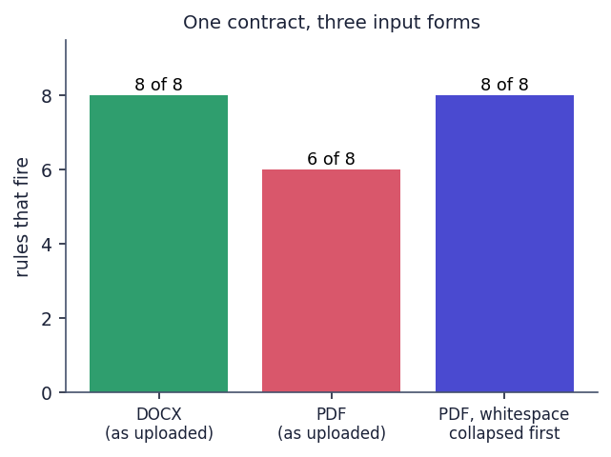
Fig. 7.1: One contract in three input forms: eight of eight rules fire on the DOCX, six of eight on the PDF, and eight of eight again when whitespace is collapsed before matching

7.7 Performance Testing
Response times were measured against the live server on the same machine over 127.0.0.1 (an Intel Core i5-12500 with 12 threads, 15.7 GB of memory, no GPU used, Windows 11) while other jobs were running, so the figures are indicative rather than a benchmark. The address 127.0.0.1 is used because the name localhost adds about two seconds per call on this machine through an IPv6 fallback. Endpoints that do not call Gemini were repeated 30 times (10 for the bcrypt and error cases), using the contract of the freelance upload (11 clauses).
Table 7.8: API response times without Gemini (live server)
Request | Runs | Median (ms) | 95th percentile (ms) | Max (ms)
GET /health | 30 | 2.5 | 4.0 | 10.6
POST /auth/login (bcrypt check) | 10 | 254.7 | 260.8 | 318.3
POST /auth/register (bcrypt hash) | 10 | 265.0 | 268.6 | 280.1
GET /contracts | 30 | 15.3 | 19.0 | 22.3
GET /contracts/{id} (report) | 30 | 9.3 | 11.2 | 13.0
GET /contracts/{id}/clauses/{cid} | 30 | 5.0 | 6.1 | 7.5
GET /contracts/{id}/graph | 30 | 9.2 | 11.8 | 12.3
GET /eval/metrics | 30 | 2.5 | 3.6 | 4.1
GET /contracts (no token -> 403) | 10 | 1.8 | 2.3 | 2.7
GET /contracts/999999 (404) | 10 | 5.0 | 8.9 | 86.9
POST /contracts/upload wrong type (400) | 10 | 4.0 | 5.7 | 5.9

The three upload requests include real Gemini calls and are dominated by them: 15.5 s for the fair contract (8 embeddings and 1 summary), 54.6 s for the real supply agreement (11 embeddings, 1 explanation and 1 summary) and 113.6 s for the one-sided contract (11 embeddings, 8 explanations and 1 summary). An embedding call took about 0.7 s while the evaluation vectors were cached, and, by subtraction, a text call roughly 10 to 25 s with the lite model used for the demonstration, so the upload time grows with the number of flags. The browser's upload request has a 180 s timeout (timeout: 180000 in frontend/src/lib/api.js); a contract with about 14 flags would exceed it even though the server would finish and store the result. By contrast, every read endpoint answers in under 20 ms at the median, the report in 9.3 ms, and the bcrypt-based log-in and registration take about 255 to 265 ms by design.
The non-API part of the pipeline (segmentation, eight regular expressions, combinations and the complexity score) processed all 510 CUAD contracts (23,869 clauses) in 28.49 s, which is 56 ms per contract, so the local code is not a bottleneck. Embeddings of the 500 training spans and 240 held-out spans were cached in about 7 minutes (about 0.6 s per call, with a few rate-limit retries).
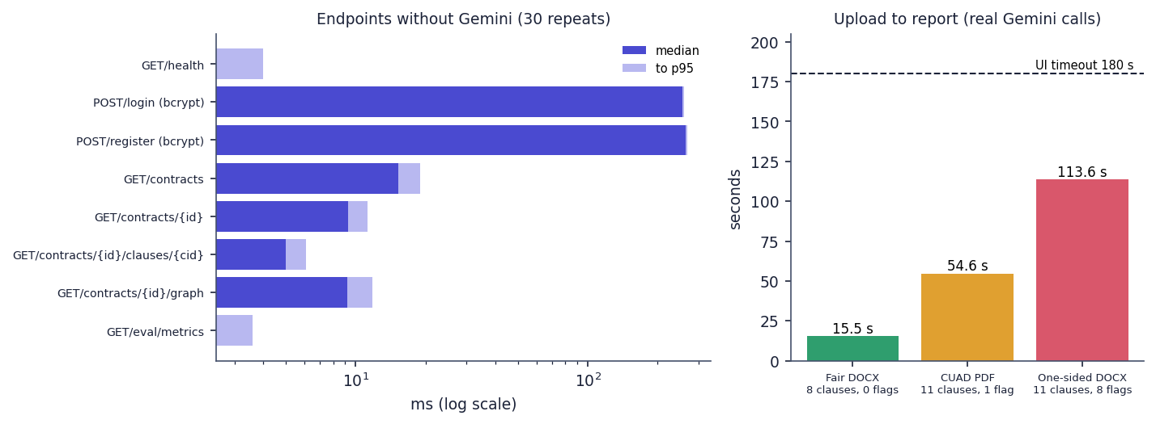
Fig. 7.2: Measured response times: endpoints without Gemini (log scale, median and 95th percentile) and the three real uploads against the 180 s browser timeout
Not measured: concurrent users, memory use under load, behaviour with a large database, the front end's load time, and other hardware.

7.8 User Acceptance Testing
No user-acceptance test was carried out and no lawyer or signatory reviewed the output. What was done is a functional acceptance run by the project team: three uploads through the real interface (see Functional Testing), which show that the intended flow works from sign-up to a clause-level report with reasons, quoted provisions and safer wording. It does not show that real users find the report understandable or that its legal reasoning is correct. The generated reasons cite Indian statutes (for example Section 74 of the Indian Contract Act, 1872 for the penalty and Section 27 for the non-compete) and read plausibly, but nobody qualified in law has checked them, and the safer wording sometimes keeps a restriction (the proposed replacement for the three-year non-compete still forbids soliciting clients for six months). A review of a sample of outputs by practising lawyers and a pilot with freelancers who read their own contracts are the most important next steps.

7.9 Limits of the Testing Done
- The automated tests stub Gemini, so they say nothing about the quality of the generated explanations, safer wording and summaries, and nothing about real embedding quality.
- The 40-clause set that produced the published 100 % precision and 94 % recall was written by the author of the rules; on 40 independently phrased clauses the same rules reach precision 0.786 and recall 0.458 (Chapter 8). The probe set was also written by a project member after reading the rule patterns, so it is independent of the wording of the shipped set but not of the project.
- The CUAD classification test uses 240 annotation spans of about 290 characters, not whole clauses of about 1,160 characters, and the split is by span text, not by contract (192 of 240 spans share a contract with a training span; the contract-disjoint score is 0.800, so the effect is small).
- The CUAD cross-check of the rules is a proxy only, because CUAD categories such as 'Uncapped Liability' are not defined as predatory.
- No Indian contracts were available: CUAD contains US filings, the sample contracts are invented, and only the real supply agreement is a real document (a contract for work at a Canadian university, analysed under a prompt that assumes Indian law).
- No browser automation suite, no load or concurrency test, no penetration test and no user study were carried out; all timings come from one machine that was running other jobs.

CHAPTER 8
RESULTS AND OUTPUT SCREENS

8.1 Output Screens
Every screen below is a real capture of ClauseGuard running with real data on 26 October 2026: a user registered through the sign-up page, three contracts uploaded through the upload page and analysed by the real pipeline (the embedding model gemini-embedding-001 and the text model gemini-3.1-flash-lite through the Gemini API), and the Evaluation page reading the metrics file written by the evaluation script. Two of the three contracts are invented for this project and one is a real public contract from the CUAD corpus. The captures are viewport screenshots of 1440 by 900 pixels taken with Playwright in Chrome.
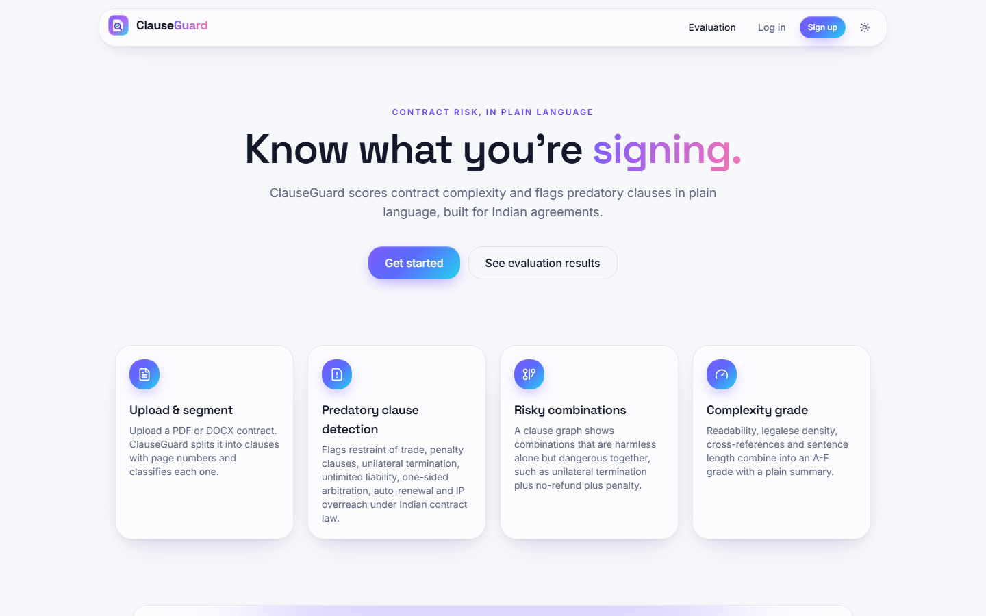  Fig. 8.1: Landing page | Fig. 8.2: Sign-up form

Landing page. The public home page: the eyebrow "Contract risk, in plain language", the headline "Know what you're signing." and the line that ClauseGuard scores contract complexity and flags predatory clauses in plain language, built for Indian agreements.
Sign-up form. The Create your account page with the e-mail neha.legal@example.com typed in, the password masked and the hint "At least 6 characters". Registering through this form creates the demonstration user whose uploads appear in the following screens; there is no pre-seeded account.
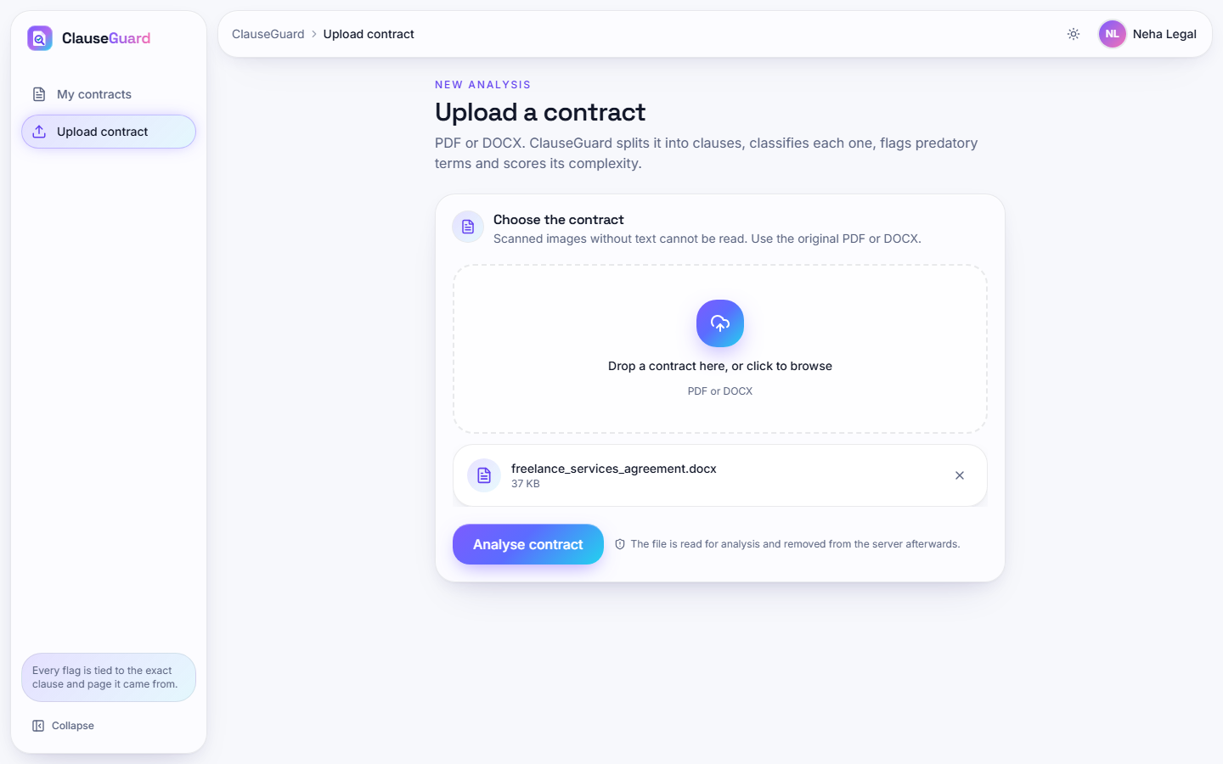  Fig. 8.3: Upload page with a file selected | 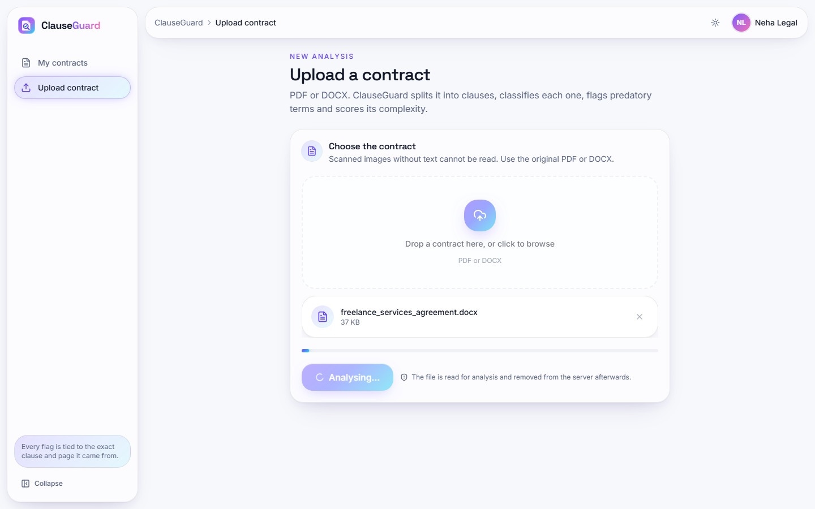  Fig. 8.4: Analysis in progress

Upload page with a file selected. The signed-in user (Neha Legal) has chosen freelance_services_agreement.docx (37 KB). The file chip shows the name and size with a remove button, and the Analyse contract button is now enabled.
Analysis in progress. About two and a half seconds after pressing Analyse contract the button reads Analysing... and is disabled, and the progress bar is at its start. The real analysis of this file took 113.6 s (11 embeddings, 8 flag explanations and one summary through Gemini), so the page stays in this state for nearly two minutes.
Fig. 8.5: Contract report: one-sided freelance agreement
The report opens with the file name, "Uploaded 26 Oct 2026, 07:58 pm - 11 clauses" and the grade badge B. Six tiles give complexity grade B (score 23.3), readability 39.8 (Flesch), legalese density 0.7 % per 100 words, 0 cross-references, average sentence length 16.2 words and 8 flagged clauses out of 11. The plain-language summary calls the terms "highly lopsided" and lists termination without notice, daily penalties, a three-year non-compete across India, unlimited liability, total IP assignment, a one-sided arbitration and automatic renewal. The bar chart counts clauses by highest severity: 4 high, 4 medium, 0 low and 3 with no flag.
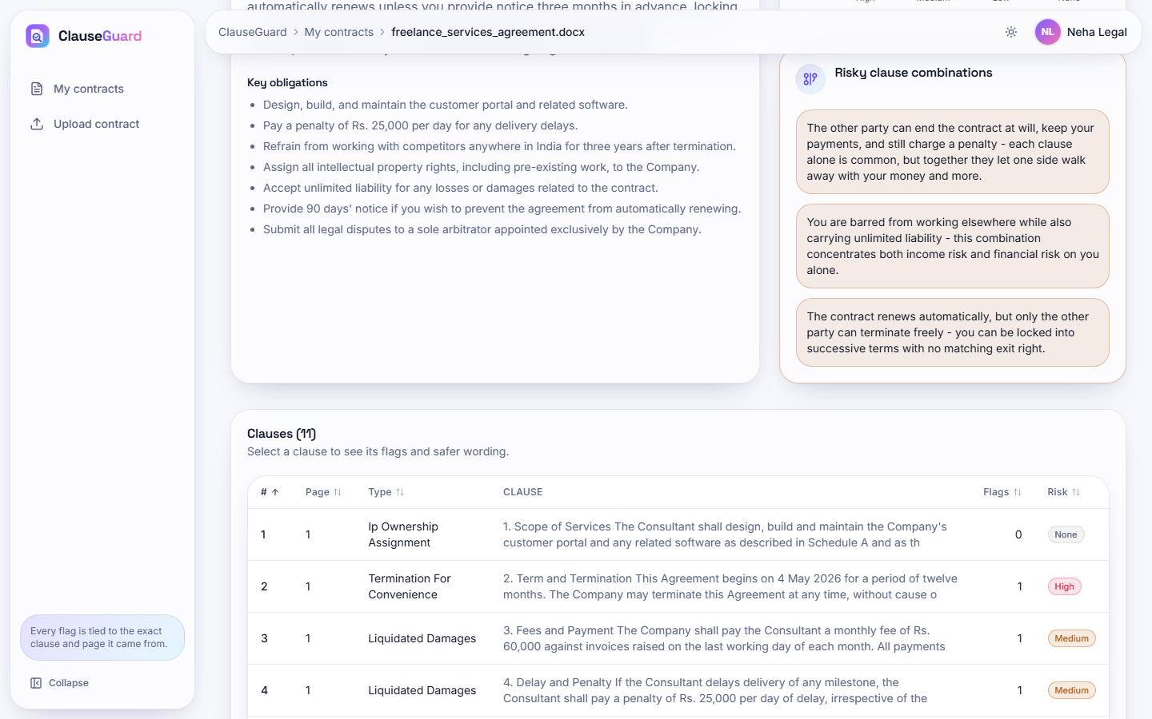
Fig. 8.6: Obligations and risky combinations

Obligations and risky combinations. The same report scrolled: seven key obligations extracted by Gemini (for example "Pay a penalty of Rs. 25,000 per day for any delivery delays") and the panel Risky clause combinations with three explanations: termination at will plus no refund plus penalty, non-compete plus unlimited liability, and automatic renewal plus one-sided termination.
Fig. 8.7: Clause detail: unilateral termination
Clause 2 (page 1) is classified as Termination For Convenience with 79 % confidence by the embedding method. The Flags tab shows a High flag Unilateral Termination with the section Why it is flagged (an at-will termination lacks the mutuality expected under Indian contract principles), the Provision quoted from the clause ("The Company may terminate this Agreement at any time, without cause or notice, at its sole discretion ...") and a green Safer wording box proposing termination by either party on 30 days' written notice with compensation for work done.
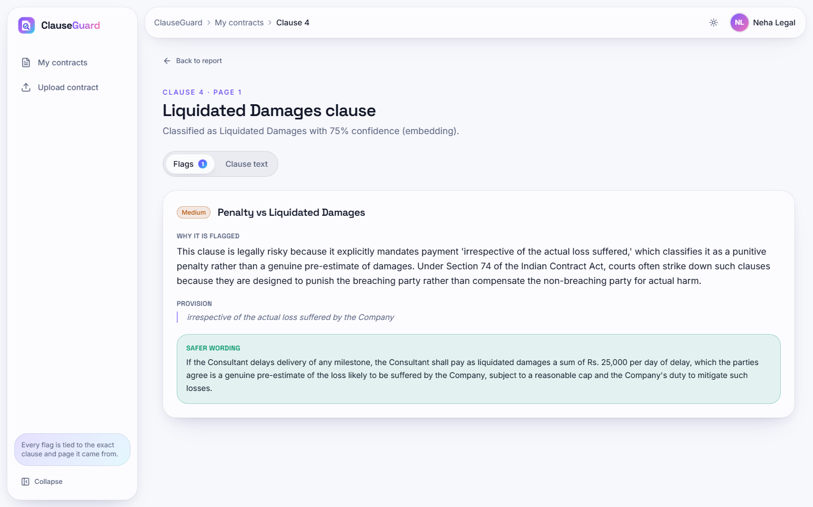
Fig. 8.8: Clause detail: penalty versus liquidated damages

Clause detail: penalty versus liquidated damages. Clause 4 is labelled Liquidated Damages with 75 % confidence. The Medium flag Penalty vs Liquidated Damages explains that a sum payable "irrespective of the actual loss suffered" is a penalty under Section 74 of the Indian Contract Act, quotes that phrase as the provision and proposes wording that calls the sum liquidated damages, a genuine pre-estimate, subject to a reasonable cap and a duty to mitigate.
Fig. 8.9: Clause graph
Eleven nodes, one per clause, each labelled with its clause type. Red nodes (8) triggered a rule and violet nodes (3: Ip Ownership, Governing Law and Non-Disparagement) did not; orange lines join clauses that belong to a risky combination, for example the Termination node with the two Liquidated Damages nodes and with Renewal Term. The right-hand panel "Risky combinations found" repeats the three combination explanations; the Selected clause card asks the user to hover or focus a node.
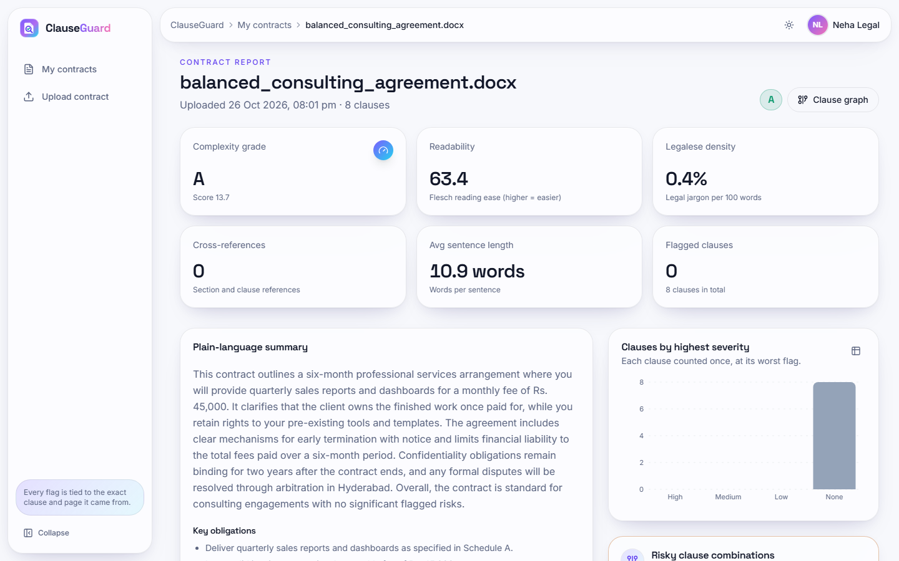
Fig. 8.10: Contract report: fair consulting agreement

Contract report: fair consulting agreement. The fair consulting agreement (8 clauses) receives grade A (score 13.7) with readability 63.4, legalese density 0.4 %, 0 cross-references, average sentence length 10.9 words and 0 flagged clauses; the severity chart has a single grey bar of 8 clauses without a flag.
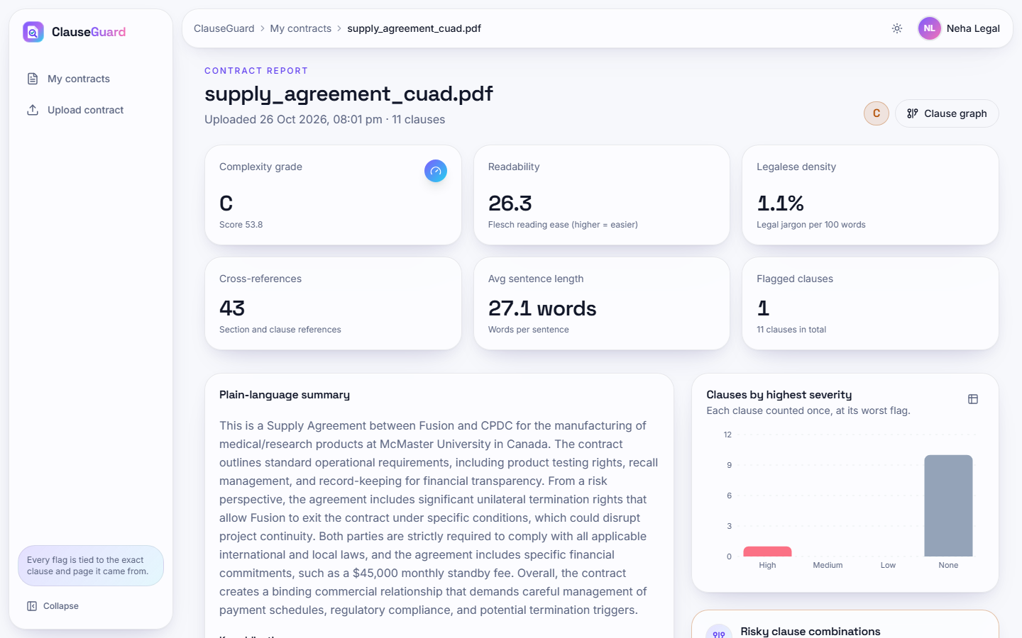
Fig. 8.11: Contract report: real supply agreement (PDF)
A real supply agreement from the CUAD corpus, typeset to a ten-page PDF, gives grade C (score 53.8), readability 26.3, legalese density 1.1 %, 43 cross-references, average sentence length 27.1 words and 1 flagged clause out of 11. The summary identifies the parties as Fusion and CPDC, mentions product testing, recalls and record keeping and points to the unilateral termination right; the chart shows 1 high-severity clause and 10 without a flag.
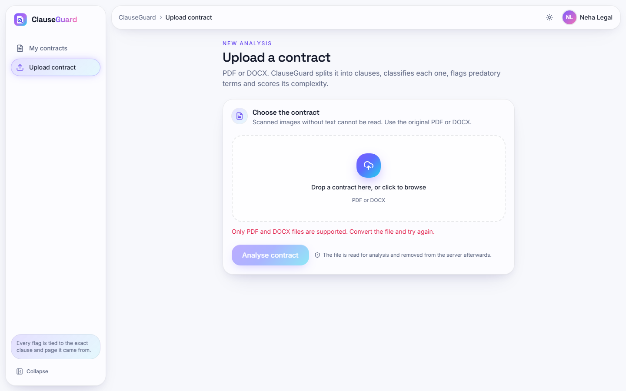  Fig. 8.12: Validation error for a wrong file type | Fig. 8.13: My contracts

Validation error for a wrong file type. After a plain-text file is selected, the upload page shows the red message "Only PDF and DOCX files are supported. Convert the file and try again." under the drop zone, and the Analyse contract button stays disabled (faded).
My contracts. The list of the three uploads of the demonstration user, sorted by upload time: supply_agreement_cuad.pdf (grade C, 1 flag, 8:01 pm), balanced_consulting_agreement.docx (grade A, 0 flags, 8:01 pm) and freelance_services_agreement.docx (grade B, 8 flags, 7:58 pm).
Fig. 8.14: Evaluation page
The public Evaluation page, captured after the stat counters finished counting: precision 100 %, recall 94 % and F1 97 % "across 40 curated examples", "Run 2026-10-26", and the per-rule table (Restraint of trade 4 TP / 0 FP / 1 FN, Unilateral termination 6 / 0 / 0, One sided arbitration 1 / 0 / 1 and so on). The page describes the scores as "measured on a held-out set"; Chapter 8 explains why the 40 examples were written by the author of the rules and are better described as a development set.

8.2 Model Performance
ClauseGuard has two measurable components of its own: a clause classifier (Gemini embeddings and 20 CUAD centroids) and a rule engine (eight regular expressions) with a clause graph and a complexity score. The text generation by Gemini, which writes the reasons, the safer wording and the summaries, cannot be scored automatically and was not measured. The two measurable components are evaluated separately, as objective 6 requires: classification against CUAD, predatory detection against labelled clauses. All figures come from experiments/**/metrics.json; the classification figures are produced by the unmodified ml/eval.py run on embeddings cached from the same Gemini calls the product makes. The measurements ran on an Intel Core i5-12500 with 15.7 GB of memory and no GPU.

8.2.1 Clause classification on CUAD
Table 8.1: Clause classification results (unmodified ml/eval.py on cached embeddings)
Measure | Result
Held-out CUAD annotation spans / categories | 240 / 20 (12 per category, seed 42)
Top-1 accuracy (shipped nearest-centroid classifier) | 0.792 (190 of 240); 0.797 after removing the 4 spans that also occur in the training set
Top-3 accuracy | 0.979 (235 of 240); top-5 0.983
Top-1 when no training span of the same contract is used | 0.800 (192 of 240 spans had a same-contract training span)
Chance level | 0.050

Table 8.2: Shipped classifier against simple baselines
Method (same train/test split) | Top-1 accuracy
TF-IDF nearest centroid | 0.621
TF-IDF + logistic regression | 0.675
Embedding 1-nearest neighbour | 0.604
Embedding 5-nearest neighbours | 0.746
Embedding nearest centroid (shipped) | 0.792
Embedding + logistic regression | 0.800

The shipped classifier is 12 to 17 points better than the two TF-IDF baselines and much better than a single nearest neighbour, which supports the choice of dense embeddings. A logistic regression on the same embeddings reaches 0.800, two spans more than the shipped method, a difference too small to matter on 240 examples; the nearest-centroid method has the advantage of needing no training beyond averaging. Scoring the same 240 spans after rebuilding the centroids without any training span from the same contract changes the top-1 value from 0.792 to 0.800, so the span-level split of the shipped script does not inflate the score noticeably.
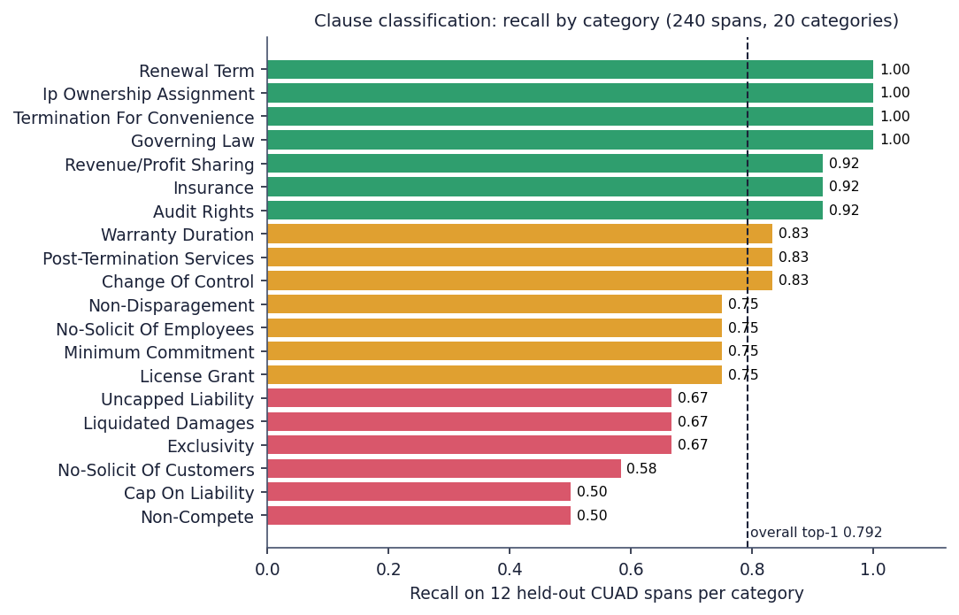
Fig. 8.15: Recall of the classifier for each of the 20 CUAD categories (12 held-out spans each)
Recall is perfect for Governing Law, Termination For Convenience, Ip Ownership Assignment and Renewal Term, which have distinctive vocabulary. It is weakest for Non-Compete (0.50), Cap On Liability (0.50), No-Solicit Of Customers (0.58), Exclusivity (0.67), Liquidated Damages (0.67) and Uncapped Liability (0.67). The confusions are between neighbouring concepts: Uncapped Liability is read as Cap On Liability (4 spans) and the reverse (3), Non-Compete as No-Solicit Of Customers (4), the two no-solicit categories with each other (3 and 3), License Grant as Exclusivity (3) and Cap On Liability as Warranty Duration (3).
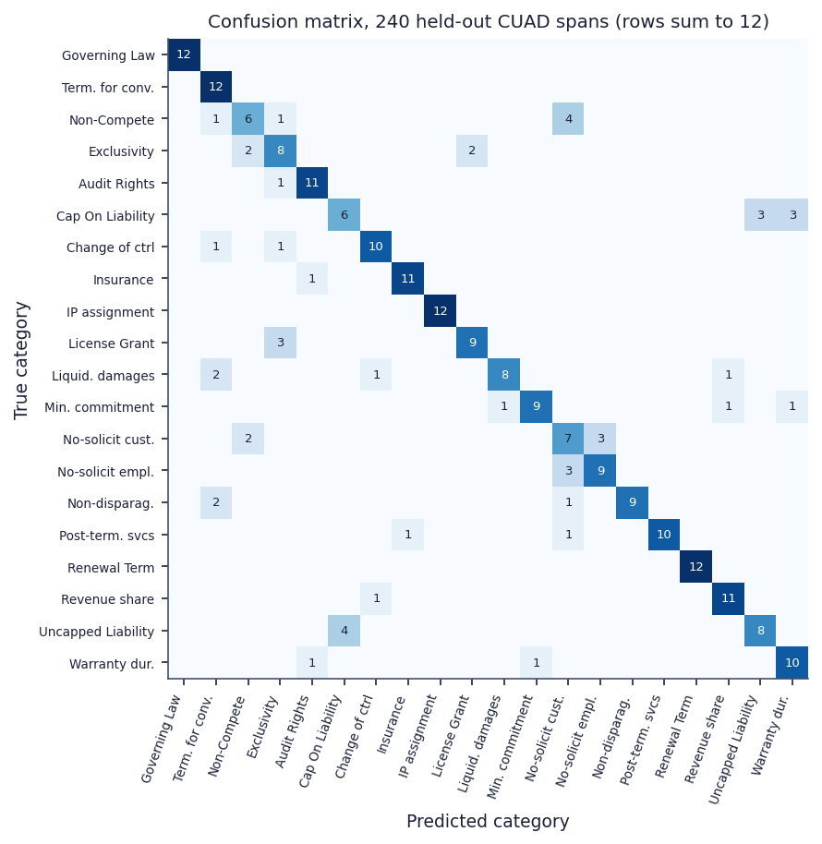
Fig. 8.16: Confusion matrix of the classifier on the 240 held-out spans (rows are true categories and sum to 12)
The two safeguards of the classifier never act. The top-1 cosine similarity of the 240 spans lies between 0.657 and 0.849 (median 0.767). The tie-break needs a margin below 0.03 and a top-1 similarity below 0.60; the margin test alone would fire on 152 of the 240 spans, but no span is below 0.657, so the tie-break fires on none. The 'Other / Unclassified' floor at 0.35 is never reached either. With the current embedding model both branches are dead code, and every clause, including definitions, notices and payment terms that are not among the 20 categories, receives one of the 20 labels. The same holds in the three real uploads: all 30 clauses carry the method embedding with a confidence between 0.72 and 0.83.

8.2.2 Predatory-clause detection
Table 8.3: Rule engine on two test sets
Test set | Clauses | TP | FP | FN | Precision | Recall | F1
Shipped set, written together with the rules | 40 | 32 | 0 | 2 | 1.000 | 0.941 | 0.970
Independent probe set (24 predatory paraphrases, 16 benign look-alikes) | 40 | 11 | 3 | 13 | 0.786 | 0.458 | 0.579

The shipped set of 40 clauses gives precision 1.00, recall 0.941 and F1 0.970, the numbers shown on the landing page and the Evaluation page. It was written by the author of the rules, who chose the wording the patterns recognise, so it measures whether the rules implement the author's intent, not whether they generalise. To test generalisation, 40 further clauses were written for this report after reading the rules: three predatory paraphrases for each rule that avoid the rule's key words, and 16 benign look-alikes. On this probe set precision falls to 0.786 and recall to 0.458, so the rules find fewer than half of the predatory clauses when the wording changes.
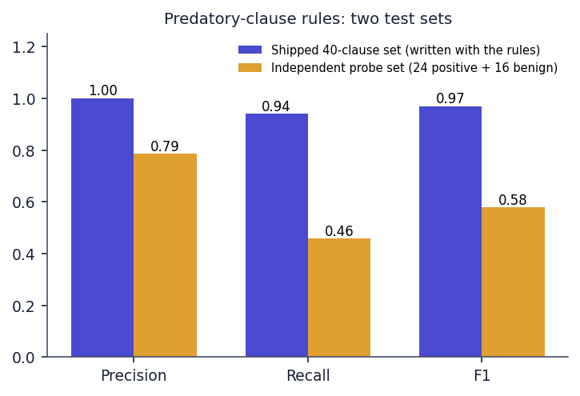
Fig. 8.17: Precision, recall and F1 of the rule engine on the shipped set and on the independent probe set
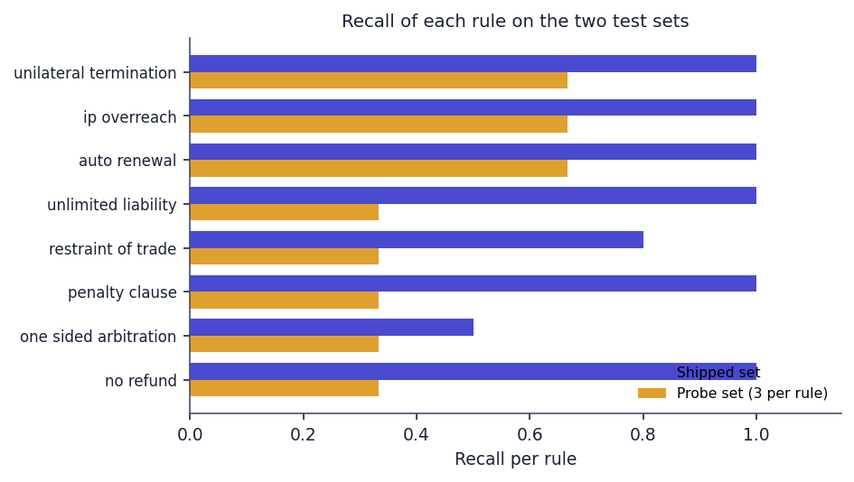
Fig. 8.18: Recall of each rule on the two test sets (three probe clauses per rule)
Per rule, the probe recall is 0.667 for auto-renewal, IP overreach and unilateral termination and 0.333 for the other five rules. The probe false alarms are instructive: a fair capped liquidated-damages clause is flagged as a penalty; "shall not engage in any outside activity that creates a conflict of interest" is flagged as restraint of trade; and "both parties shall be liable for any and all losses caused by their own gross negligence" is flagged as unlimited liability. The 13 misses are keyword-free paraphrases (for instance "reserves the right to end this engagement whenever it chooses" or "fees once paid cannot be returned for any reason") and one wording slip: "shall not be entitled to any refund" is missed because the pattern reads "not entitled".
Table 8.4: Rules against the closest CUAD categories (a proxy, not a recall)
CUAD category | Closest rule | Spans | Rule fires | Share
Non-Compete | restraint of trade | 257 | 21 | 8.2 %
Liquidated Damages | penalty clause | 121 | 68 | 56.2 %
Termination For Convenience | unilateral termination | 246 | 32 | 13.0 %
Uncapped Liability | unlimited liability | 167 | 0 | 0.0 %
Renewal Term | auto renewal | 208 | 69 | 33.2 %
Ip Ownership Assignment | ip overreach | 317 | 0 | 0.0 %

CUAD offers a second, independent view, with a caveat: its categories describe clause topics, not predatory terms, so the share is a proxy. The penalty rule fires on 56.2 % of the Liquidated Damages spans and the auto-renewal rule on 33.2 % of the Renewal Term spans, while the unlimited-liability and IP-overreach rules never fire on the 167 Uncapped Liability and 317 Ip Ownership Assignment spans, whose wording differs from the patterns. On 5,032 spans of eleven unrelated categories any rule fired on 37 (0.74 %): restraint of trade 14, penalty 12, unilateral termination 10 and no-refund 3.
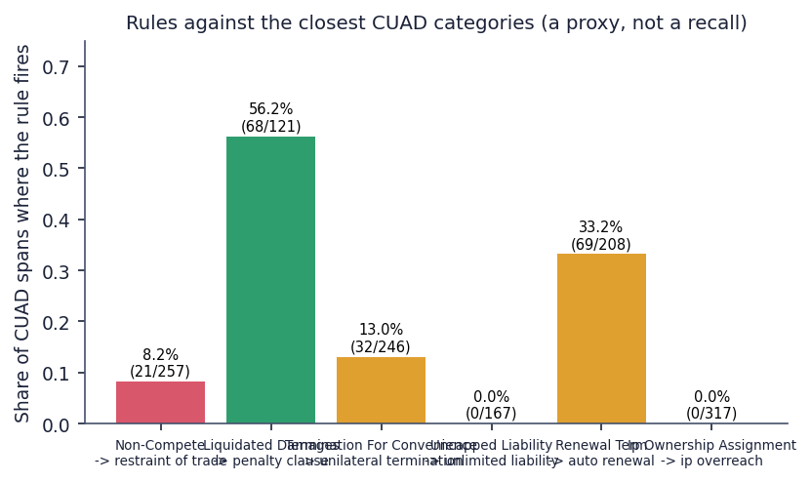
Fig. 8.19: Share of CUAD spans on which the closest rule fires

8.2.3 Corpus-scale run and the complexity score
Table 8.5: Non-API pipeline over all 510 CUAD contracts
Measure | Result
Contracts parsed (segment, rules, combinations, complexity) | 510 of 510
Total time / per contract | 28.49 s / 56 ms
Clauses: total, median, mean, min, max | 23,869; 20.5; 46.8; 1; 611
Contracts split on numbered headings / with fewer than 5 clauses | 444 / 84
Median clause length | 1,158 characters
Clauses flagged / contracts with at least one flag | 2.2 % / 255 of 510
Contracts with a risky combination | 11 (auto-renewal + unilateral termination 10, termination + no-refund + penalty 2)
Clauses per rule | restraint 163, penalty 152, unilateral termination 84, no-refund 72, auto-renewal 66, unlimited liability 4, one-sided arbitration 0, IP overreach 0
Complexity grades A / B / C / D / F | 4 / 169 / 268 / 68 / 1
Complexity score min / median / mean / max / sd | 6.9 / 45.5 / 45.8 / 85.5 / 12.3
Median components: Flesch, legalese per 100 words, cross-references, words per sentence | 25.65, 1.125, 26, 28.9
Correlation of score with contract length | 0.297

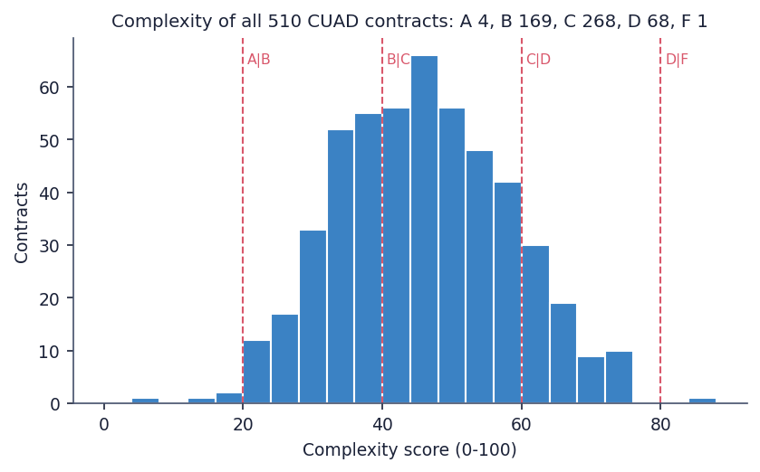
Fig. 8.20: Complexity scores of the 510 CUAD contracts with the grade boundaries
The corpus run shows that the local part of the pipeline is fast and does not crash on any of 510 contracts, from a single clause to 611. Real contracts are mostly grades B and C (437 of 510); very few are A or F. The complexity score is a lexical measure and is only weakly related to length (correlation 0.30). Its weights and cut-offs were chosen by the author and have not been compared with human ratings of difficulty, so the grade is best read as a relative indicator.

8.2.4 Same contract as DOCX and as PDF
Table 8.6: Effect of the input format on the rule engine
Input form of the same text | Clauses | Rules found | Combinations
DOCX, as uploaded | 11 | 8 of 8 | 3
PDF, as uploaded | 11 | 6 of 8 (IP overreach and one-sided arbitration missed) | 3
PDF, whitespace collapsed before matching | 11 | 8 of 8 | 3
Fair DOCX (control) | 8 | 0 of 8 | 0

PDF extraction keeps the visual line breaks, and several rules use .{0,N} between two key phrases, which does not cross a newline. The same contract therefore yields 8 rules as DOCX but only 6 as PDF; collapsing whitespace before matching restores all eight. The figure for this comparison is given with the testing in Chapter 7.

8.3 Results of the Application
The complete product was exercised with three real uploads through the browser. The table summarises what the pipeline returned and how long it took; the individual screens are shown in the section Output Screens.
Table 8.7: Real uploads through the web application
Upload | Clauses | Flags | Risky combinations | Complexity grade (score) | Time
freelance_services_agreement.docx (invented, one-sided) | 11 | 8 (one per rule) | 3 | B (23.3) | 113.6 s
balanced_consulting_agreement.docx (invented, fair) | 8 | 0 | 0 | A (13.7) | 15.5 s
supply_agreement_cuad.pdf (real CUAD contract, 10 pages) | 11 | 1 | 0 | C (53.8) | 54.6 s

One-sided contract. Every rule fired once on the DOCX, each on the intended clause, and the three combinations were found; the report quotes the triggering phrase of each clause and proposes a fairer wording. The complexity grade is B because the contract is written in plain words (average sentence of 16.2 words, no cross-references); the grade says nothing about fairness. Fair contract. No rule fired and no combination was found; this is the only evidence of the false-positive behaviour on a complete, realistic contract (the CUAD cross-check gives a false-alarm share of 0.74 % on unrelated clause types). Real contract. The real supply agreement is dense (grade C, 43 cross-references, 27.1 words per sentence) and only one termination clause was flagged. With the original CUAD text the same rules find 2 flags (auto-renewal and unilateral termination) and one combination in 25 clauses, but the typeset PDF changes the segmentation (11 clauses) and the run therefore found fewer; that comparison is not like-for-like and is given only as an illustration of how sensitive the output is to the input form.
Classification of whole clauses. In the author's reading, the label shown in the clause table is plausible for 5 of the 11 clauses of the freelance contract (termination, penalty, IP, renewal, governing law) and for 4 of the 8 clauses of the fair contract. Examples of wrong labels are Scope of Services as Ip Ownership Assignment, Fees as Liquidated Damages, Liability as Cap On Liability (the opposite of an unlimited liability clause), Dispute Resolution as Cap On Liability and Confidentiality as Non-Disparagement. This is lower than the 79 % on spans because a whole clause carries a heading and several topics, and because the classifier cannot answer 'none of the 20'. The reading covers 19 clauses and is indicative only.
Responsiveness. Reading endpoints answer within 20 ms at the median and the report endpoint within 9.3 ms; the bcrypt-based log-in takes about 255 ms. Upload time is dominated by the Gemini calls: 15.5 s with 1 text call, 54.6 s with 2 and 113.6 s with 9. The 180 s timeout of the browser request limits a contract to roughly fourteen flags with this model.

8.4 Comparison with the Base Paper
The base paper [1] is SmartLaw Advisor (IEEE Access, 2026), a retrieval-augmented legal assistant for Saudi Arabia built on Gemini 1.5 Flash. ClauseGuard keeps its jurisdiction-aware, LLM-backed idea and applies it to Indian contracts, but the two systems do different things and are evaluated on different data with different metrics, so no numerical comparison is made and no superiority is claimed. The table lists what each reports.
Table 8.8: SmartLaw Advisor [1] and ClauseGuard side by side (figures are as reported or measured by each)
Aspect | SmartLaw Advisor [1] | ClauseGuard (this project)
Task | Legal question answering (chatbot) and contract compliance analysis | Clause segmentation and classification, predatory-clause flags, risky combinations, complexity grade, plain-language report
Jurisdiction and language | Saudi Arabia, Arabic | India (rules cite Indian statutes), English
Generative model | Gemini 1.5 Flash (also GPT-4, GPT-3.5, ALLaM, Command-A compared) | Gemini text model (this run: gemini-3.1-flash-lite) for explanations and summaries; Gemini embedding model for classification
Retrieval | Chroma vector store of Arabic legal chunks, GATE-AraBERT-v1 embeddings, cross-encoder reranking | No retrieval from a legal corpus; nearest centroid over 20 CUAD categories; the rule's legal basis is placed in the prompt
Knowledge base | Custom Arabic corpus of Saudi regulations validated by legal specialists | Eight hand-written rules with statute references; CUAD (US filings) for classification
Evaluation data | 150 legal questions in ten domains; 50 real contract drafts | 240 held-out CUAD spans; 40-clause shipped set; 40-clause probe set; 510 CUAD contracts (non-API run); three real uploads
Headline metric | Answer accuracy 98.67 % (148 of 150) for Gemini 1.5 Flash; qualitative clause-by-clause review for contract analysis | Classification top-1 0.792 and top-3 0.979 on CUAD spans; rule precision / recall 1.00 / 0.94 (shipped set) and 0.79 / 0.46 (probe set)
Speed reported | 1.63 s average response (baseline); 143.52 s per query in the full RAG evaluation pipeline | 9 ms to 15 ms for reading endpoints; 15.5 s to 113.6 s per upload, dominated by Gemini calls
Contract analysis | Checklist of essential clauses and LLM-assisted semantic compliance check | Per-clause rule flags with quoted provision and safer wording; three clause combinations; no missing-clause checklist
Not addressed | Clause combinations, complexity scoring, Indian law | Missing-clause detection, Arabic, retrieval-augmented answers, a legal chatbot
Hardware | Cloud virtual machine (Xeon Platinum 8272CL, 32 GB); Gemini hosted | Desktop i5-12500, 15.7 GB, no GPU; Gemini hosted

Three differences deserve emphasis. First, the headline figures measure different things: 98.67 % is the share of 150 Saudi-law questions answered correctly, whereas 79.2 % is the share of CUAD annotation spans assigned to the right one of 20 categories; neither can be read against the other. Second, the base paper's contract analysis is judged qualitatively on sample outputs, and ClauseGuard's detection is scored with precision and recall against labelled clauses, which is the more checkable of the two but rests on small, author-written sets. Third, the base paper's data are in Arabic and cover Saudi regulations validated by experts, while ClauseGuard has no Indian-law corpus and no lawyer-labelled contracts; its legal knowledge is eight rules.
Table 8.9: Related work, results as reported by their authors
Related work (for orientation) | Task and data | Reported result
ContractEval [2] | 19 LLMs, CUAD test data, 41 risk categories, span extraction | F2 of 0.672 and 0.678 for the top two models; proprietary models ahead of open-source ones
A few good clauses [3] | Domain-trained small model against five frontier LLMs, 24 contracts, 508 field instances, 26 targets | Macro F1 0.812, micro F1 0.842; extraction cost 78 % to 97 % lower
Legal document analysis system [4] | 10 clause types, missing-clause detection, weighted risk score, AWS serverless | 94.2 % average extraction accuracy on 20 synthetic contracts; correlation 0.87 between score and expert rating on 30 contracts

None of these results is comparable with the present figures: ContractEval and [3] extract spans or fields from whole contracts with large models, whereas ClauseGuard classifies given spans with embeddings, and [4] scores missing clauses on synthetic documents. They are listed to show the kind of evaluation a stronger version of ClauseGuard should adopt: a lawyer-labelled test set of whole contracts, a span-level metric, and an agreement study between the risk score and expert ratings.

8.5 Sample Inputs and Outputs
The three sample contracts are in docs/sample_inputs/; the outputs below are copied from the application database filled by the real uploads. The input is the clause text as segmented by the pipeline, and the flag texts were generated by Gemini.
Table 8.10: Sample outputs for the one-sided freelance agreement
Clause (input, shortened) | Flag and provision quoted | Reason (generated) | Safer wording (generated)
2. Term and Termination: "The Company may terminate this Agreement at any time, without cause or notice, at its sole discretion, and the Consultant shall have no right to object ..." | Unilateral termination (high): "The Company may terminate this Agreement at any time, without cause or notice, at its sole discretion ..." | Grants the Company the power to end the contract at once without warning or justification and leaves the Consultant without recourse; such at-will termination lacks the mutuality expected under Indian contract principles. | Either party may terminate by 30 days' written notice; the Consultant is entitled to compensation for services rendered and expenses incurred up to the effective date.
3. Fees and Payment: "All payments made under this Agreement are non-refundable under any circumstances, including early termination by the Company ..." | No refund (medium): "All payments made under this Agreement are non-refundable under any circumstances ..." | Prevents recovery of payments even if the company terminates early; may be an unfair trade practice under the Consumer Protection Act. | Fees are payable for services rendered up to termination; on early termination by the Company without cause the Consultant is paid for all work performed and documented expenses.
4. Delay and Penalty: "... the Consultant shall pay a penalty of Rs. 25,000 per day of delay, irrespective of the actual loss suffered by the Company ..." | Penalty vs liquidated damages (medium): "irrespective of the actual loss suffered by the Company" | A sum payable irrespective of actual loss is a punitive penalty rather than a genuine pre-estimate; Section 74 of the Indian Contract Act lets courts refuse such clauses. | The same sum as liquidated damages that the parties agree are a genuine pre-estimate, subject to a reasonable cap and a duty to mitigate.
6. Liability: "The Consultant shall be liable for any and all losses, damages, claims and expenses ... with no limitation on liability whatsoever." | Unlimited liability (high): "with no limitation on liability whatsoever" | The Consultant must pay every possible loss without a ceiling, an unbounded and disproportionate financial risk. | Total aggregate liability limited to the fees actually paid in the twelve months before the event giving rise to the claim.

The reasons and the provisions are faithful to the clauses in these examples, and the quoted provision is, as the prompt requires, a phrase copied from the clause. Two further examples show the limits. The safer wording for the three-year non-compete (clause 5) keeps a restriction: it forbids soliciting existing clients and using confidential information for six months after termination, which a lawyer might still question under Section 27. The report for the real supply agreement flags clause 6 ("FUSION may terminate this Agreement without cause by providing CPDC with [***] prior written notice") as unilateral termination and says that CPDC has no reciprocal right; the same contract gives CPDC a right to terminate for cause (clause 7.4), so the statement is true only for termination without cause. The notice period, redacted in the source with the marker [***], is carried into the proposed wording unchanged.
Table 8.11: Sample summaries
Contract | Extract of the generated plain-language summary | Extract of the key obligations
Fair consulting agreement (grade A, 0 flags) | "... clarifies that the client owns the finished work once paid for, while you retain rights to your pre-existing tools and templates ... Overall, the contract is standard for consulting engagements with no significant flagged risks." | Deliver quarterly sales reports and dashboards as specified in Schedule A; refund any pre-paid fees for work not yet performed if the contract ends early; provide 30 days' written notice if you wish to terminate early.
Real supply agreement (grade C, 1 flag) | "This is a Supply Agreement between Fusion and CPDC for the manufacturing of medical/research products at McMaster University in Canada ... the agreement includes significant unilateral termination rights ..." | Pay all invoices within the specified timeframe; notify CPDC promptly of any product recall; pay a recurring monthly production standby fee of $45,000.

The summary of the real contract is accurate in outline but is framed by the same Indian-law prompt ("From a risk perspective ...") even though the contract concerns work at a Canadian university; the tool has no way to detect or change the jurisdiction. No lawyer reviewed these texts.

8.6 Success and Failure Analysis

8.6.1 What worked
- End-to-end operation. Three contracts, in two formats and with 8, 8 and 11 clauses, went from the browser to a clause-level report, with every flag tied to the clause text and page, a quoted provision and a safer wording.
- All eight rules fire on a contract that contains them (DOCX), and all three combinations are found; the fair contract raises no flag.
- Dense embeddings classify CUAD spans well (top-1 0.792, top-3 0.979) and beat TF-IDF baselines by 12 to 17 points.
- The local pipeline is fast and robust: 510 real contracts in 28.5 s without a failure.
- The decision is auditable. Whether a clause is predatory is decided by a regular expression that can be read and tested; Gemini only words the explanation, so the verdict does not change between runs.
- Failures are reported cleanly: a wrong file type, an empty document, a missing key and a Gemini error each give a specific message and leave no partial record.

8.6.2 What failed, and why
Table 8.12: Failure cases with cause
Failure | Evidence | Cause
Predatory clauses written without the key word are missed | Probe recall 0.458 against 0.941 on the shipped set; 13 of 24 paraphrases missed | Rules are keyword regular expressions; the shipped set was written with the same vocabulary
PDF input finds fewer flags than DOCX | 6 of 8 rules in the PDF, 8 of 8 in the DOCX with identical text | PDF text keeps line breaks and .{0,N} does not cross a newline
Title, parties and recitals disappear | Test U5: preamble dropped when a page has two or more numbered headings | Segmenter starts at the first heading
Unusual heading styles give few clauses | 84 of 510 CUAD contracts give fewer than 5 clauses | Only 1., 1.1 and Section 1 style headings are recognised; a clause across a page break is split
Every clause receives one of the 20 CUAD labels | Top-1 similarity 0.657 to 0.849; tie-break and 'Unclassified' never fire; 5 of 11 and 4 of 8 labels plausible on real clauses | Thresholds 0.60 and 0.35 were set for another embedding scale; classifier trained on spans, applied to whole clauses
Fair clauses are flagged | Capped liquidated damages flagged as a penalty; a conflict-of-interest clause as restraint of trade; mutual liability for gross negligence as unlimited liability | Patterns match the phrase, not the legal effect
The complexity grade does not reflect fairness | One-sided freelance contract grade B (23.3); fair contract grade A (13.7) | The score measures wording only
Long uploads time out in the browser | 113.6 s for 8 flags; the request limit is 180 s | One Gemini call per flag (about 12 s each) in sequence
Gemini quota | gemini-flash-latest returned 429 and timed out at the start of the run; free tier allows 20 text requests per day per model | Shared free-tier key; the demonstration used gemini-3.1-flash-lite set through the environment
The Evaluation page overstates its evidence | It says scores are "measured on a held-out set" and "nothing here is hand-picked" | The 40 clauses were written by the rule author

8.7 Limitations of the Results
- The classification test is on annotation spans, not on the whole clauses the product classifies, and it uses US contracts. The split is by span, not by contract (checked: 0.800 when contract-disjoint).
- The rule test sets are small (40 clauses each), written by project members, and the probe set was written after the rules were read. Neither is a lawyer-labelled set of Indian contracts, so the precision and recall figures are indicative.
- The CUAD rule cross-check is a proxy: CUAD categories describe topics, not predatory terms.
- No Indian contract corpus was available; the only real contract analysed is a US/Canadian supply agreement, and its jurisdiction cannot be changed in the tool.
- The quality of the generated reasons, safer wording and summaries was read by the authors on 19 clauses and three summaries but not verified by a lawyer, and no measure of hallucination was made.
- Timings come from one desktop computer that was also running other jobs, over a shared free-tier key, with a lite text model chosen after the default model timed out.
- The complexity weights and grade boundaries were not validated against human ratings, and the combination logic matches rule ids anywhere in a contract without regard to proximity or party.

8.8 Objectives versus Outcomes
Table 8.13: Objectives against outcomes
No. | Objective (batch document 6) | Outcome | Evidence
1 | Segment uploaded contracts into clauses and classify clause types | Achieved with limits | Heading-based segmenter (84 of 510 CUAD contracts give fewer than 5 clauses); top-1 0.792 and top-3 0.979 on 240 CUAD spans
2 | RAG pipeline with the Claude API and pgvector semantic search | Not as stated | Gemini replaces Claude; vectors are SQLite blobs compared with NumPy; no retrieval from a legal corpus, only nearest-centroid classification and a legal-basis text in the prompt
3 | Neo4j knowledge graph of clause relationships, legal concepts and precedents | Partly | NetworkX graph per contract with one node per clause and three combination patterns; no concept or precedent nodes; not persisted
4 | Flag predatory clauses and combinations using Indian contract-law criteria | Achieved in a limited form | Eight rules with Indian statute references and three combinations; shipped set precision 1.00 / recall 0.94, independent probe set 0.79 / 0.46
5 | Overall complexity score and plain-language risk summary | Achieved | A-F grade from four components; Gemini summary and key obligations on all three uploads; text not expert-verified; grade does not measure fairness
6 | Evaluate classification and predatory detection separately | Achieved | Separate metrics in ml/eval.py, plus a probe set, a CUAD cross-check, baselines and a 510-contract run

Of the six objectives, three are met in the form stated or close to it (1, 5, 6), one in a limited form (4), and two only in part or not as stated (2 and 3), because the build uses a lighter stack than the abstract describes. The measured results show that the system works end to end and that its classifier is useful; they also show that the rule engine is the weakest component and that the headline detection score depends on the test set that produced it.

CHAPTER 9
CONCLUSION

9.1 Summary of the Work
This project built ClauseGuard, a full-stack tool that reads an Indian-style contract in PDF or DOCX, splits it into clauses with page numbers, assigns each clause one of 20 CUAD clause types with Gemini embeddings and a nearest-centroid search, flags eight kinds of predatory clause with Indian-law rules, finds three risky combinations of clauses, scores the complexity of the wording as a grade from A to F, and has Gemini explain each flag in plain language with the quoted provision and a safer wording. A React web application shows the report, the clause detail, a clause graph, the user's contracts and an evaluation page; a FastAPI backend with SQLite, JWT and bcrypt serves it through nine endpoints; and a pytest suite of 73 cases (68 passing, 5 documenting known gaps) checks the code without calling Gemini.
The two measurable parts were evaluated separately. On 240 held-out CUAD spans the classifier reaches top-1 accuracy 0.792 and top-3 accuracy 0.979, well above TF-IDF baselines (0.621 and 0.675). The rule engine scores precision 1.00 and recall 0.941 on the 40 clauses that shipped with it, but only precision 0.786 and recall 0.458 on 40 independently phrased clauses, so its real recall is closer to one half. The non-API pipeline processed all 510 CUAD contracts in 28.49 s. Three real uploads through the browser behaved as designed: the one-sided contract produced 8 flags and 3 combinations, the fair contract none, and a real supply agreement one.
The build differs from the batch abstract: it uses Gemini instead of the Claude API, SQLite and NumPy instead of pgvector, and an in-memory NetworkX graph instead of Neo4j, and it has no retrieval from a legal corpus. These differences, and the limits found by testing, are stated in this report rather than hidden.

9.2 Objectives Achieved
Of the six objectives, three are achieved as stated or nearly so, one in a limited form and two only in part. Segmenting contracts and classifying clauses (objective 1) works with limits, because the segmenter recognises only some heading styles and the classifier must give every clause one of 20 labels. The complexity score and the plain-language summary (objective 5) and the separate evaluation of classification and detection (objective 6) are in place. Flagging predatory clauses and combinations under Indian law (objective 4) is implemented as eight rules and three combinations, with the recall limits above. The RAG pipeline with the Claude API and pgvector (objective 2) and the Neo4j knowledge graph of concepts and precedents (objective 3) were not built as stated: Gemini replaces Claude, there is no retrieval over a legal corpus, vectors are SQLite blobs, and the graph is a per-contract NetworkX graph without concepts or precedents. Chapter 8 gives the evidence for each.

9.3 Key Findings
1. A high score on a test set written with the rules is not evidence of generalisation. Precision 1.00 and recall 0.941 on the shipped 40 clauses become 0.786 and 0.458 on 40 independently phrased clauses; the rules miss 13 of 24 paraphrases and flag three fair clauses.
2. Dense embeddings classify clause topics well. Top-1 0.792 and top-3 0.979 on 240 CUAD spans, against 0.621 and 0.675 for TF-IDF baselines; the score is 0.800 when training spans from the same contract are removed, so the span-level split did not inflate it.
3. The classifier's safeguards never act. Top-1 similarities lie between 0.657 and 0.849, so the tie-break (needs below 0.60) and the 'Other / Unclassified' floor (below 0.35) are dead code and every clause gets one of 20 labels; on whole clauses of real contracts only about half of the labels are plausible (19 clauses read).
4. The input format changes the verdict. The same contract text gives 8 of 8 rules as DOCX and 6 of 8 as PDF, because the rules use .{0,N} across line breaks; text before the first heading is discarded and 84 of 510 CUAD contracts yield fewer than five clauses.
5. Complexity is not fairness. The one-sided freelance contract is grade B (23.3) and the fair one grade A (13.7); real CUAD contracts are mostly B or C (437 of 510).
6. The local pipeline is cheap; the language model is the cost. 56 ms per contract for segmentation, rules and scoring, against 15.5 s to 113.6 s per upload because each flag needs a Gemini call, and a free-tier quota of 20 text requests a day per model.
7. Generated text is plausible but unverified. Reasons and quoted provisions were faithful in the examples read, but the safer wording of the non-compete still restrains the consultant for six months, the Fusion reason overstates the absence of a reciprocal right, and every report is framed as Indian law whatever the contract's jurisdiction.
8. The build is lighter than the abstract. Gemini, SQLite with NumPy and NetworkX replace Claude, pgvector and Neo4j; the project states this openly.

9.4 Practical Applications
In its present form ClauseGuard is a working prototype and a teaching platform for contract review, not a legal service; its output is information and not legal advice. With the improvements of Chapter 10, the same structure could support four uses: a first-pass reading of a freelance, consulting or small-business contract that lists the clauses worth a second look and explains them in plain language; a checklist for a lawyer reviewing a batch of contracts, using the page-linked flags to save time; a teaching aid that shows how Section 27, Section 74 and similar provisions bear on common clauses; and a benchmark harness for comparing rule-based, embedding-based and language-model detectors on the same clause sets.

9.5 Known Limitations
- The rule engine is eight regular expressions: recall on independently phrased clauses is 0.458 and fair clauses are sometimes flagged; combinations are matched on rule ids anywhere in the contract.
- The test sets are small, written by project members and not labelled by lawyers; no Indian contract corpus was used, because none was available (CUAD contains US filings).
- Input handling: PDF line breaks defeat some rules, text before the first heading is dropped, only some heading styles split clauses, clauses crossing a page are cut, DOCX has no page numbers, and scanned PDFs cannot be read.
- Classification forces 20 labels, its fallback branches never act, and it was trained on spans rather than whole clauses.
- The complexity score is lexical and unvalidated; the generated explanations and summaries are not verified by a lawyer and carry an Indian-law framing for every contract.
- Dependence on Gemini: free-tier quota, 12 s or more per call, a 180 s browser timeout, contract text sent to an external service, and no partial result when an upload fails.
- Engineering: malformed Gemini JSON is reported as HTTP 400 instead of 502 (a JSONDecodeError is a ValueError); CORS open to all origins, no rate limiting, a default JWT secret fallback, no browser tests and no load test; the shipped .env.example names retired Gemini models.

CHAPTER 10
FUTURE SCOPE

10.1 Improvements
- Normalise the text before matching. Collapse whitespace and line breaks before the rules run (8 of 8 rules on the PDF in the experiment), keep the preamble, recognise Article I, roman-numeral and lettered headings, and merge clauses that run across a page.
- Widen and test the rules. Add the paraphrase families that the probe set exposed, replace key-word patterns by pattern-plus-context checks, and re-measure on a held-out set that no rule author has seen; keep the 40-clause set as a regression test and relabel it a development set on the Evaluation page.
- Calibrate the classifier. Set the tie-break and floor thresholds from the observed similarity distribution (the margin test alone would fire on 152 of 240 spans), add an explicit 'none of the 20' class trained on boilerplate clauses, and build the classification test from whole clauses with a contract-disjoint split.
- Fix the engineering gaps: a time budget or background job for long uploads with progress on the page, partial results when Gemini fails, a stricter CORS policy, rate limiting, a mandatory JWT secret and an updated .env.example with current model names.
- Show uncertainty. Display the classifier's confidence and a warning that labels are advisory, and mark flags that rest on a single pattern.

10.2 Additional Features
- Missing-clause detection against a checklist of essential clauses (payment, termination, liability, confidentiality, governing law, dispute resolution), as in the base paper [1], to complement the flags on clauses that are present.
- A jurisdiction setting (India, other) that changes the rule set and the prompt, and detection of the governing-law clause so that a foreign contract is not read under Indian law.
- Export of the report to PDF or DOCX with the flags and safer wording as tracked changes, and a side-by-side view of the original and the proposed clause.
- A comparison of two versions of the same contract, and a library of vetted fair clauses to suggest in place of generated wording.
- A question-and-answer panel over the uploaded contract using retrieval over its own clauses, which would finally give the retrieval-augmented component that the abstract describes.
- Support for Hindi and other Indian languages and for scanned contracts through optical character recognition.

10.3 Scalability and Deployment
The next step is a hosted deployment: a managed database in place of SQLite, a background worker that analyses contracts asynchronously and streams progress to the page, a paid Gemini tier or a locally hosted open model so that quotas and confidentiality are under the operator's control, HTTPS, a secret key from the environment, rate limiting and structured logging. Batching the embedding and explanation calls would cut the upload time from minutes to seconds. pgvector or Neo4j should be introduced only if a feature needs them (cross-contract similarity search, or a graph of concepts and precedents); at the scale of one contract per request the current brute-force cosine and the NetworkX graph are sufficient. A continuous-integration run of the 73 test cases, a monitored distribution of classifier confidence, and a load test with concurrent users would turn the single-machine timings of this report into capacity figures.

10.4 Further Research
- An Indian contract corpus with lawyer labels. Collect and annotate Indian freelance, employment, lease and service contracts for predatory terms under Sections 27, 73 and 74 of the Indian Contract Act and the Consumer Protection Act, with agreement between several lawyers, so that precision and recall can be reported on real, unseen data.
- A whole-clause classification set with a contract-disjoint split, to measure what the product actually does rather than what CUAD spans suggest.
- A hybrid detector. Combine the rules (high precision, auditable) with a language-model judge or a fine-tuned small model [3], measure the gain on the probe-style paraphrases and the cost in time and money, and follow the evaluation design of ContractEval [2] (F2, Jaccard overlap, 'no related clause' rate).
- Risk scoring validated against experts. Learn or calibrate the weights of the complexity score and of a combined risk score from lawyer ratings, in the manner of the correlation study of [4].
- Graph reasoning that is more than three patterns: a knowledge graph of clause types, legal concepts and precedents, with combination detection that respects the party affected and the distance between clauses.
- Faithfulness of generated explanations. Measure how often the quoted provision is a verbatim substring, how often the cited section is correct, and how often the safer wording introduces new obligations.

REFERENCES
[1] F. Almutairy, S. Almutairi, M. Abdullah, and S. Salman, "SmartLaw Advisor: AI-powered legal consultation and contract analysis for Saudi Arabia," IEEE Access, vol. 14, pp. 32638 ff., 2026, doi: 10.1109/ACCESS.2026.3665420.
[2] S. Liu, Z. Li, R. Ma, H. Zhao, and M. Du, "ContractEval: Benchmarking LLMs for clause-level legal risk identification in commercial contracts," arXiv:2508.03080, Aug. 2025.
[3] N. Lincoln, N. Whitehouse, J. Mar, and R. Perera, "A few good clauses: Comparing LLMs vs domain-trained small language models on structured contract extraction," arXiv:2605.05532, May 2026.
[4] D. Charan R, S. Siddarth, and M. Jeevitha, "Automated legal clause extraction and risk scoring using NLP and generative AI," Int. J. Res. Appl. Sci. Eng. Technol. (IJRASET), vol. 14, no. IV, Apr. 2026, doi: 10.22214/ijraset.2026.79369.
[5] "ClauseMiner: Prompt-engineered large language model for accurate, scalable legal clause extraction," Eng. Appl. Artif. Intell., 2026 (listed in the batch literature survey; not retrieved).
[6] "Autonomous contract analysis and clause risk detection using Legal-BERT," in Proc. 2025 Int. Conf. Sustainable Communication Networks and Application (ICSCN), 2025 (listed in the batch literature survey; not retrieved).
[7] "A study on large language model-based approach for construction contract risk detection," in Proc. 2024 Int. Conf. Big Data and Digital Management, 2024 (listed in the batch literature survey; not retrieved).
[8] D. Hendrycks, C. Burns, A. Chen, and S. Ball, "CUAD: An expert-annotated NLP dataset for legal contract review," in Proc. NeurIPS Datasets and Benchmarks Track, 2021, arXiv:2103.06268.
[9] I. Chalkidis, M. Fergadiotis, P. Malakasiotis, N. Aletras, and I. Androutsopoulos, "LEGAL-BERT: The muppets straight out of law school," in Findings of the Assoc. Computational Linguistics: EMNLP 2020, 2020, pp. 2898-2904.
[10] J. Devlin, M.-W. Chang, K. Lee, and K. Toutanova, "BERT: Pre-training of deep bidirectional transformers for language understanding," in Proc. NAACL-HLT, 2019, pp. 4171-4186.
[11] P. Lewis et al., "Retrieval-augmented generation for knowledge-intensive NLP tasks," in Advances in Neural Information Processing Systems (NeurIPS), vol. 33, 2020, pp. 9459-9474.
[12] N. Reimers and I. Gurevych, "Sentence-BERT: Sentence embeddings using Siamese BERT-networks," in Proc. EMNLP-IJCNLP, 2019, pp. 3982-3992.
[13] J. Lee et al., "Gemini Embedding: Generalizable embeddings from Gemini," arXiv:2503.07891, 2025.
[14] G. Salton and C. Buckley, "Term-weighting approaches in automatic text retrieval," Information Processing and Management, vol. 24, no. 5, pp. 513-523, 1988.
[15] R. Flesch, "A new readability yardstick," J. Applied Psychology, vol. 32, no. 3, pp. 221-233, 1948.
[16] A. A. Hagberg, D. A. Schult, and P. J. Swart, "Exploring network structure, dynamics, and function using NetworkX," in Proc. 7th Python in Science Conf. (SciPy), 2008, pp. 11-15.
[17] F. Pedregosa et al., "Scikit-learn: Machine learning in Python," J. Machine Learning Research, vol. 12, pp. 2825-2830, 2011.
[18] N. Provos and D. Mazieres, "A future-adaptable password scheme," in Proc. USENIX Annual Technical Conf. (FREENIX Track), 1999, pp. 81-91.
[19] M. Jones, J. Bradley, and N. Sakimura, "JSON Web Token (JWT)," RFC 7519, Internet Engineering Task Force, May 2015.
[20] Government of India, "The Indian Contract Act, 1872 (Act No. 9 of 1872)," sections 27, 73 and 74.
[21] Government of India, "The Arbitration and Conciliation Act, 1996 (Act No. 26 of 1996)."
[22] Government of India, "The Consumer Protection Act, 2019 (Act No. 35 of 2019)."
[23] Government of India, "The Copyright Act, 1957 (Act No. 14 of 1957)."

APPENDIX A
IMPORTANT CODE
The listings below are extracted from the source files when this report is built, so they match the code that produced the results.

A.1 Nearest-Centroid Classification with Tie-Break
Listing: classify_clause() in backend/app/services/classification.py
def classify_clause(text: str, embedding: np.ndarray | None = None) -> dict:
"""Returns {clause_type, confidence, method, embedding (np.ndarray)}."""
categories, centroids = _get_centroids()

if embedding is None:
embedding = np.asarray(
gemini_client.embed_text(text, task_type="RETRIEVAL_QUERY"), dtype=np.float32
)

sims = cosine_similarity_matrix(embedding, centroids)
order = np.argsort(-sims)
top1_idx, top2_idx = int(order[0]), int(order[1])
top1_sim, top2_sim = float(sims[top1_idx]), float(sims[top2_idx])

method = "embedding"
label = categories[top1_idx]
confidence = top1_sim

if top1_sim - top2_sim < TIE_BREAK_MARGIN and top1_sim < 0.60:
top3_idx = [int(i) for i in order[:3]]
candidates = [categories[i] for i in top3_idx]
try:
label, confidence = _tie_break(text, candidates, top1_sim)
method = "gemini_tiebreak"
except Exception: # noqa: BLE001 - fall back to embedding result
pass

if confidence < 0.35:
label = UNKNOWN_LABEL

return {
"clause_type": label,
"confidence": round(float(confidence), 3),
"method": method,
"embedding": embedding,
}

A.2 One Predatory-Clause Rule and the Detector
Listing: The first of the eight rules and detect_flags() in backend/app/services/rules.py
Rule(
id="restraint_of_trade",
label="Restraint of Trade / Non-Compete",
severity="high",
legal_basis="Indian Contract Act 1872, Section 27 - agreements restraining trade are void, "
"subject to narrow exceptions (e.g. sale of goodwill).",
pattern=re.compile(
r"\bnon[- ]compet|restrain(?:t|ing)?\s+(?:of\s+)?trade|shall not (?:engage|work|be employed|"
r"provide services) (?:in|with|for)|competing business|solicit.{0,40}(?:client|customer|employee)",
re.IGNORECASE,
),
),
Rule(
id="penalty_clause",
...
def detect_flags(clause_text: str) -> list[Rule]:
return [rule for rule in RULES if rule.pattern.search(clause_text)]

A.3 Complexity Score
Listing: score_contract() in backend/app/services/complexity.py
def score_contract(full_text: str, num_clauses: int) -> dict:
readability = flesch_reading_ease(full_text) # higher = easier
legalese = legalese_density(full_text) # higher = harder
cross_refs = cross_reference_count(full_text) # higher = harder
avg_sent = avg_sentence_length(full_text) # higher = harder

# Normalize each component to 0-100 "difficulty" (higher = more complex).
readability_difficulty = 100 - readability
legalese_difficulty = min(100.0, legalese * 8)
cross_ref_difficulty = min(100.0, (cross_refs / max(num_clauses, 1)) * 40)
sentence_difficulty = min(100.0, max(0.0, (avg_sent - 15) * 3))

complexity_score = round(
0.35 * readability_difficulty
+ 0.30 * legalese_difficulty
+ 0.20 * cross_ref_difficulty
+ 0.15 * sentence_difficulty,
1,
)

if complexity_score < 20:
grade = "A"
elif complexity_score < 40:
grade = "B"
elif complexity_score < 60:
grade = "C"
elif complexity_score < 80:
grade = "D"
else:
grade = "F"

return {
"complexity_score": complexity_score,
"complexity_grade": grade,
"readability_score": readability,
"legalese_density": legalese,
"cross_reference_count": cross_refs,
"avg_sentence_length": avg_sent,
}

A.4 Risky Combinations
Listing: detect_risky_combinations() in backend/app/services/graph.py
def detect_risky_combinations(clauses: list[dict]) -> list[dict]:
"""clauses: list of {id, flags: [rule_id, ...]}. Returns list of
{combo_id, reason, clause_ids: [...]} for each combo whose rule_ids are all
present somewhere in the contract (possibly on different clauses)."""
rule_to_clauses: dict[str, list[int]] = {}
for c in clauses:
for rule_id in c["flags"]:
rule_to_clauses.setdefault(rule_id, []).append(c["id"])

present_rules = set(rule_to_clauses.keys())
hits = []
for combo in RISKY_COMBOS:
if combo["rule_ids"].issubset(present_rules):
clause_ids = sorted({cid for rid in combo["rule_ids"] for cid in rule_to_clauses[rid]})
hits.append({
"combo_id": combo["id"],
"reason": combo["reason"],
"rule_ids": sorted(combo["rule_ids"]),
"clause_ids": clause_ids,
})
return hits

The listings of the clause splitter, the explanation prompt, the upload pipeline and the ownership check are given in the code walkthrough of Chapter 6 and are not repeated here.

APPENDIX B
INSTALLATION AND USER GUIDE

B.1 Installation Guide
ClauseGuard runs on Windows with Python 3.10 or later and Node.js (the build used Python 3.11.9 and Node 24). The commands below are those of the project's setup.bat, run.bat and README; the ports 8106 (backend) and 5106 (frontend) are fixed.
1. Run setup.bat in the 8.ProjectCode folder. It creates .env from .env.example, creates venv, installs backend\requirements.txt, runs npm install in frontend and downloads CUAD if data\cuad\CUADv1.json is missing (it is committed, so this normally does nothing).
2. Open .env and set GEMINI_API_KEY (a free key from https://aistudio.google.com/apikey), GEMINI_TEXT_MODEL and GEMINI_EMBEDDING_MODEL. The embedding name must begin with models/. The example file names two models that Google has retired (gemini-2.0-flash, models/text-embedding-004); use current names such as gemini-flash-latest or gemini-3.1-flash-lite and models/gemini-embedding-001.
3. Run run.bat. It opens two windows, the backend (uvicorn app.main:app on port 8106) and the frontend (npm run dev on port 5106), and opens http://localhost:5106 in the browser. Use localhost, not 127.0.0.1, for the page: the Vite server listens on localhost.
4. Sign up with any e-mail and a password of at least six characters; there is no pre-seeded account.
5. Tests: venv\Scripts\python.exe -m pytest (the suite stubs Gemini and needs pytest and httpx in the virtual environment). Live smoke test: venv\Scripts\python.exe scripts\smoke_test.py (needs a working key).
6. Evaluation: venv\Scripts\python.exe ml\eval.py writes experiments\eval\metrics.json. The extra experiments of this report are scripts\exp_embed_cache.py, scripts\exp_classification.py, scripts\exp_rules_corpus.py and scripts\exp_format_parity.py; the sample contracts are written by scripts\make_sample_inputs.py.
Table B.1: Common problems
Problem | Remedy
Upload fails with 'GEMINI_API_KEY is not configured' (HTTP 503) | Set the key in .env and restart the backend
Upload fails with 429 or 'over its quota' (HTTP 502) | Wait for the quota to reset, use another key, or set GEMINI_TEXT_MODEL to a model with quota; in this run gemini-flash-latest hit a limit of 20 text requests per day
Upload fails with 404 or 'Invalid model name' | A retired model name is in .env; set a current one
The page shows an error after about three minutes of analysis | The browser request timed out at 180 s; the contract has too many flags for one request
Port already in use | Stop the other process or change BACKEND_PORT / FRONTEND_PORT in .env

B.2 User Guide
Table B.2: User guide
Task | How
Create an account | Sign up from the landing page; any e-mail and a password of six or more characters; you land on the upload page
Analyse a contract | Upload contract: drop or choose a PDF or DOCX, press Analyse contract and wait; a long contract with many flags can take two minutes. Scanned images without text cannot be read
Read the report | The report shows the complexity grade and its four components, the plain-language summary, the key obligations, the risky combinations and the clause table with type, page, flags and risk
Open a flagged clause | Select a row: the Flags tab shows the rule, severity, why it is flagged, the quoted provision and the safer wording; the Clause text tab shows the clause
See the clause graph | Report, Clause graph: red nodes triggered a rule, orange lines join clauses of a risky combination; hover a node for its text
Find earlier contracts | My contracts lists every contract with grade, flag count and upload time; select one to reopen it
Check the measured quality | Evaluation (public): precision, recall and F1 of the rules on the 40-clause set, the per-rule table and the CUAD classification accuracy

ClauseGuard is a prototype. Its flags, explanations and summaries are produced by pattern rules and a language model and have not been reviewed by a lawyer; they are information, not legal advice. The text of every uploaded contract is sent to the Gemini service for embedding, explanation and summary.

APPENDIX C
ADDITIONAL SCREENS
Additional captures of the running application (26 October 2026, 1440 by 900 pixels).
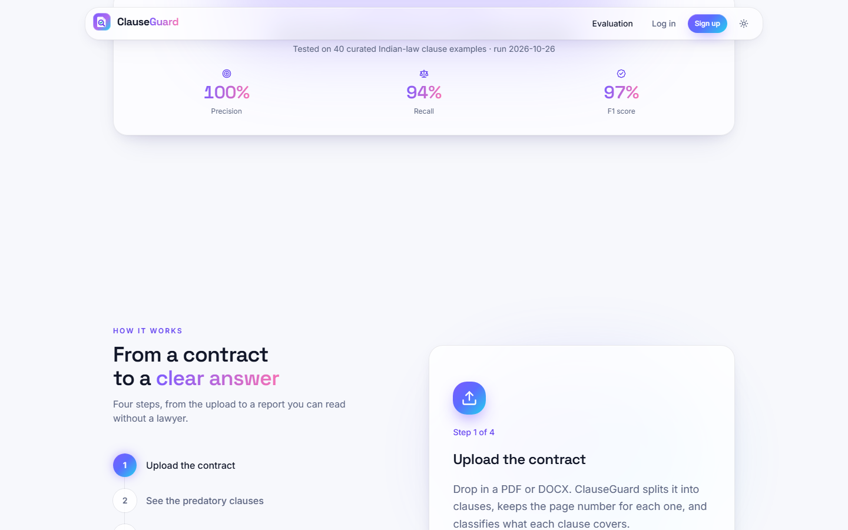  Fig. C.1: Landing page, measured results and how it works | 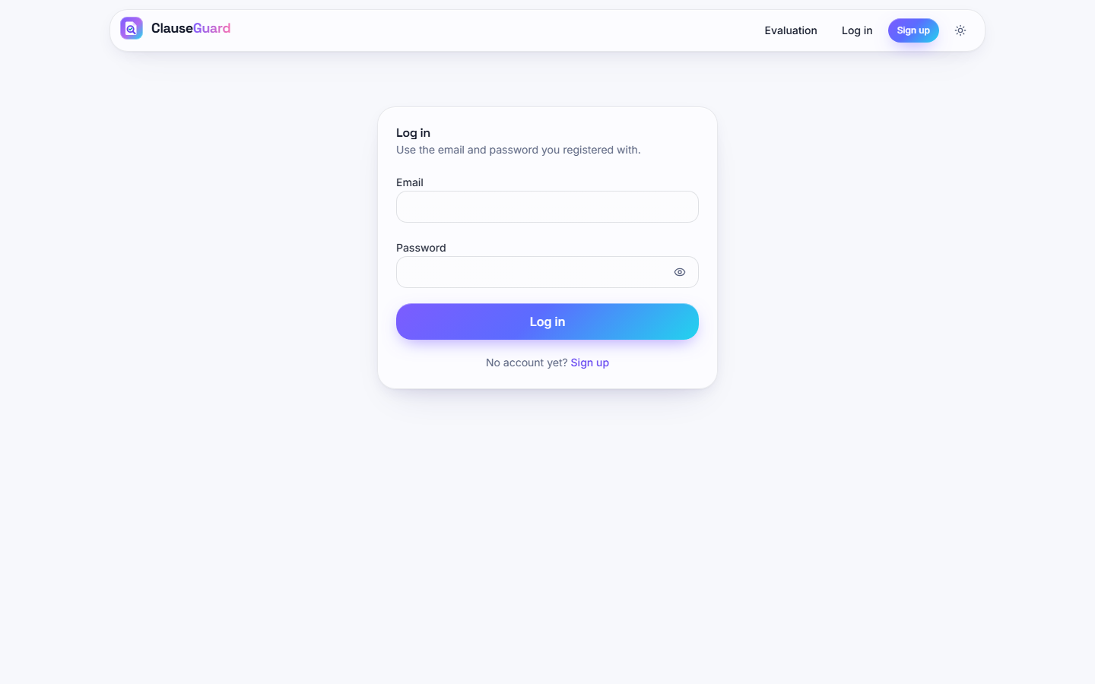  Fig. C.2: Log-in form

Landing page, measured results and how it works. The landing page scrolled: the strip "Tested on 40 curated Indian-law clause examples - run 2026-10-26" with precision 100 %, recall 94 % and F1 97 %, and below it the section "From a contract to a clear answer" with the four steps (Upload the contract, See the predatory clauses, and two more) and the card for step 1 of 4.
Log-in form. The Log in page: "Use the email and password you registered with", empty e-mail and password fields and a link to Sign up for new users.
Fig. C.3: Upload page before a file is chosen | Fig. C.4: Clause table of the freelance agreement

Upload page before a file is chosen. The Upload a contract page inside the signed-in shell: sidebar with My contracts and Upload contract, the drop zone "Drop a contract here, or click to browse", a disabled Analyse contract button and the privacy note.
Clause table of the freelance agreement. Rows 1 to 7 of the clause table with page, type, a 160-character preview, the number of flags and a risk badge: clause 1 Ip Ownership Assignment (no flag), 2 Termination For Convenience (High), 3 and 4 Liquidated Damages (Medium), 5 No-Solicit Of Customers (High), 6 Cap On Liability (High) and 7 Ip Ownership Assignment (High). The labels for clauses 1, 3, 5 and 6 are not the clauses' real subject.
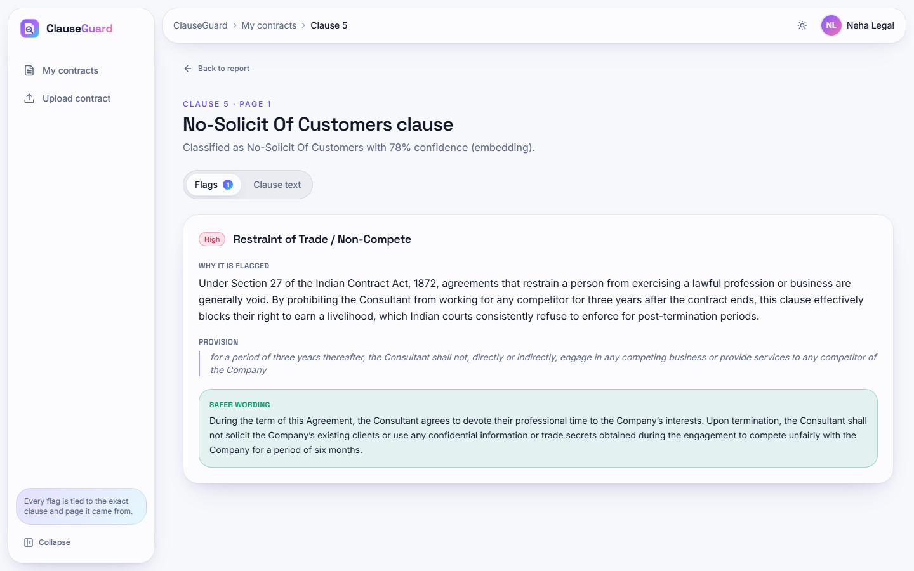  Fig. C.5: Clause detail: restraint of trade | 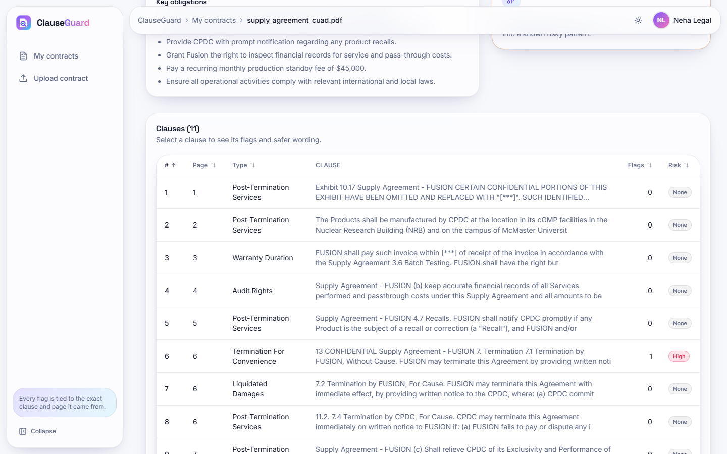  Fig. C.6: Clause table of the real PDF contract

Clause detail: restraint of trade. Clause 5 is labelled No-Solicit Of Customers (78 %). The High flag Restraint of Trade / Non-Compete cites Section 27 of the Indian Contract Act, 1872, quotes "for a period of three years thereafter, the Consultant shall not ... engage in any competing business ..." and proposes a version limited to non-solicitation of clients and misuse of confidential information for six months.
Clause table of the real PDF contract. Rows 1 to 9 of the 11 clauses of the supply agreement with their page numbers (1 to 7). Clause 6 on page 6, Termination For Convenience, carries the only flag (High). Several rows begin with running headers such as "Supply Agreement - FUSION" because the PDF text keeps page headers, and five rows are labelled Post-Termination Services.
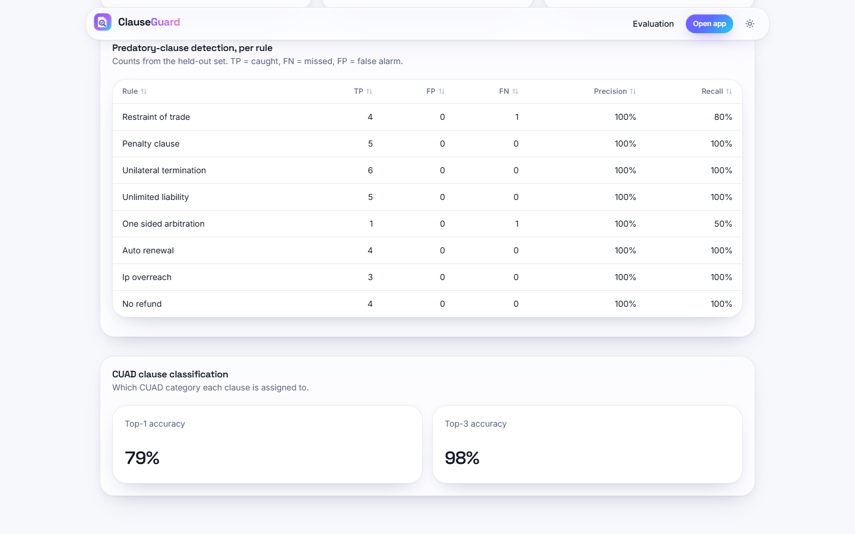
Fig. C.7: Evaluation page, per-rule table and classification

Evaluation page, per-rule table and classification. The Evaluation page scrolled: the per-rule table of the 40-clause set and the card CUAD clause classification with Top-1 accuracy 79 % and Top-3 accuracy 98 %, which are the values of the unmodified evaluation script on 240 held-out CUAD spans.

